|  |
| --- |
|  |
| **CELS Applicant User Guide** |
|  |

Table of Contents

1 Introduction & Background 3

2 Purpose of Individual Account 4

2.1 Who should create an Individual Account? 4

2.1.1 Online CEL Application 5

2.1.2 Paper CEL Application 5

2.1.3 Request a CEL Application (mailed to you) 5

2.2 CEL Application Checklist 6

3 Logging into CELS 7

3.1 Individual Account Registration 7

3.2 Keystone Login 9

3.3 Preferred Name 10

3.4 CELS has a Chatbot! 11

3.5 Accessing the CELS Chatbot 11

3.6 Chatbot access from the CELS landing page 11

3.7 Chatbot access from within CELS 12

3.8 Chatbot assistance by role: Applicant 12

3.9 Submitting a Chatbot Feedback Ticket 13

3.10 Submitting a Help Ticket 13

3.11 Disconnect from the CELS Chatbot 14

4 Applicant Dashboard 15

4.1 Dashboard Account Header 15

4.1.1 Messages 15

4.1.2 Alerts 19

4.1.3 Uploading Attachments 19

4.1.4 Deleting Attachments 22

4.1.5 Edit Applications 23

4.1.6 Delete Applications 25

4.2 CEL Results and Letters 26

4.3 Summary of Application 28

5 Creating a New CEL Application 29

5.1 What to Expect 29

5.2 General Questions 31

5.3 Applicant Demographic Information 32

5.4 Applicant Address Information 34

5.5 Applicant Contact Information 36

5.6 Applicant Household Member Information 36

5.7 Child Care Provider Information 37

5.8 Application Summary 38

5.9 Signature-Consent and eSignature 40

5.10 Payment 41

5.11 Confirmation 42

6 FAQ for CELS 44

# Introduction & Background

The Child Care Development Block Grant (CCDBG) requires states to have requirements, policies, and procedures to require and conduct criminal clearances and verification for certified child care providers, child care staff members, and any individuals residing in a child care facility age 18 and older.

As part of these requirements, Pennsylvania must provide a child care Consolidated Eligibility Letter (CEL) that combines the results of the following clearances and verifications:

* Child Abuse History clearance
* Federal Bureau of Investigation (FBI) Criminal History clearance
* National Sex Offender Registry (NSOR) verification
* Pennsylvania State Police Criminal History (PATCH) clearance
* Out-of-State Clearances, if required

As a result of this initiative, a new application called the Consolidated Eligibility Letter System (CELS) has been established. CELS supports the following processes:

* The CEL Application is submitted by the applicant or child care provider.
  + A CEL can be requested by an applicant and sent to the employer or requested by the employer with a copy being sent to the applicant.
* Paper CEL Applications that are mailed to the Clearance Verification Unit (CVU) will be entered into CELS by a CVU worker. The applicant may include any relevant Out of State Clearances with their paper CEL application, which will also be uploaded into CELS.
* The CVU processes the CEL request and notifies the provider/applicant of the outcome of the CEL request. The possible determinations are as follows:
  + The applicant is eligible to work with children in a child care setting.
  + The applicant is ineligible to work with children in a child care setting.
  + The applicant is eligible to reside in a child care facility.
  + The applicant is ineligible to reside in a child care facility.

The CEL request replaces individual clearance or verification requests with the exceptions of the FBI Criminal History clearance and out-of-state clearances where the state requires the CVU to submit the individual application. In addition to receiving a CEL, the applicant will receive the individual clearance and verification results that make up the CEL.

# Purpose of Individual Account

The intent of an Individual Account, also referred to as a Citizen Account, for the purpose of the Consolidated Eligibility Letter System (CELS) is to allow an individual who work in or reside in a child care setting to electronically apply for their required background checks and access their finalized eligibility result.

Creating an Individual Account on the CELS site is the fastest way to complete an application and review the results. If you have a Keystone Login for another Commonwealth application, such as the Child Welfare Portal, you may log in to CELs using your existing Individual Account username and password. An email address may only be associated with one Individual Account. If you need to create a new Individual Account for any reason, you will not be able to reuse an email address. ***Please ensure all contact information is accurate and correct****.* Any inaccuracies can cause a delay in processing your results. The exact amount of time it will take to complete the CEL Application will vary. Please note that Individuals located outside of the United States may not be able to create an Individual Account for the purpose of applying for a CEL. Individuals located outside of the United States who are unable to create an Individual Account must apply for a CEL by completing the paper CEL application.

A CEL Result is valid for 60 months (5 years) unless you had a break in child care employment that was greater than 180 days. If you have not worked in a child care setting for more than 180 days, you must obtain a new CEL Application before working in a new child care setting.

NOTE: An Individual Account is specific to one person. Individual accounts may not be shared.

## Who should create an Individual Account?

An Individual Account is necessary for a person wishing to electronically apply for a CEL who has not previously registered for an Individual Account for another Commonwealth IT System, such as the Child Welfare Portal.

Examples of who would benefit from an Individual Account include:

* An individual who wishes to work in a child-care center, group child care home or family child care home.
* An individual with an ownership interest in a certified child care provider.
* An individual who wishes to work in the organization or management of a child care provider.
* An individual who is a household member of a certified child care facility. A household member of a certified child care facility is defined as an individual 18 years of age or older residing at least 30 calendar days per year at a certified child care facility.
* Any individual applying for a CEL on behalf of themselves.

A CEL Application can be completed online from your computer or mobile device through CELS <https://www.pa.gov/en/agencies/dhs/resources/keep-kids-safe/child-abuse-clearances.html>

### Paper CEL Application

You can download a blank CELS Application in English or Spanish from the CELS home page, <https://www.pa.gov/en/agencies/dhs/resources/keep-kids-safe/child-abuse-clearances/child-care-employee.html>

Applicants may also request a paper CEL Application to by using the CELS Chatbot to create a ServiceNow ticket.

After you download the application, print, and complete the application, mail your completed application with the correct payment in the form of a business check, personal check, or money order to the Clearance Verification Unit (CVU):

Clearance Verification Unit

P.O. Box 8170

Harrisburg PA. 17105-8170

If you are using a payment code to request a CEL, you may provide the payment code on the paper CEL Application in the payment section. You must provide a signature for the CEL Application to be accepted.

Request a CEL Application (mailed to you)

If you would like a blank copy of the CEL Application mailed to you, please call 1-877-371-5422 or use the CELS Chatbot to make a request. Applications are also available for pick up between the hours of 08:00 am and 04:30 pm located at:

Clearance Verification Unit

2525 North 7th Street

Harrisburg PA. 17110

Applications can also be dropped off at this address between the hours of 08:00 am and 04:30 pm. Note that same-day processing is not available for applications dropped off in person to the CVU.

## CEL Application Checklist

Before you start your CEL Application, you will need to have the following information:

* Addresses where you have previously lived since 1975.
* Names of all individuals with whom you have lived since 1975 including parents, siblings, spouses, and extended family members.
* Any names or aliases you have used since 1975 (including maiden name).

A prepaid code, check, or money order. Applicants applying online through CELS may pay with a credit card. **Note:*****When applicants are applying online through CELS they only have the option of using a pre-paid code or debit/credit card.***

# Logging into CELS

All applicants and providers have access to the **Home Page** where they can log into CELS.

If you are an individual and need to obtain a CEL and do not have a Keystone Login, you must create an **Individual Account**. Select **Create Individual Account** on the CELS home page to start the Citizen Account registration.

**Note: *If you have an existing Keystone Login, such as a Child Welfare Portal account, from the CELS home page, select Login to Individual Account.***

## Individual Account Registration

If you do not have a Keystone Login, you will first need to register for an Individual **Account**. From the CELS home page, select the **Create Individual Account** link to get started. You will complete all required fields for the Individual Account:

1. Personal Information-Enter your first name, last name, date of birth, and email address.
2. Create a Username and Password-You may choose your email address as your username. Once you create your username, it cannot be changed. An Individual Account is linked to only one email address.

**Note**: ***Select a password you can easily remember*.**

1. Security Questions-Select three security questions and answers.

**Note**: ***Security questions should be created so they are easy to remember.***

1. Terms and Conditions-Check the box to agree to the terms.
2. Back to CELS Home Page button navigates the applicant back to the CELS home page or the Register button progresses to the Keystone Login page.

By selecting the **Register** button, you will receive a **Success message** and then be navigated to the Keystone Login and enter your Individual Account credentials, which is your **Keystone Login**.

If you are not ready to complete the registration select the **Back to CELS Home Page** button which will navigate back to the home page.

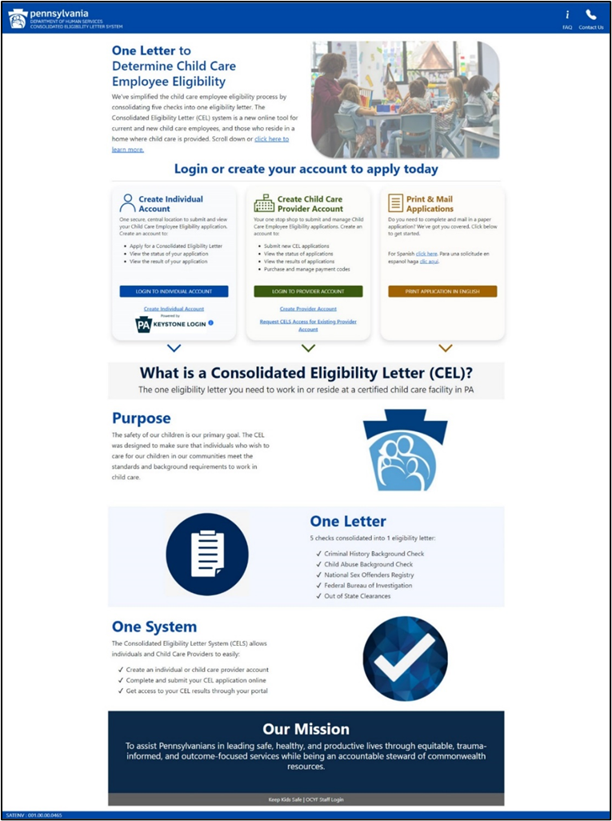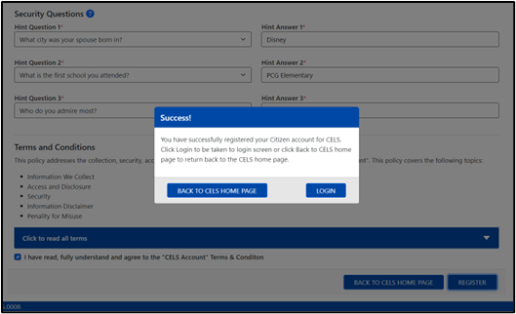

## Keystone Login

If you already have a **Keystone Login**, you will not need to create an Individual Account. At the CELS home page, select the **Login to Individual Account** button to continue to the **Keystone Login** screen.

Enter your **Keystone Login** user ID and password credentials and select **Login**. After you login with your **Keystone Login,** you will be navigated to the Applicant Dashboard.

**Note that if you are unable to recover your user ID after using the “Forgot User ID” function available via the Self-Service for Individuals on the login page, you will need to create a new account. The new account must be under a different email address, as an email address can be associated to only one account.**

To recover your password, please use the “Forgot Password” function available via Self-Service for Individuals. If you are unable to recover your password due to inadequate security questions or a locked account, please utilize the CELS Chatbot to report the incident.

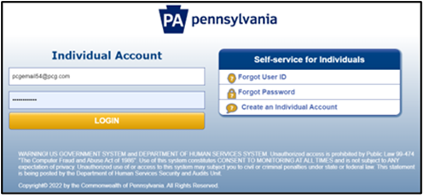

## Preferred Name

When you first log into the CELS, you are asked a question about your Preferred Name and can change your displayed name to your Preferred Name.

You can select **Change Name** and a pop-up will appear. You will be given an opportunity to enter a **Preferred Name**. You can also select **Keep Name** or **Remind Me Later**.

**Note: Once changed, the Preferred First Name information cannot be reverted to a previous name. If you elect to use the Change Name function, please use care in selecting your Preferred First Name before clicking the Save button.**

## CELS has a Chatbot!

CELS includes a helpful Chatbot to assist users in a variety of situations. The CELS Chatbot is available to provide users of CELS immediate support. The CELS Chatbot can provide general information related to the CEL application process, frequently asked questions, and how to use the system. In some scenarios, when the CELS Chatbot is unable to resolve a user’s concern the CELS Chatbot will provide the user the option to raise a ticket for further assistance.

## Accessing the CELS Chatbot

Users can access the Chatbot either prior to logging into CELS, or after logging in to CELS. The level of assistance the Chatbot can offer increases after you have logged into CELS.

## Chatbot access from the CELS landing page

When the initial CELS landing page opens, the Chatbot dialog box automatically displays.

## Chatbot access from within CELS

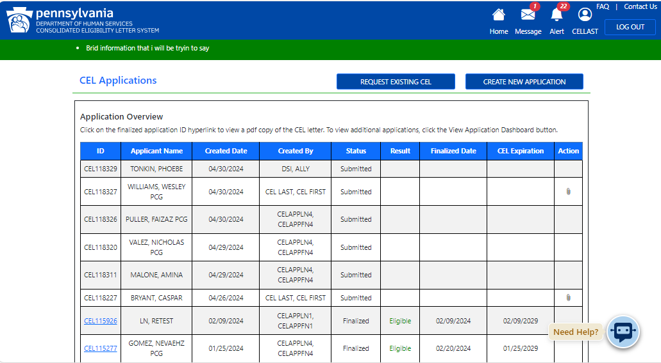Once logged in to CELS, users can access the CELS Chatbot on most CELS screens. To access the CELS Chatbot, just click on the Chatbot icon on the lower right area of the screen.

## Chatbot assistance by role: Applicant

The CELS Chatbot can assist Applicants with the following items:

|  |  |
| --- | --- |
| Account Help | Help Accessing your Account |
| Creating an Account |
| Managing an Account |
| Apply for a CEL | Have a paper Application mailed to you |
| Get help completing an application |
| Get E-signature help |
| CEL Payments | View electronic application payment |
| Submit paper application payment |
| CEL Status | View electronic application status |
| View printed and mailed in application status |
| General CEL Information | Review CEL requirements |
| Learn more about CEL |
| View an existing CEL |
| Request clearance results |
| CELS Dashboard | Manage CEL application |
| Track your application |
| View recent CEL applications |
|  |  |

Throughout the user guide, the Chatbot icon will appear whenever an applicable task is discussed where the Chatbot can help.

## Submitting a Chatbot Feedback Ticket

If you have a comment to help improve the Chatbot’s performance, the Chatbot will guide you through the steps to leave feedback via a ticket.

**Note**: ***Mandatory fields have a red asterisk (First Name, Last Name, E-mail, Phone, User Type and Description). The Description field has a limit of 3000 characters*.**

|  |  |
| --- | --- |
|  |  |

## Submitting a Help Ticket

In identified scenarios when the CELS Chatbot cannot resolve an issue, the CELS Chatbot can assist users to enter a help ticket for further assistance. Submitted tickets are responded to within two business days.

Once the help ticket is successfully submitted, you will receive this message: “*The ticket will be responded to within 2 business days. Expect an email from* [*copaprod@servicenow.com*](mailto:copaprod@servicenow.com) *. If not received, please check your spam/junk folder.”*

|  |  |
| --- | --- |
|  |  |

## Disconnect from the CELS Chatbot

Users may disconnect from their Chatbot session by clicking the **X** in the Chatbot’s upper right corner and then clicking **Yes** in the subsequent confirmation dialog. When a user disconnects from the CELS Chatbot, the conversation history will be deleted.

|  |  |
| --- | --- |
|  |  |

The Applicant Dashboard helps you keep track of the status and progress of your CEL Application and review any messages and alerts for your CEL Application. Once you have logged into the CELS you are directed to the Applicant Dashboard. The dashboard consists of 4 areas:

* Dashboard Account Header
* Dashboard Tabs
* Messages and Alerts
* Upload Attachments

## Dashboard Account Header

The Applicant Dashboard allows you to:

* Create a new CEL Application
* Access previously created or submitted applications
* Review finalized applications

You can:

* Edit previous unsubmitted CEL Applications.
* Delete previous unsubmitted CEL Applications.
* View a summary of your submitted application that is processing.
* Attach an out-of-state clearance result to a submitted application.
* View out-of-state clearance attachment previously uploaded to an application.
* View clearance/Verification results and letters associated with a finalized CEL.

The **Message** icon allows you to view and respond to messages from the CVU related to additional information needed to complete a submitted application. When you respond to a message, you may upload requested attachments in the **Message Detail** popup. When there are new messages for you there will be a number next to the **Message** icon.

**Note: *If you do not view a message sent to you by OCYF within 7 days, an email notification will be sent to the email account you used during account creation. The email will notify you that you have an unread message in CELS.***

Once you select the **Message** icon in the header, a list of messages will show. Select the blue **eye** icon in the View column to review or respond to the message.

1. The screenshot below is an example of a new message for an applicant. Once you review the message, select the **Respond** button.

The Application Messages table columns are the following:

|  |  |
| --- | --- |
| New | This column shows messages that have not been viewed by the Applicant. There is a “!” sign if the message is unviewed. If all the messages have been viewed, there is nothing displayed. |
| Application ID | Each CEL Application has its own specific unique application number. |
| Provider Name | Name of the child care provider or facility that is requesting the child care clearance(s). |
| Reason for Request | The reason the child care provider or facility is requesting clearance(s) from you, the applicant. |
| Date/Time of Request | This column is the date and time when CVU sent a request for additional information. |

1. Once you select the **Respond** button, the **Message Details** dialog box shows.
   1. Type your response to the request in the **Response** text box.
   2. Upload an attachment, if necessary.
   3. Click the **affirmation** checkbox.
   4. Provide your eSignature.

**Note**: ***Your eSignature is the same first and last name you used to register your CEL account.***

* 1. Then select the **Send** button.

**

To respond to a message from your dashboard, from the message screen, select the View Column (eye icon) to open the Message Details screen.

1. Graphical user interface, text, application

   Description automatically generatedTo respond to a message, from the **Message Detail** screen, select the **Respond** button. Complete the following fields:
   * **A**-Request-The message from CVU for a specific CEL Application will be here for your review.
   * **B**-Response-Type your response to the CVU request. If you have your FBI Clearance ID number, you will enter the information in the Response box. For example, “*I am providing my FBI Clearance ID number for this application. The FBI Clearance ID number is xxxxxx*.”
   * **C**-Affirm Box-It is mandatory that you check the affirm box to confirm the information you are submitting is accurate.
   * **D**-eSignature-It is mandatory for you to provide your first and last name as your eSignature. Your eSignature must be the same name you used to create your account.
   * **E**-Out of State Clearance-You can attach your out of state clearance(s) or FBI Clearance(s). The attachment will go to CVU for the specific application in the message.

**Note: *You cannot review your attachment before selecting the Send button. Please be cautious in adding the correct attachment.***

* + **F**-Once you complete all mandatory fields in this message details screen, select the Send button to submit the response.

### Alerts

The Alerts icon allows you to view the list of alerts that are triggered after the CEL Application is submitted. Alerts are linked to a specific CEL ID and provide the reason for the alert. Clicking the **X** button next to the specific CEL ID clears the alert from the table. The number of alerts is next to the **Alert** icon in the header.

Alerts can be informational (FBI Results are overdue) or require a response from you, the applicant.

1. Example of an alert that requires a response from an applicant:

* “*The applicant is required to register for a fingerprint background check and have their fingerprints taken. Failure to complete this check in a timely manner may result in your CEL results being determined Ineligible. Please contact the Clearance Verification Unit, at 877-371-5422, if you have any questions about this process*.”

1. Example of an alert that is informational for an applicant:

* “*Unsubmitted CEL 123456 has been deleted.”*

**After submitting your CEL application, you may upload any required out-of-state clearance at any time by following these steps:**

* 1. **Navigate to your CELS Dashboard by selecting the home button.**
  2. **Locate the applicable CEL application that you would like to add attachments to.**
  3. **Select the paperclip icon in the action column.**
  4. **Select the drop-down to select the applicable State, Territory, or Tribe.**
  5. **Select the Choose File button.**
  6. **Browse- Locate the file on your computer that you want to submit, then select Open.**
  7. **Select Upload-Once you have located your file, select the Upload button.**
  8. **Confirm the correct document name appears in the Attachment Title table.**
  9. **Repeat this process, if necessary to add multiple attachments.**
  10. **Select the Save button.**

**After receiving a message from the CVU requesting your out-of-state clearance you may follow these steps to upload an attachment in the Message Details box (this process is outlined 4.1.1):**

1. **Pre-Requisite: The CVU sends you a message requesting out-of-state clearances or FBI Clearance ID. You receive a message alert.**
2. **View Message**
3. **Click Respond**
4. **Select the Upload Out-of-state Clearance link and the attachment popup appears.**
5. **Browse- Locate the file on your computer that you want to submit,** then select Open.
6. Select the drop-down and select the desired State, Territory, or Tribe.
7. **Upload-Once you have located your file, select the Upload button.**
8. **Confirm the correct document name appears in the Attachment Title table.**
9. **Complete the affirmation.**
10. **Select the Save button.**

**Note**: **Only one file may be uploaded at a time. You can only upload the following types of files: .pdf, .doc, .docx, .jpeg, .jpg.**

* Out-of-state background checks are required anytime an employee has lived outside of Pennsylvania within the last five years. There are THREE required out-of-state background checks:
* Out-of-State Criminal History Check*
* Out-of-State Sex Offender Registry Check*; and
* Out-of-State Child Abuse and Neglect Registry Check.

*NOTE: Each state has the option to use a fingerprint to conduct these checks, so the process will vary from state to state. Additional information on each state’s requirements can be found here <https://childcare.gov/state-resources-home>

* State Agencies may be open or closed sharing. The term “Open state” and “Closed state” refers to a state’s ability under the law to provide clearance information to the requester. A Closed state typically refers to a state in which clearance results must be requested by and provided to the individual who is named on the clearance. An Open state refers to a state that allows clearance information to be requested by and provided to other entities, such as a state agency or a provider.
  + Examples:
    - John lived in South Dakota, a closed state. The Out of State clearance information must be applied for and sent to John. Once John receives the out of state clearance results, John is responsible for including that information in the CELS.
    - Jill lived in Ohio, an open state. The Out of State clearance information can be obtained by the CVU once the Jill mails a check or money order for Ohio out-of-state clearance along with the completed, applicable clearance application to the CVU. In this example, the check or money order Jill sends to the CVU should be made payable to Ohio as that is the state the clearance is being requested for.
* If you move out of state and continue to work for a Pennsylvania child care provider, your out-of-state clearances will need to be obtained prior to your first clearance or CEL expiring at 60 months (five years).
* CVU will request out-of-state clearances on your behalf whenever possible. You will be required to obtain your own out-of-state clearance(s) only when the out-of-state agency’s regulations requires you to do so.
* **For CVU to request your out-of-state clearances, you must mail a check or money order for each out-of-state clearance along with the completed, applicable clearance application to the CVU.  The check or money order should be made payable to the state the clearance is being requested for.**

To learn the details of out-of-state clearance requirements by state please visit <https://childcare.gov/state-resources-home> , search for the state you need additional information on, and then click on “Criminal Background Checks” section.

If you need further information about out-of-state clearances, please visit: [*https://www.dhs.pa.gov/KeepKidsSafe/Clearances/Pages/Out-of-State-Clearances.aspx*](https://www.dhs.pa.gov/KeepKidsSafe/Clearances/Pages/Out-of-State-Clearances.aspx)

### ****Deleting**** Attachments

In the CEL Applications table, select the submitted application you need to delete the attachment from.

**Note**: **The green paperclip icon is shown for submitted applications with attachments. The black paperclip icon is for submitted applications without attachments.**

1. Once you select the green **paperclip** icon, an Attachments popup appears. In the Attachment popup, select the **trashcan** icon to delete the attachment in the associated row.
2. Within the Delete Confirmation dialog box, select **OK**. Next, select the **Save** button.
3. If you do not want to delete the attachment, select the **Cancel** button to return to the CEL Applications table.

### 

### ****Edit Applications****

You can edit your application before submitting and paying the application fee. You can only edit application(s) that are incomplete.

1. You will log in to CELS and navigate to the Applicant Dashboard. The CEL Application table displays the most recent applications you have started or completed.

1. Locate the incomplete CEL ID in the table and select the **pencil** icon found in the **Action** column. The below screen appears.
2. You can either select **Continue from the Beginning** or **Continue From the Last Page Saved**.

1. If you select the **Continue From the Beginning** link, you will navigate back to the first screen of the CELS Application: Getting Started.

1. If you select **Continue from the Last Page Saved** link, you will navigate to the last page you saved in your application. This page will vary for each application.
2. You can complete your application, and make modifications or updates as needed.

Applications can be deleted only if the application has not been submitted. An unsubmitted application will have the status of “Incomplete.” On the applicant dashboard home page (CEL Applications), select the unsubmitted application you want to delete.

1. Select the red trash can icon in the Action column.

1. You must select a Reason for Deletion in the dropdown:
   1. Application Not Needed
   2. Other
   3. User Error
2. You can **provide** a typed **explanation** for why this application is being deleted in the message text box, but it is not mandatory.
3. Once you have completed the mandatory fields, select the **Delete** button.

**Once your CEL is finalized, you will receive an** email with the subject line, “Your CEL has been Finalized”. By logging into your CELS account you may **view and print your finalized CEL result. Additionally, you may view the overall determination of the individual clearance results that make up your CEL. The finalized CEL result will also be mailed to you through the United States Postal Service. Please note that it may take up to 10 business days from the date your CEL result is finalized for you to receive your paper CEL result. A request for a duplicate copy of your CEL result to be mailed to you will not be fulfilled if the CEL result finalized date is within 10 days of the request date. The CELS Results screen will break down the individual clearance results that make up your CEL and identify which clearance results are eligible or ineligible.**

**Follow the steps below to review the individual clearance results that make up your CEL result:**

1. Graphical user interface

   Description automatically generated with low confidenceFrom the Applicant Dashboard home page, locate the Finalized Application and then select the blue eye icon in the Action column**.**
2. **The CEL Results window will pop up and you can review which clearance results are eligible or ineligible.**

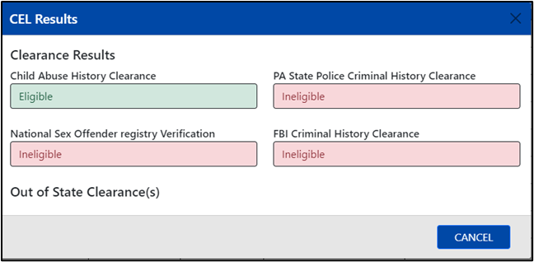

1. **Your finalized CEL may be viewed and printed by following the steps below:**
   1. **From the Applicant Dashboard homepage, click on the CEL ID that has a hyperlink and says Finalized in the Status column.**
   2. **A new window will open allowing you to view and or print your finalized CEL result.**

**Sample**

**Ineligible Letter**

**Sample**

**Eligible Letter**

## Summary of Application

From the Applicant Dashboard you may view the summary of a submitted or finalized application. To view the summary of an application, select the **paper** icon in the action column of the finalized or submitted CEL that you would like to view.

The **Application Summary** will open in a new window, and you can select **Expand All** to review each section in detail.

# Creating a New CEL Application

The process to complete a new CEL application is outlined in this section. Within the application a required field will have an asterisk; if the required field is not completed the application will not be able to be submitted until the information is entered.

1. To begin the process of creating a new CEL application, select the New Application button.

The navigation buttons will allow you to quickly navigate to the various sections of the application. The icons turn blue when the screen is fully complete. The icon turns red to indicate the screen contains incomplete information. The icon turns green to indicate it is the current screen. The Navigation buttons are as follows:

1. What to Expect
2. Apply
3. Signature
4. Payment
5. Confirmation

## What to Expect

The **What to Expect** page is the start of the CEL application process. This screen provides an overview of the application process, and privacy information, and lets you know what information you will need to complete your application.

You are navigated to this page after selecting the **New Application** button from the account home page.

1. The apply section has several pages for you to review. The pages in this section are:

* General Questions
* Applicant Demographic Information
* Applicant Address Information
* Applicant Contact Information
* Applicant Household Member Information
* Member Information Review
* Child Care Provider Information
* Application Summary

## General Questions

The General Questions screen captures the overall purpose of the certification and requests information on whether you applied for your FBI Criminal History Background Check.

Select your **Purpose of Certification**. (You can only select one option.)

You must submit your FBI Clearance ID number within 45 days of submitting your application. For the purposes of the CELS, please provide the Universal Enrollment Identification (UE ID) in the FBI Clearance ID space. The UE ID is assigned at the time of the FBI check request. Note, the FBI Background Check must be obtained with the same 45 day period of applying for a CEL.

**Submitting a CEL Application without FBI Clearance ID number**

If you do not have your FBI Clearance ID number at the time of completing your CEL Application, select **No** to the question “*Has the applicant applied for their FBI Criminal History Background Check?*” in the General Questions section and select the Next button.

If you select **No** to the FBI question, you will receive an email notification reminding you that you must obtain your FBI Criminal History Background Check.

**Note**: ***If you need more information on the FBI Criminal History Background Check, visit Keep Kids Safe:*** [***https://www.dhs.pa.gov/KeepKidsSafe/Clearances/Pages/***](https://www.dhs.pa.gov/KeepKidsSafe/Clearances/Pages/)***.***

***Once you have submitted your CEL Application, you cannot make any edits to your application.***

If you entered the FBI number incorrectly and submitted the CEL, you can correct it by uploading FBI Criminal History Background Check via the **attachment** icon.

If you submitted your application without your FBI Clearance ID number and have the FBI Criminal History Background Check result, you can alternately add it as an attachment from your dashboard. See **Attachments** for more information.

**Submitting a CEL Application with an FBI Clearance ID number**

If you have applied for the FBI background check, select **Yes**, and enter UE ID. After completing this screen, select the **Next** button.

## Applicant Demographic Information

The **Applicant Demographic** screen captures details about you, the applicant, including Previous Names (including maiden name) you have used since 1975. When you have completed this screen select the **Next** button:

* You must include all previous names (maiden) you have used since 1975. ​
* You can add a previous name by selecting the **green** **Add Previous Name**button.
* The mandatory fields are: First Name, Last Name, Date of Birth, Gender, and Social Security Number.

* If you have had no previous names, check the box next to “**No Previous Names Used Since 1975.**”
* If a previous name was entered mistakenly, you can delete the name by selecting Delete.
  + Confirm you want to delete this name by selecting OK or Cancel if you do not want to delete the previous name.

## Applicant Address Information

The **Applicant Address Information** screen captures details about your current addresses as well as Previous Addresses.

On this screen, you provide your home address, mailing address, and any previous addresses you have lived at since 1975. If you do not have a previous address, check the **No Previous Address** box.

If your home and mailing address are the same, check the box for **Home and Mailing Address** are the same.

If you have resided outside the state in the past five years, select **Yes**. You will have to include your previous out of state address.

**Note:** **CVU will request out-of-state clearances on your behalf whenever possible. You will be required to obtain your own out-of-state clearance(s) only when the out-of-state agency’s regulations requires you to do so. For CVU to request your out-of-state clearances, you must mail a check or money order for each out-of-state clearance along with the completed, applicable clearance application to the CVU.  The check or money order should be made payable to the state the clearance is being requested for.**

Your home and mailing addresses must be validated. To validate your address, select the **Validate Address** button. When the pop-up appears, it is asking you to confirm the address. You will select **Use This** next to the Recommended or user-entered address.

If your home and mailing address are different, both addresses will need to be validated.

## Applicant Contact Information

The next screen is Applicant Contact Information. Providing a primary phone number and email address is required. After reviewing the information, select **Next**.

The next screen is **Applicant Household Member Information.** You must includeeveryone you live with or have lived with at any time, from 1975 to the present.

You must include at least one person with the relationship of Parent, Legal Guardian, or Grandparent.

If you were not raised by a parent, grandparent, or legal guardian, but rather were raised by a state agency, you should enter your own information to the Applicant Household Member Information screen. Within the relationship dropdown the selection “Ward of the State” should be applied. Please note that Ward of the State would not apply to foster children.

To add additional household members, select **Add Another Household Member**.

To delete a household member, select the red **Delete** button.

The screenshot below shows the fields available for a household member’s information.

The following fields are required for all household members:

* first name
* last name
* relationship to the applicant

Once all information has been completed select **Next**.

## Child Care Provider Information

The next screen is **Child Care Provider Information**. The Child Care Provider screen captures details about the Child Care Provider who will be receiving the finalized CEL result. This is the child care provider you are employed by, seeking employment by or are a household member in.

**Attention, Provider Name, Address Line 1, City, County, State/Region/Province, Zip/Postal Code, Country, Provider Phone Number, Provider Email, and Confirm Provider Email** are all mandatory fields in this section.

The **Attention** field should have the name of the individual at child care facility who will receive the CEL.

The **Provider Name** should have the name of the facility that the CEL result will be mailed to.

The provider’s address must be validated. Validate the provider’s address by selecting the **Validate** Address button. A pop-up may appear, asking the individual entering the application to confirm the address. The individual must determine the correct address.

Once you complete the Provider Information select **Next***.*

## Application Summary

The next screen is **Application Summary** screen. You must review the information you entered. You may make edits to any of the following sections in your application should you find errors or need to add additional information to any of the below section:

1. **General Questions** - Purpose of Certification, if you have applied for FBI Criminal History Background Check and FBI Clearance ID Number.
2. **Applicant Demographic Information**- Name, Date of Birth, Gender, Social Security Number, and Previous Names since 1975.
3. **Applicant Address Information**- Home Address, Mailing Address, and Previous Addresses since 1975.
4. **Applicant Contact Information** - Phone Number(s) and Email Address.
5. **Household Information** - Household members since 1975.
6. **Child Care Provider Information** - Attention Name, Provider Name, Address, Provider Phone Number, and Provider Email.

To make edits to a section, select the **edit** button in the specific area you want to edit. You can also collapse the sections. Once you have finished reviewing select **Next**.

**NOTE: Once an application is submitted and paid for, updates cannot be made to the application.**

## Signature-Consent and eSignature

The **Consent and eSignature** page captures your consent for the release of information.

Check all the boxes that apply for the clearances you need to obtain.

If you have resided out of state in the past five years, check the box for each state to provide consent, allowing CVU to obtain your out of state clearances.

**NOTE**: Your **eSignature** must be the same first and last name you used to register your account. After completing this screen, select the **Next** button.

The Payment section contains the **Payment Method** page. The **Payment Method** screen captures what payment will be used when submitting the application.

If you are using a pre-paid payment code to pay for the application, you will need to select **Yes**, enter the **Payment Code** then select **Submit** to continue.

1Q0JLN3CTSXT

If you do not have a Payment Code, then select **No**, and click **Submit**, the **Credit Card Payment** screen displays. Complete the Card Holder Name, Credit/Debit Card Number, Credit/Debit Card Expiration Month and Year, Credit/Debit Security Code, Billing Street Address, Billing ZIP code, and Email address. Then click the **Pay With Your Credit Card** button.

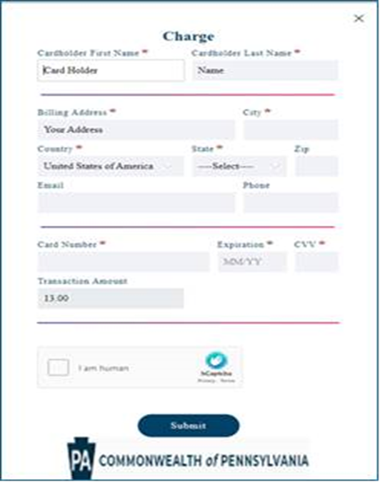Do not select the **Pay with Your Credit Card** button multiple times as this can cause multiple charges to your card.

## Confirmation

The Confirmation section contains the **Submission Confirmation** page. After applying, you can click the blue **Return to Your Account Dashboard** button.

Please check your email for confirmation about your application. If you do not receive a confirmation email, please contact CVU at 1-877-371-5422. You can also check the status of your application on the CELS Applicant dashboard.

**You will receive the following confirmation message if you have not resided outside of Pennsylvania within the last five years.**

If you have resided outside the state in the past five years, **CVU will request out-of-state clearances on your behalf whenever possible. You will be required to obtain your own out-of-state clearance(s) only when the out-of-state agency’s regulations requires you to do so. For CVU to request your out-of-state clearances, you must mail a check or money order for each out-of-state clearance along with the completed, applicable clearance application to the CVU.  The check or money order should be made payable to the state the clearance is being requested for.**

Please visit Keep Kids Safe Out-of-State Clearance page (<https://www.pa.gov/en/agencies/dhs/resources/keep-kids-safe/child-abuse-clearances/out-of-state-clearances.html> ) for further assistance. Failure to obtain out of state clearances or provide required payment(s) in a timely manner will result in a delay in finalizing your CEL Application.

**You will receive the following confirmation message if you have resided out of Pennsylvania within the past five years.**

# Contact Information for CELS

For questions regarding CELS Applications, contact the Office of Children Youth and Families (OCYF) Clearance Verification Unit by selecting the **Contact Us** button in your dashboard.

# FAQ

By selecting the **FAQ** button the CEL FAQ pdf. document will open.

