CELS Provider User Guide

Table of Contents
1 Introduction & Background 4
2 Purpose of a Provider Account 4
2.1 Who Should Create a Child Care Provider Account? 5
2.2 Create a Child Care Provider Account 5
2.3 What if I Already Have a B- Account? 6
3 Logging in to CELS 6
3.1 Keystone Login 7
3.2 Preferred Name (Optional) 9
3.3 CELS has a Chatbot 10
3.4 Accessing the CELS Chatbot 10
3.5 Chatbot Access from the CELS Landing Page 10
3.6 Chatbot Access from Within CELS 10
3.7 Chatbot Assistance by Role: Provider 11
3.8 Submitting a Chatbot Feedback Ticket 11
3.9 Submitting a Help Ticket 12
3.10 Disconnect from the CELS Chatbot 13
4 Provider Dashboard 14
4.1 Dashboard Header 15
4.1.1 Messages 15
4.1.2 Alerts 16
4.1.3 Home 18
4.1.4 FAQ 18
4.1.5 Contact Information 18
5 Requesting an Existing CEL 19
6 Creating a New CEL Application 22
6.1 What to Expect 25
6.2 General Questions 26
6.3 Applicant Demographic Information 26
6.4 Applicant Address Information 27
6.4.1 Home Address Section 27
6.4.2 Mailing Address Section 28
6.4.3 Previous Address information 29
6.5 Applicant Contact Information 34
6.6 Applicant Household Member Information 35
6.7 Child Care Provider Information 38
6.8 Application Summary 39
6.9 Provider Attestation and eSignature 41
6.10 Payment 42
6.11 Confirmation 43
7 Viewing and Responding to Messages 45
8 Working with Alerts 47
9 Application Dashboard 49
9.1 Viewing and Printing a CEL 52
9.2 CEL Application Search 54
10 Editing and Correcting a CEL Application 55
10.1 Deleting an Incomplete CEL 57
11 Payment Codes 59
11.1 Payment Code Life Cycle 59
11.2 Payment Code Dashboard 60
11.3 Purchase Payment Codes 61
11.4 Payment Code Search 63
11.5 Assign Payment Codes 66
11.6 Unassign Payment Codes 67
12 Attachments 69
12.1 Upload an Attachment for a Submitted Application 69
12.2 Upload an Attachment for a Previous Address for a New Application 71
12.3 Deleting a Previous Address 74
12.4 Upload an Attachment – CVU Requests Additional Information 74
13 Submitting FBI Clearance ID for a Submitted CEL 79

Introduction & Background
The Child Care Development Block Grant (CCDBG) requires states to have requirements, policies, and procedures to require and conduct criminal clearances and verification for certified child care providers, child care staff members, and any individuals residing in a child care facility age 18 and older.
As part of these requirements, Pennsylvania must provide a child care Consolidated Eligibility Letter (CEL) that combines the results of the following clearances and verifications:

- Child Abuse History clearance
- Federal Bureau of Investigation (FBI) Criminal History clearance
- National Sex Offender Registry (NSOR) verification
- Pennsylvania State Police Criminal History (PATCH) clearance
- Out-of-State Clearances, if required

As a result of this initiative, a new application called the Consolidated Eligibility Letter System (CELS) has been established. CELS supports the following processes:
- The CEL Application is submitted by the applicant or child care provider.
  - A CEL can be requested by an applicant and sent to the employer or requested by the employer with a copy being sent to the applicant.
- Paper CEL applications that are mailed to the Clearance Verification Unit (CVU) will be entered into CELS by a CVU worker. The applicant may include any relevant out-of-state Clearances with their paper CEL application, which will also be uploaded into CELS.
- After processing the CEL, the CVU will notify both parties (the child care provider and applicant) one of the following possible statuses:
  - The applicant is eligible to work with children/reside in a child care setting.
  - The applicant is ineligible to work with children/reside in a child care setting.
  - The applicant is provisionally eligible to work with children/reside in a child care setting.

The CEL request replaces individual clearance or verification requests with the exceptions of the FBI Criminal History clearance and out-of-state clearances where the state agency requires the applicant to submit the individual application. In addition to receiving a CEL, the applicant will receive the individual clearance and verification results that make up the CEL.

Purpose of a Provider Account
A Provider Account (or Business Partner Account) is issued to someone who accesses Commonwealth IT systems, such as CELS, as a business user associated with a specific organization. For purposes of CELS, the expectation is for individuals to use a business partner account when they are performing essential job duties on behalf of a child care organization.
Note: Business Partner accounts are different from Individual accounts, also referred to as Citizen accounts. When someone is submitting a CEL as an individual applicant, they would do so by using a Citizen account.
If you are a business partner for an organization, the business partner account allows you access to Commonwealth IT systems solely to facilitate business duties that are associated with your organization.
The Provider account, in the case of CELS, allows approved representatives of an organization to generate payment codes, submit and manage CEL applications for employees/potential employees, and request existing CEL results for staff/potential staff. Additionally, when a payment code is used to cover the fee of a CEL application, the organization’s representative(s) will have access to view the result of the CEL.
It is possible for individuals to have both a Citizen account and a Business Partner Account. For example, Jane uses a business partner account when she manages CEL results for her staff at a child care facility. Since Jane works as a staff member in a child care facility, Jane also has a citizen account to apply for her own CEL every 60 months (five years).

Who Should Create a Child Care Provider Account?
Provider accounts are necessary for those individuals managing clearance/background checks of employees or potential employees as part of their essential job duties within a child care provider who has not previously registered for a Business Partner Account (B-). Examples of who would benefit from a provider account include:
- Child care service providers (child day-care centers, family child-care home, group child care home).
- Those seeking to manage the clearance results of staff that provide child-care services.
- Those seeking to purchase and provide pre-paid codes to employees, potential employees, or household members.
- Anyone who needs to manage clearance and background check results of employees or household members where child-care services in a home setting (other than the child’s own home) at any one time to four, five or six children who are not relatives of the caregiver are provided.
Several state agencies within the Commonwealth established the use of a Business Partner Account. A Business Partner Account permits individuals to gain access to multiple state agency sites as a way of simplifying the business partner experience.
To utilize this functionally, users must go through a one-time Business Partner Account registration process where they will create a Business Partner User ID (B-). Moving forward individuals will use their Business Partner User ID to complete management tasks affiliated with their specific position. Note: B- accounts are registered to a specific user within an organization. A Business Partner Account may not be shared. After completing the registration steps, it is escalated accordingly in order to receive Commonwealth approval. Business Partner accounts must be associated with a unique email address.
Please note that individuals located outside of the United States may not be able to create or access a Business Partner Account.

Create a Child Care Provider Account
Click the Create Provider Account link on the CELS Login screen and follow the steps to complete the registration process and create a Business Partner ID (B-).

What if I Already Have a B- Account?
Users who have previously created a Business Partner Account (B-) do not need to create another ID. These users can request access to the Consolidated Eligibility Letter system using their existing Business Partner ID (B-).
Click Request CELS Access for Existing Provider Account on the CELS login screen and complete the Profile and User Release Agreement sections.
Note: that if a user wishes to submit a CEL application for themselves, the CEL application must be submitted as an individual user via their citizen account.

Logging in to CELS
Scroll to the middle of the CELS login page and select among the following links:
Selection | Intended For…
Login to Provider Account | Users who already have a B- account and have previously requested and received CELS access.
Create Provider Account | Users who currently do not have a B- account.
Request CELS Access for Existing Provider Account | Users who already have a B- account but have not yet requested access to CELS.
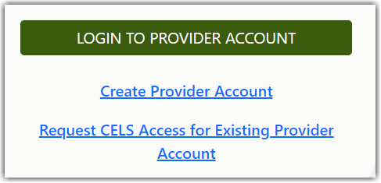
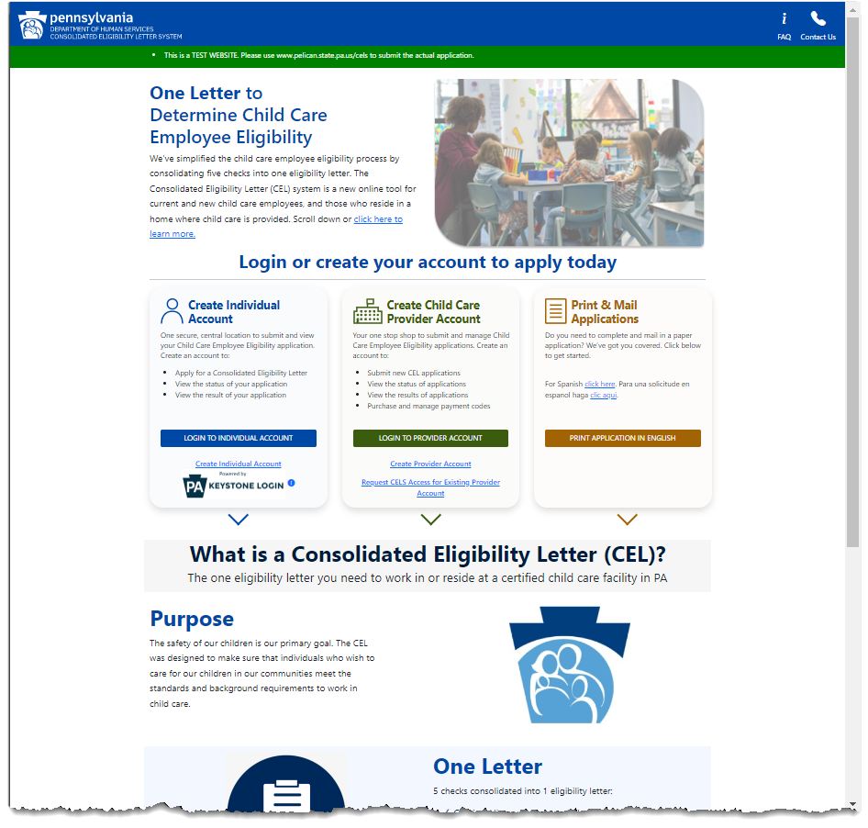

Keystone Login
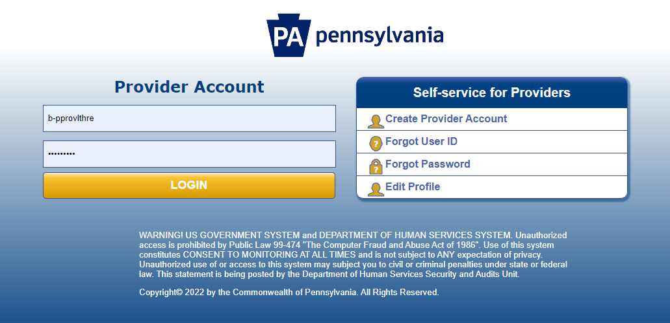
Users will log in with their Business Partner user ID (b-) on this page. They will enter their Business Partner user ID and password and then select Login.

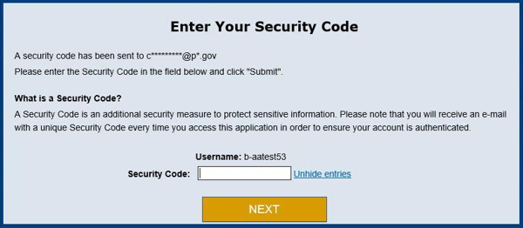
Note: Users will receive an additional prompt with a one-time security code request when logging into CELS. An email containing the security code is sent to the email address associated with your Provider Account. Enter the code in the field provided and click Next.
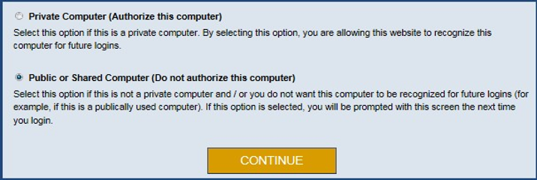

A final prompt asks whether the user is logging in from a private or public (shared) computer. Click the corresponding radio button, then click Continue. After entering your security code correctly, you will gain access to CELS.

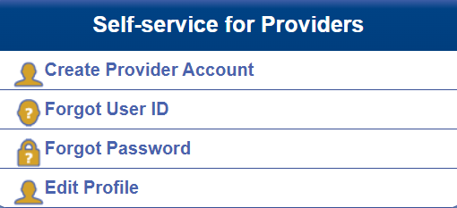
The Keystone screen also allows users to recover a forgotten user ID, unlock an account, reset a password, or update an expired password using the Self-service for Providers functions that display on the screen next to the login fields.

- Forgotten User ID – Clicking the Forgot User ID link will present the user with a screen to enter their name and email address. An email is then sent to the user’s registered email account with their User ID. Please note that if you are unable to recover your User ID via the Forgot User ID function that you will need to create a new account using a different email address, as an email address may only be associated to one account.
- Forgotten Password – Clicking the Forgot Password link will present the user with a screen to enter their User ID. After clicking OK, a second screen displays and prompts the user to answer their Password Hint questions. After successfully answering the Password Hint questions and clicking OK, the user is then prompted to enter and confirm a new password. Business Partners who need additional assistance resetting their password or unlocking their account should call the Account Administration Help Line at 1-800-281-5340.

Preferred Name (Optional)
When a user first logs in to CELS, they are asked a question about their Preferred Name and will have the option of changing their display name to their Preferred Name.
Users can optionally select Change Name and a pop-up will appear that will allow them to enter a Preferred First Name. They can also select Keep Name or Remind Me Later.
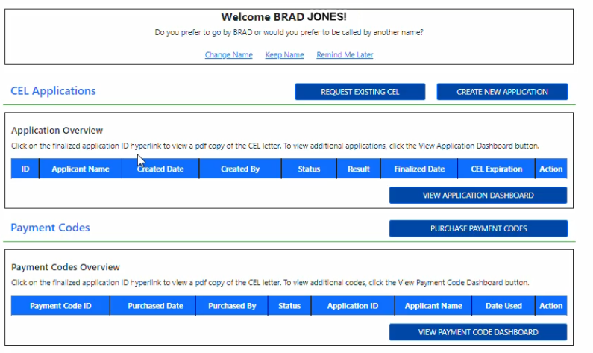
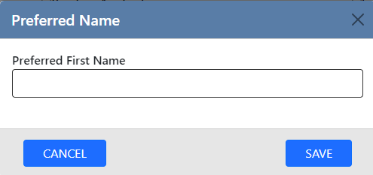
Note: Once changed, the Preferred First Name information cannot be reverted to a previous name. Users who elect to use the Change Name function should use care in selecting a Preferred First Name before clicking the Save button.

CELS has a Chatbot 
CELS includes a helpful Chatbot to assist users in a variety of situations. The CELS Chatbot is available to provide users of CELS immediate support. The CELS Chatbot can provide general information related to the CEL application process, frequently asked questions, and how to use the system. In some scenarios, when the CELS Chatbot is unable to resolve a user’s concern the CELS Chatbot will provide the user the option to raise a ticket for further assistance.

Accessing the CELS Chatbot
Users can access the Chatbot either before or after logging in to CELS. The level of assistance the Chatbot can offer increases after you have logged into CELS.

Chatbot Access from the CELS Landing Page
When the initial CELS landing page opens, the Chatbot icon automatically displays.
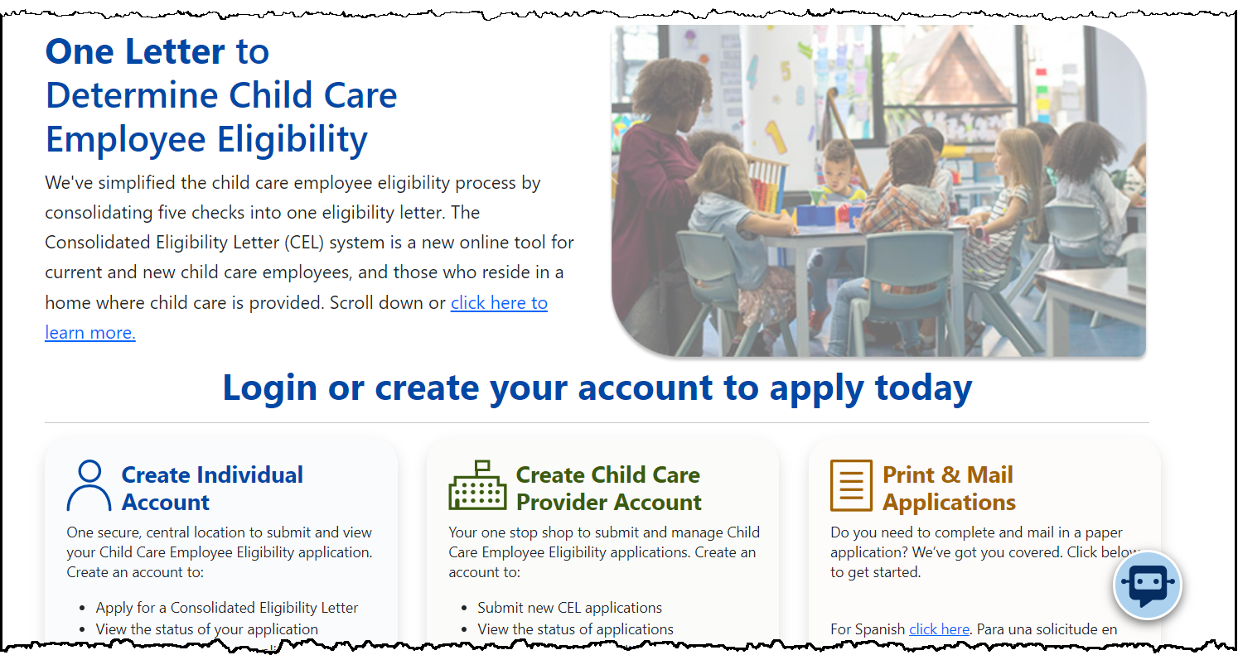

Chatbot Access from Within CELS
Once logged in to CELS, users can access the CELS Chatbot on most screens. To access the CELS Chatbot, just click on the Chatbot icon on the lower right area of the screen.
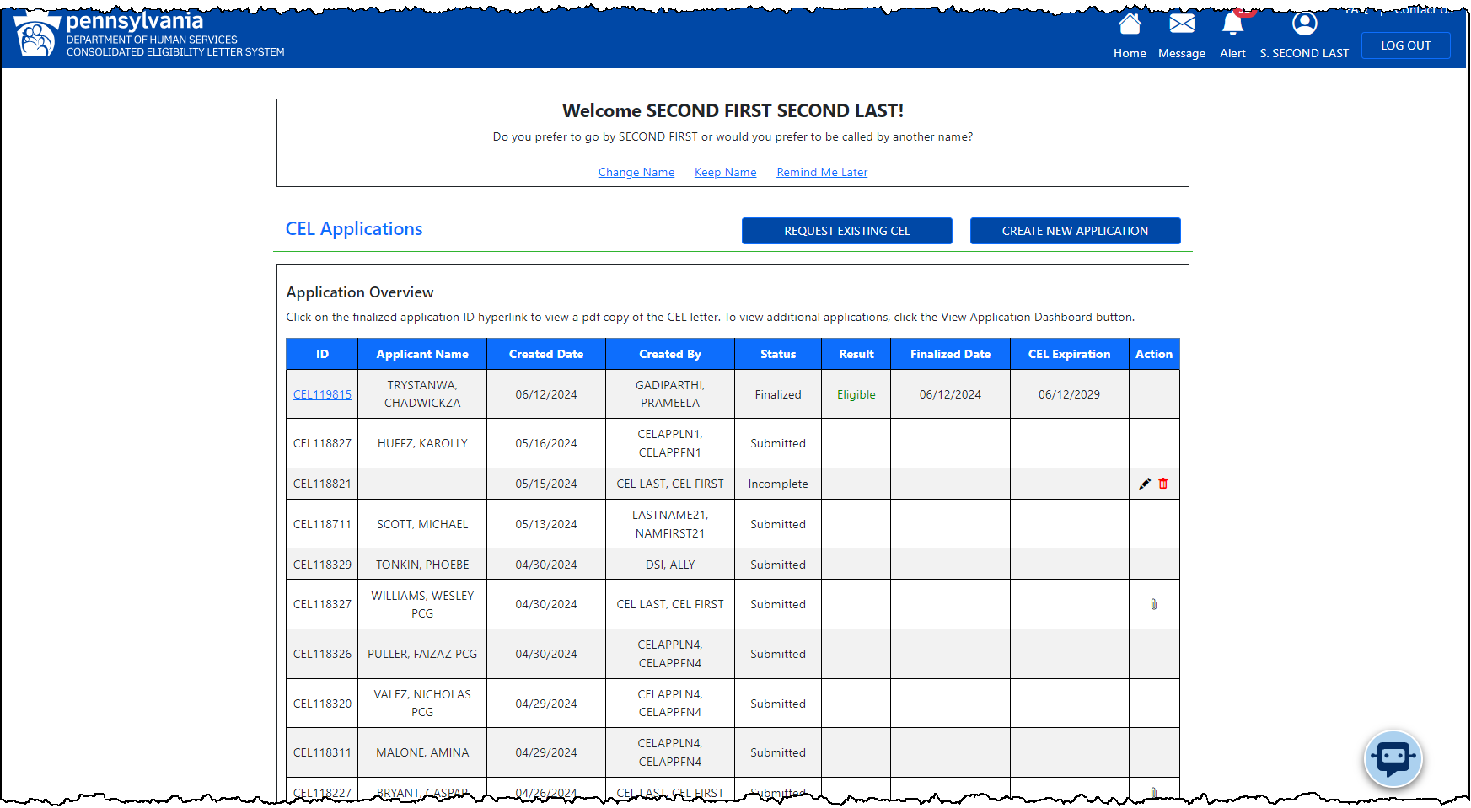

Chatbot Assistance by Role: Provider
The CELS Chatbot can assist Provider users with the following items:
Account Help | Help Accessing Provider Account
 | Creating an Account
 | Managing an Account
Apply for a CEL | Have a paper Application mailed to you
 | Get help completing an application
 | Get E-signature help
CEL Payments | Electronic application payment
 | Paper application payment
CEL Status | Electronic application status
 | Printed and mailed in application status
General CEL Information | CEL requirements
 | Learn more about CEL
 | Request an existing CEL
 | Request clearance results
CELS Dashboard | Application status tracking
 | Alerts and Messages
Throughout the user guide, the Chatbot icon will appear whenever an applicable task is discussed where the Chatbot can provide assistance.

Submitting a Chatbot Feedback Ticket
If you have a comment to help improve the Chatbot’s performance, the Chatbot will guide you through the steps to leave feedback via a ticket.
Note: Mandatory fields have a red asterisk (First Name, Last Name, E-mail, Phone, User Type and Description). The Description field has a limit of 3000 characters.
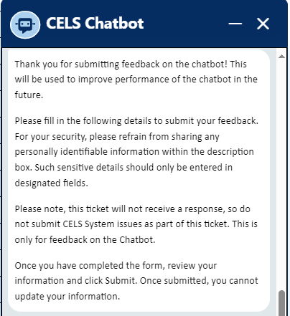 | 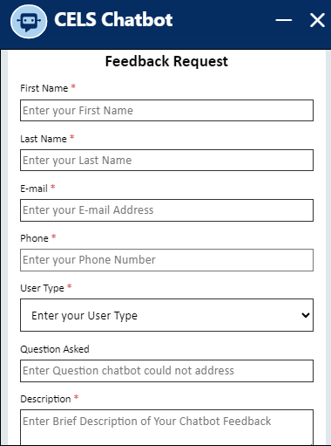

Submitting a Help Ticket
In identified scenarios when the CELS Chatbot cannot resolve an issue, the CELS Chatbot can assist users with entering a help ticket for further assistance. Submitted tickets are responded to within two business days.
Once the help ticket is successfully submitted, you will receive this message: “The ticket will be responded to within 2 business days. Expect an email from copaprod@servicenow.com . If not received, please check your spam/junk folder.”

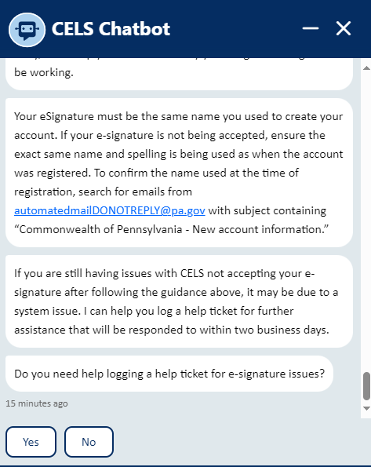 | 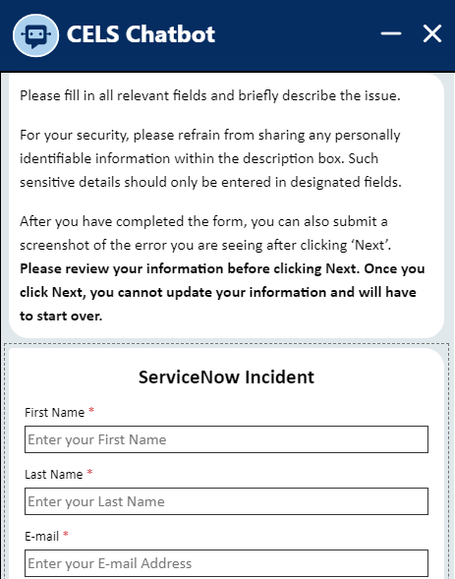

Disconnect from the CELS Chatbot
Users may disconnect from their Chatbot session by clicking the X in the Chatbot’s upper right corner and then clicking Yes in the subsequent confirmation dialog. When a user disconnects from the CELS Chatbot, the conversation history will be deleted.
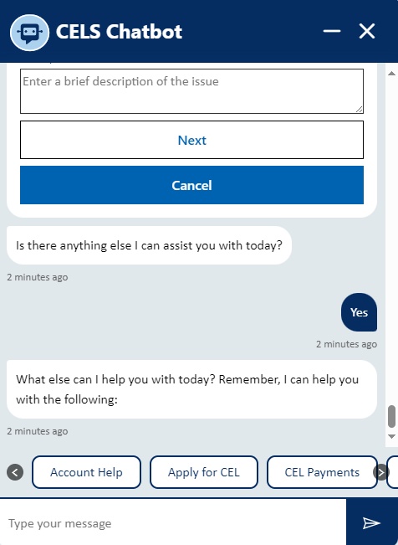 | 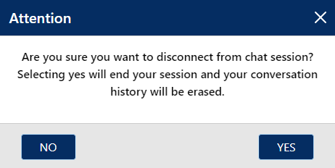

Provider Dashboard
Once the user has logged into the CELS they will be directed to the Provider Dashboard. The dashboard consists of two areas:
- CEL Applications
- Payment Codes
The CEL Applications section allows users the ability to create a new CEL application, access previously created, submitted, and finalized CEL applications, and view attachments associated with an application. The CEL Applications section provides an overview of the 10 most recently created CEL applications. Additional applications can be viewed by clicking the View Application Dashboard button.
Users can edit or delete previously created, unsubmitted CEL applications that they or another user within their organization created. To delete a CEL application that is incomplete and has not been submitted select the red trash can icon. To view attachments associated with a submitted CEL application select the paper clip icon. Users can also view when applications are submitted by themselves, another user within their organization, or an applicant who uses a payment code associated with the provider’s organization.
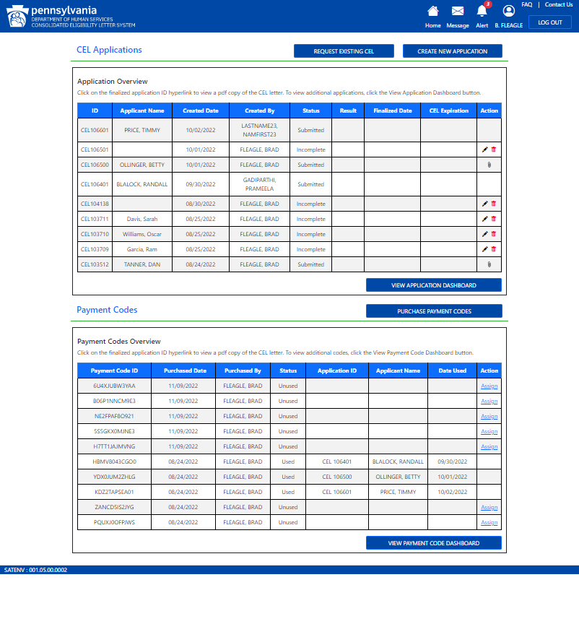
The Payment Codes section allows users the ability to create and manage payment codes. Additionally, the Payment Codes section provides users with an overview of the 10 most recently created payment codes. The user can create payment codes by accessing the Generate Payment Code screen. To access the Generate Payment Code screen, users may click on the Purchase Payment Codes button.
The user can also view unused codes, assigned codes, and details about used codes that have been purchased by their organization. See Payment Codes on page 58 for more information.

Dashboard Header
The Account Header’s dashboard elements are listed below.

Messages
The Message screen allows providers to view and respond to messages from the CVU related to additional information needed for the processing of a submitted application. Users can also upload documentation requested by CVU. Users are navigated to this screen after clicking on the Messages icon on their account dashboard.
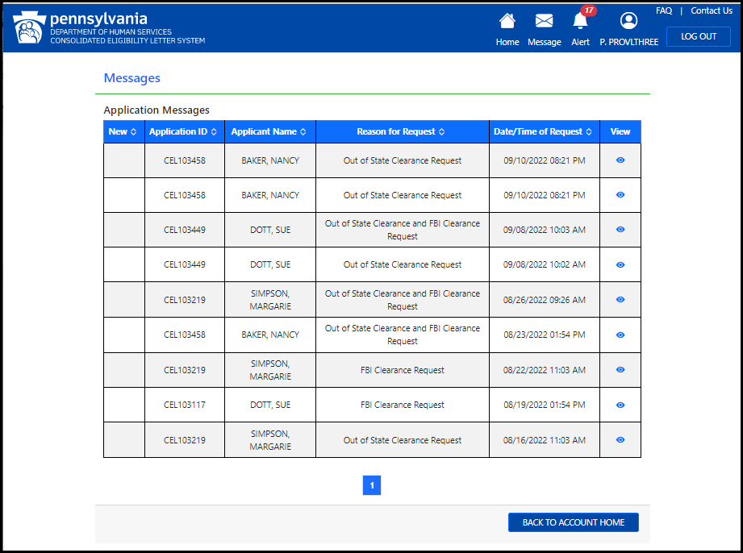
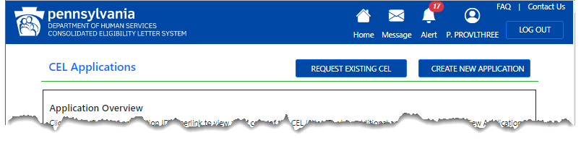

Alerts
The Alert icon allows users to see the list of alerts and the associated CEL IDs. The Alert icon includes a red label that indicates the number of current alerts. For example, the Alert icon below indicates that there are 17 alerts to view.
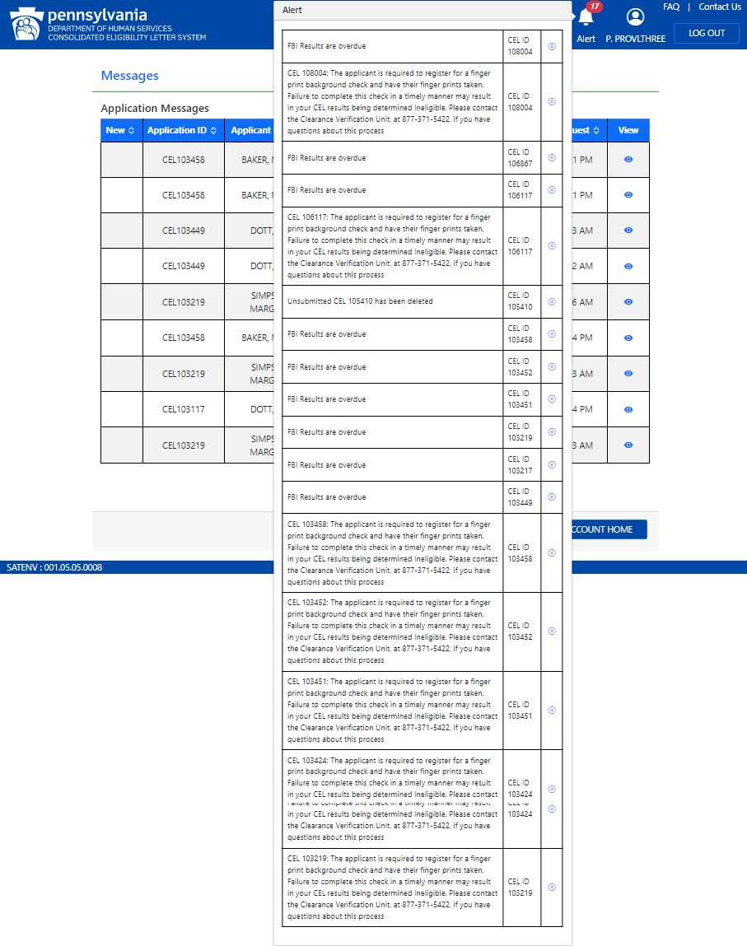

Home
Click the Home icon to return to the User Dashboard.

FAQ
By selecting the FAQ button the CEL FAQ pdf. document will open.

Contact Information
Click the Contact Us link to view details on how to reach the CVU.
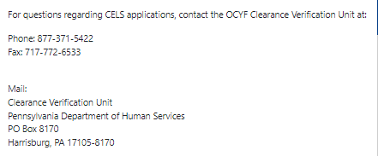

Requesting an Existing CEL
The Request Existing CEL feature allows users to request a CEL for a new employee who previously had a CEL generated for a different provider and has been employed by a certified childcare facility within the last 180 days. The following steps are provided below to complete this action.
- Click the Request Existing CEL button.
- On the users CEL Request screen, the user does the following:
- Completes the Child Care Provider Information section.
- Completes the Applicant Information section.
- Selects the confirmation Checkbox for the attestation stating that the applicant has worked within the child care field within the last 180 days.
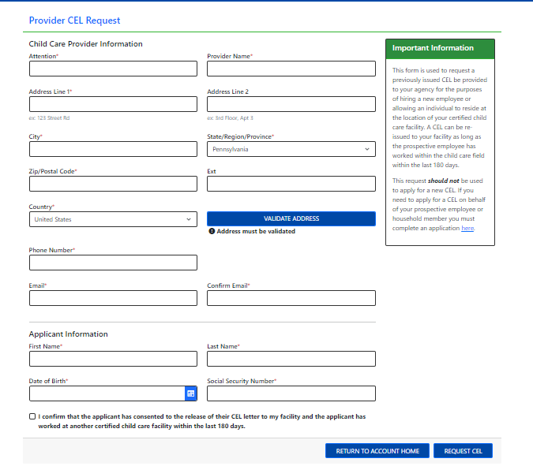

- After entering all required fields and selecting the confirmation checkbox. An Attestation pop up displays:
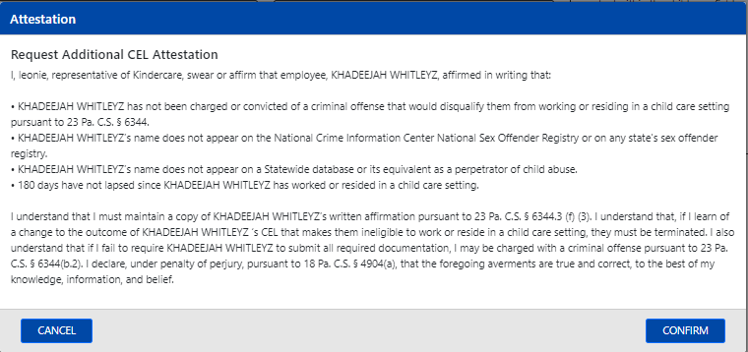
- Review the attestation for accuracy:
- Select Confirm button to confirm. The Attestation dialog closes and the CEL Request screen displays.
- Select Cancel button to return to the CEL Request screen.

- Select the Request CEL button on the Provider CEL Request screen. A confirmation message displays at the top of the screen.
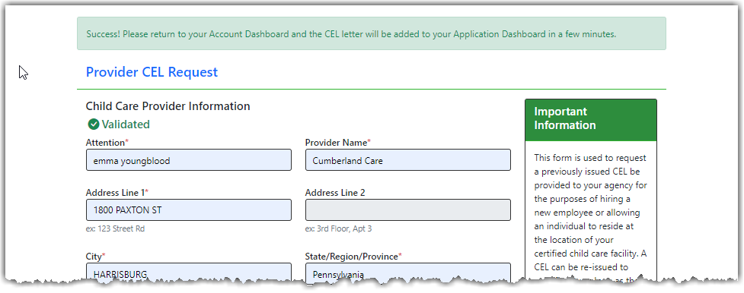
Review the confirmation message:

Note: The CELS requires an exact match on the data requested in the Applicant Information section of the Provider CEL Request screen to generate an existing CEL for a new employee. For example, the first name, last name, date of birth and Social Security Number of the employee has to be entered exactly as it was entered when the individual applied for their original CEL. Once the new employee is successfully added a provider may access a copy of the CEL from the Provider Dashboard. In addition, a hard copy of the CEL will be sent to the new provider through the United States Postal Service. Please note it may take up to 10 business days to receive a copy of the CEL in the mail.

Creating a New CEL Application
The process to complete a new CEL application is outlined in this section. Within the application a required field will have an asterisk; if the required field is not completed the application will not be able to be submitted until the information is entered.
- To begin the process of creating a new CEL application, click on the Create New Application button.
An Attention dialog box will display, reminding the provider that they can only submit an application on behalf of another person.
- Select Ok to process.
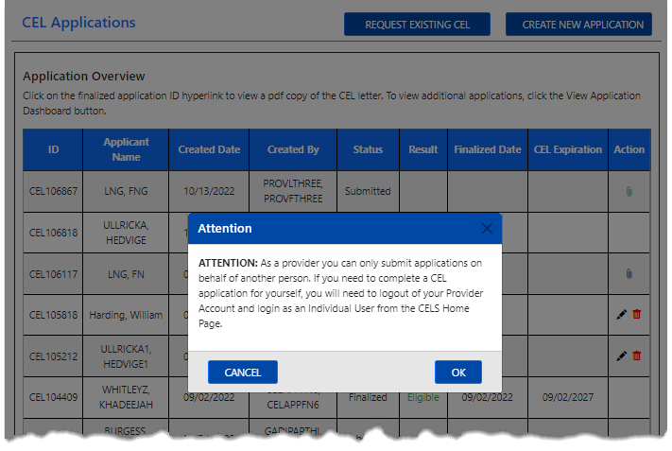
- Select Cancel to return to the previous page.
By selecting OK the Getting Started screen displays.
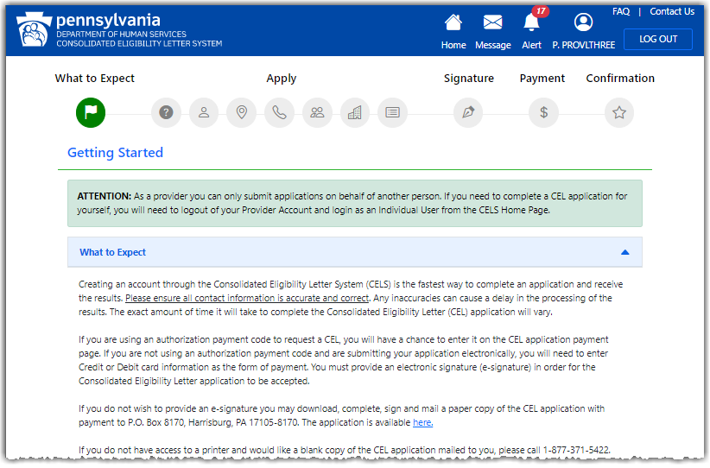
The navigation buttons that appear at the top of the Getting Started screen allows users to quickly navigate to the various sections of the application. The icons turn blue as you complete the screens. A red icon indicates information is incomplete. The icon turns green to indicate it is the current screen. The Navigation Buttons include:
- What to Expect
- Apply
- Signature
- Payment
- Confirmation
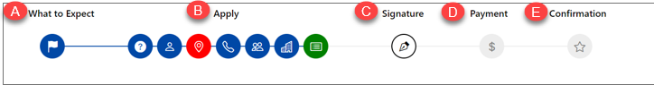.
Note: The black icon sections have not been completed yet. The greyed icon sections do not become active until the prior sections have been completed.
The areas and the icons at the top of the Getting Started screen are described below, along with a brief overview of the related screens. Additional information on each screen is available in the following pages of the Creating a New CEL Application process.
Area | Icon | Description
What to Expect |  | The Getting Started screen gives the user a brief overview of the application process, states how long the CEL is valid, and directs where to go for assistance if there are questions about the application.
Apply |  | The General Questions screen indicates the purpose of the certification, whether a Federal Bureau of Investigations (FBI) Criminal History Background Check was performed and if so, provides a field to enter the FBI Clearance ID number. For the purposes of the CEL, the unique identifying number (UE ID) that is assigned when an applicant request an FBI check will be used as the FBI Clearance ID.
 |  | The Applicant Demographic Information screen lists the applicant’s demographic information, Social Security Number, and previous name, if applicable.
 |  | The Applicant Address Information screen captures the applicant’s current home address, mailing address, and any previous addresses the applicant has lived at since 1975.
 |  | The Applicant Contact Information screen records the applicant’s primary, secondary, or mobile phone numbers, as well as the applicant’s email address.
 |  | The Applicant Household Member Information screen records the names of everyone the applicant has lived with, at any time, from 1975 to present.
 |  | The Child Care Provider Information screen records the name, address, phone number, and email address of the Child Care Provider that has requested that the applicant obtain a Consolidated CEL.
 |  | The Application Summary screen provides an opportunity to review all the information entered for the Consolidation Eligibility Letter CEL.
Signature |  | The Consent/Release of Information screen consists of a confirmation of written approval to obtain and release the CEL, an affirmation of the information’s accuracy, and eSignature that matches the first and last name in the provider’s b-account.
Payment |  | The Payment Method screen allows the user to either enter a payment code or be navigated to a third-party payment screen.
Confirmation |  | The Confirmation screen displays upon the successful submission of the CEL.

What to Expect
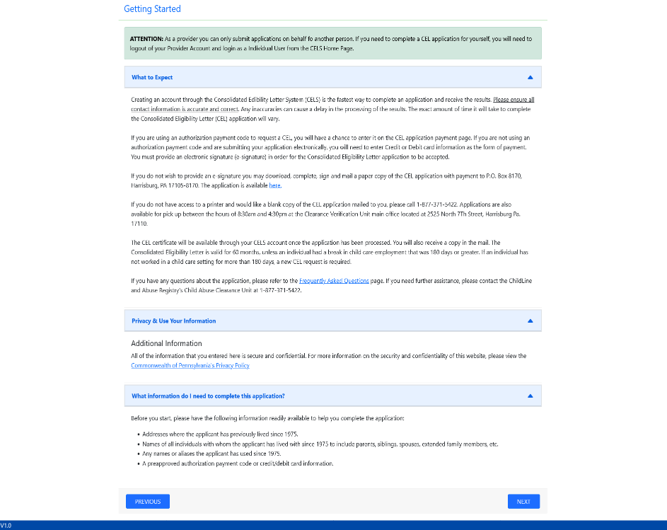
The What to Expect page is the start of the CEL application process. This screen provides an overview of the application process, privacy information, and lets users know what information they will need to complete their application. Users are navigated to this page after selecting the New Application button from their account home page.
Note: Users will review this screen and then click Next to go directly to the General Questions screen.

General Questions
The General Questions screen captures the overall purpose of the certification and also requests information on whether the applicant applied for their FBI Criminal History Background Check.
- Complete the Purpose of Certification section.
- If the applicant applied for the FBI Criminal History Background Check, select the Yes radio button, and enter the FBI Clearance ID number. Please provide the UE ID assigned at the time of the FBI check request in the FBI Clearance ID space.
- Select Next button.
Note: If the applicant has not applied for FBI Criminal history Background select No. The applicant must submit their FBI Clearance ID number before or after submitting the CELS application. The FBI Clearance ID number must be provided within 45 days of submitting the CELS application.
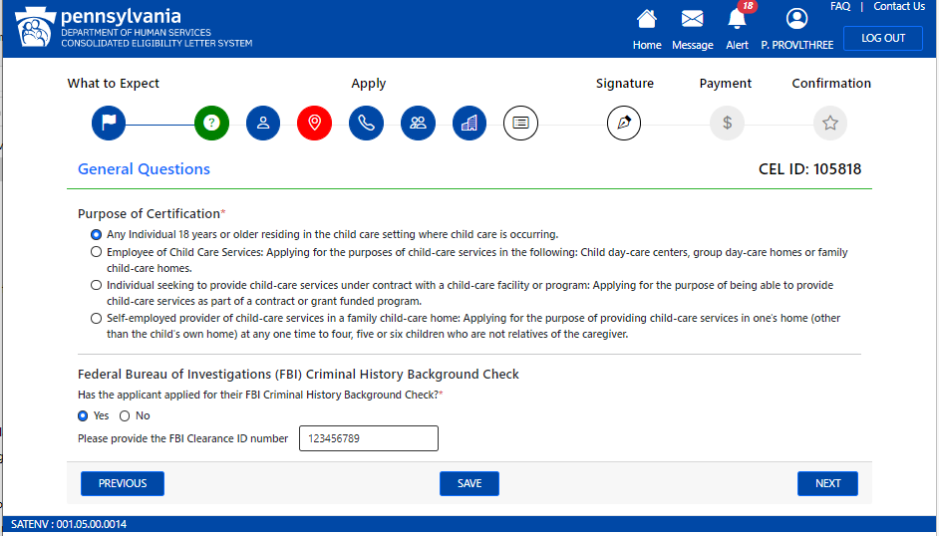
An e-mail notification will be sent to the Provider’s email account if the Applicant has not applied for any FBI clearance (if they selected “No” to the FBI Criminal History question).

Applicant Demographic Information
The Applicant Demographic Screen captures details about the applicant, including any previous names the applicant may have used.
- Complete the required fields for First and Last Name, Date of Birth, Gender, and Social Security Number.
- If the applicant has used a previous name or alias, click the Add Previous Name button, and complete the required name information. Otherwise, select the No Previous Names Used Since 1975 checkbox.
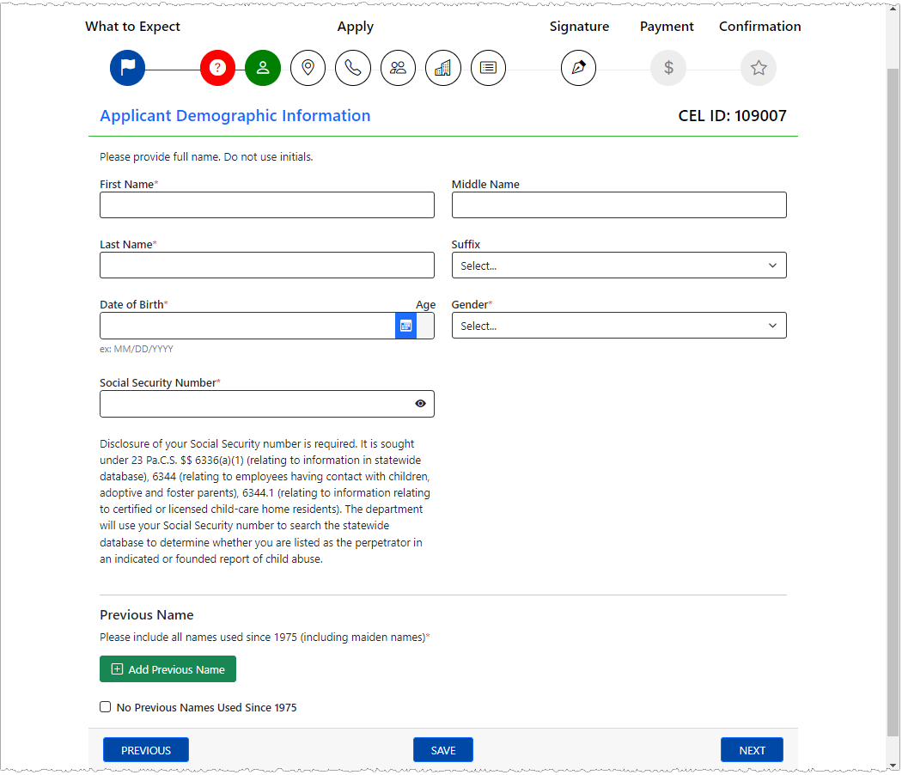
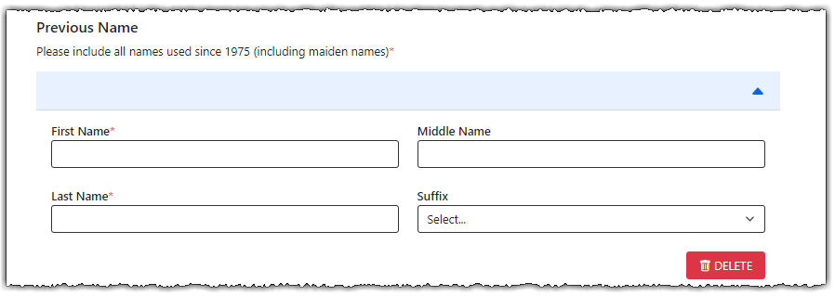
The Previous Name information appears after selecting the Add Previous Name button.
If a previous name is mistakenly entered, it can easily be deleted by clicking the Delete button.
- Select Next to continue.

Applicant Address Information
The Applicant Address Information Screen captures details about the applicant’s current addresses as well as any previous addresses. This screen captures the applicant’s home address, mailing address and any previous addresses lived at since 1975.

Home Address Section
- Complete the Home Address fields.
- Select the Validate Address button.
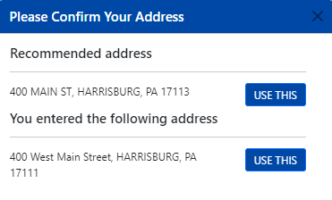
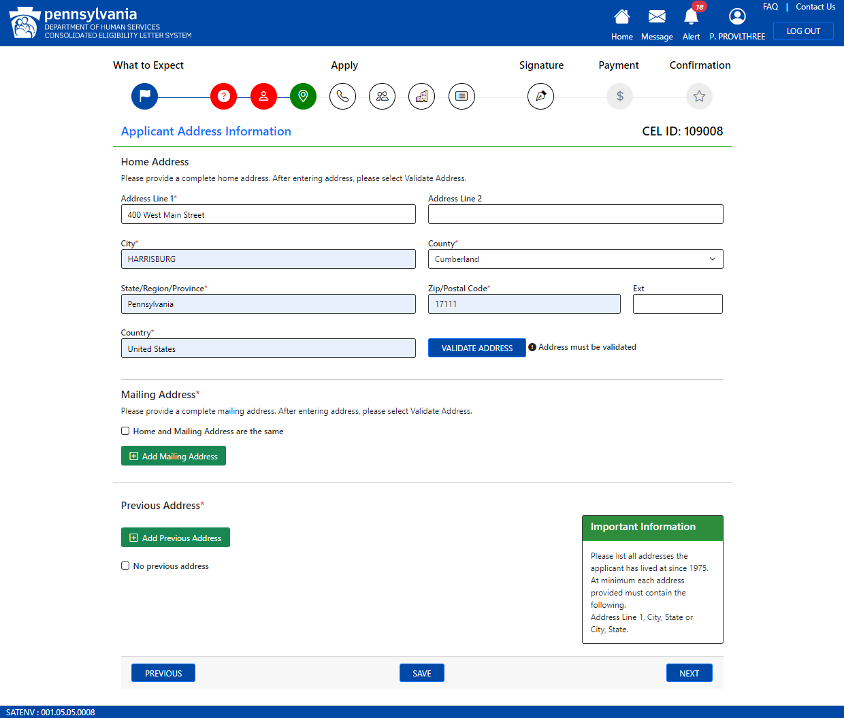
- Select the Use This button for the address that most closely matches the applicant address, from the Please Confirm Your Address pop-up.
Note: If an applicant’s home address is out-of-state, CELS issues the following prompt when an applicant resides in an open sharing state: “The applicant must send their completed out-of-state clearance application, along with the applicable payment, to the Child Verification Unit Office in order to complete CEL application processing.” The CVU will request out-of-state clearances on an applicant’s behalf whenever possible. Applicants will be required to obtain their own out-of-state clearance(s) only when the out-of-state agency’s regulations requires the individual to do so. For CVU to request the applicant’s out-of-state clearance(s), a check or money order for each out-of-state clearance along with the completed, applicable clearance application must be mailed to the CVU. The check or money order should be made payable to the state the clearance is being requested for.
For additional details on open vs closed states please review 6.4.3.

Mailing Address Section
If the home address and the mailing address are different, then both addresses will need to be verified.
- If the home address and the mailing address are the same:
- Select Home Address and Mailing Address are the same checkbox.
- Continue to Previous Address Section
- If the home address and the mailing address are different:
- Select the Add Mailing Address button.
- Complete the Mailing Address fields.
- Select Validate Address button.
- Select the Use This button for the address that most closely matches the applicant address, from the Please Confirm Your Address pop-up.
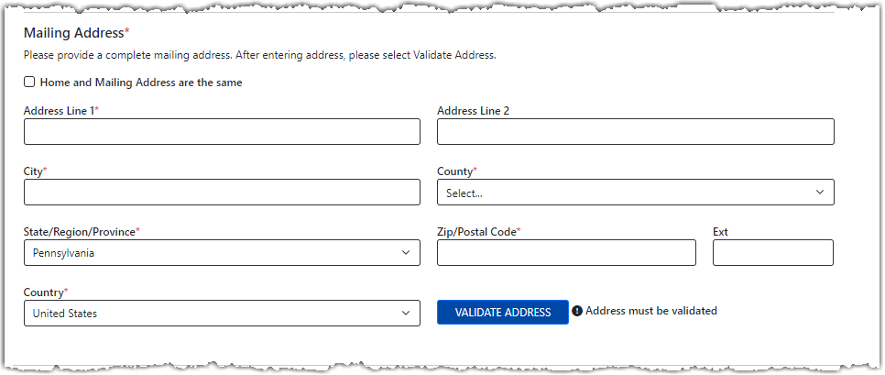

Previous Address information
All previous addresses the applicant has lived in since 1975 should be added in this section.
- If there is no previous address
- Select the No Previous Address checkbox.
- Select Next.
- There are previous addresses:
- Complete the Previous Address information. Each address provided must contain, at minimum, Address Line 1, City, State or City, State.
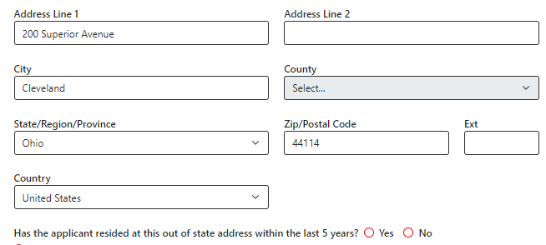
- Complete the CELS prompt: Has the applicant resided at this out of state address within the last 5 years?

- If the applicant resided at the out-of-state address within the last five years, select Yes. CELS will respond with additional information depending on the state that is listed, as shown below.
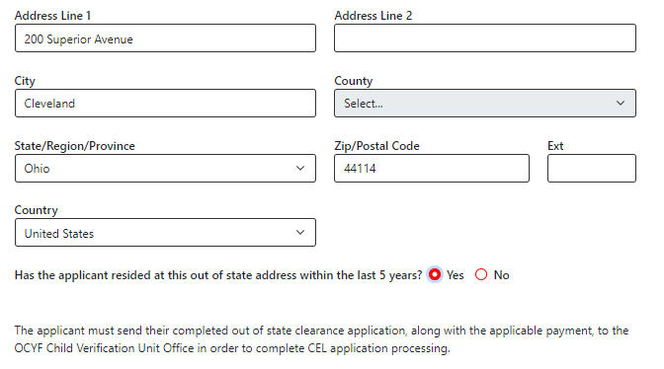
Note: In this example, the applicant resided in an open records state, so the applicant must provide the completed out-of-state clearance application(s), and payment(s), to the CVU to complete the CEL application processing. The CVU works with out-of-state agencies to process the clearance application(s).
- Out-of-state background checks are required anytime an employee has lived outside of Pennsylvania within the last five years. There are THREE required out-of-state background checks:
- Out-of-State Criminal History Check*;
- Out-of-State Sex Offender Registry Check*; and
- Out-of-State Child Abuse and Neglect Registry Check.
*NOTE: Each state has the option to use a fingerprint to conduct these checks, so the process will vary from state to state. Additional information on each state’s requirements can be found here https://childcare.gov/state-resources-home
- State Agencies may be open or closed sharing. The term “Open state” and “Closed state” refers to a state’s ability under the law to provide clearance information to the requester. A Closed state typically refers to a state in which clearance results must be requested by and provided to the individual who is named on the clearance. An Open state refers to a state that allows clearance information to be requested by and provided to other entities, such as a state agency or a provider.
  - Examples:
    - John lived in South Dakota, a closed state. The Out of State clearance information must be applied for and sent to John. Once John receives the out of state clearance results, John is responsible for including that information in the CELS.
    - Jill lived in Ohio, an open state. The Out of State clearance information can be obtained by the CVU once the Jill mails a check or money order for Ohio out-of-state clearance along with the completed, applicable clearance application to the CVU. In this example, the check or money order Jill send to CVU should be made payable to Ohio as that is the state the clearance is being requested for.

- If you move out-of-state and continue to work for a Pennsylvania child care provider, out-of-state clearances will need to be obtained prior to when the individual’s first clearance or CEL expires at 60 months (five years).
- CVU will request out-of-state clearances on an applicant’s behalf whenever possible. Applicants will be required to obtain their own out-of-state clearance(s) only when the out-of-state agency’s regulations requires the individual to do so.
- For CVU to request out-of-state clearances, a check or money order for each out-of-state clearance along with the completed, applicable clearance application must be mailed to the CVU. The check or money order should be made payable to the state the clearance is being requested for.

To learn the details of out-of-state clearance requirements by state please visit https://childcare.gov/state-resources-home , search for the state you need additional information on, and then click on “Criminal Background Checks” section.
If you need further information about out-of-state clearances, please visit:
- Out-of-state Clearances (pa.gov)
- https://www.dhs.pa.gov/KeepKidsSafe/Clearances/Pages/Out-of-State-Clearances.aspx

The screenshots below provide an example of a state that allows an applicant to request their own clearances. In this example, the applicant did NOT request their clearances.
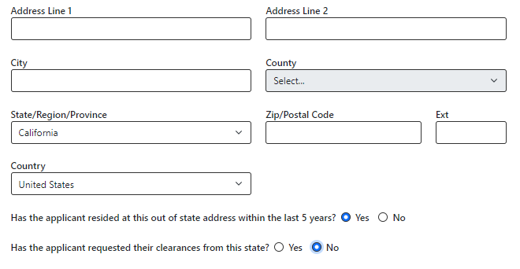
Note: In the above screenshot the applicant did NOT request their clearances, therefore the option to attach their out-of-state clearance results is not provided.
If the applicant did request their clearance from the state, CELS issues the following prompt to upload the out-of-state Clearance.
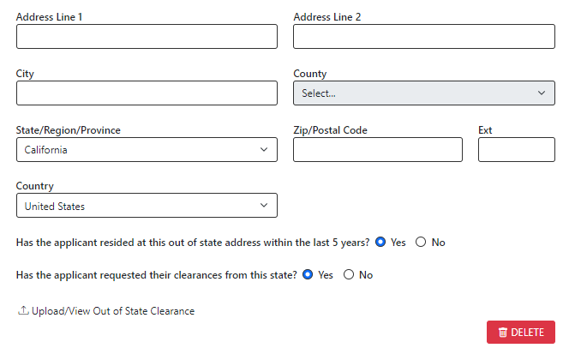

Note: In the above screenshot the applicant did request their clearances from the state, therefore the option to attach the out-of state clearance result is provided.
For detailed instructions on uploading an out-of-state Clearance, see Upload an attachment for a Previous Address for a New Application on page 70.
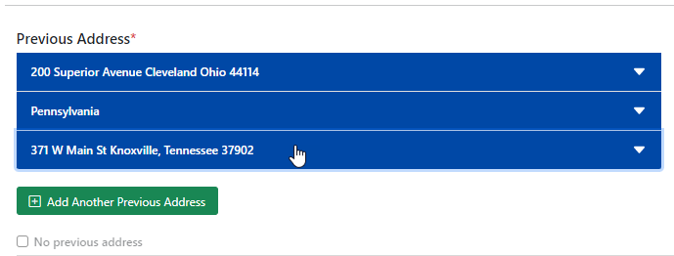
As previous addresses are added, they appear in the Previous Address section of the Applicant Address Information screen as a clickable link.
To delete a Previous Address record, navigate to the Applicant Address Information for the desired CEL and scroll down to the Previous Address section. CELS displays the record.
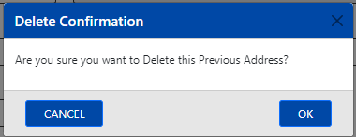
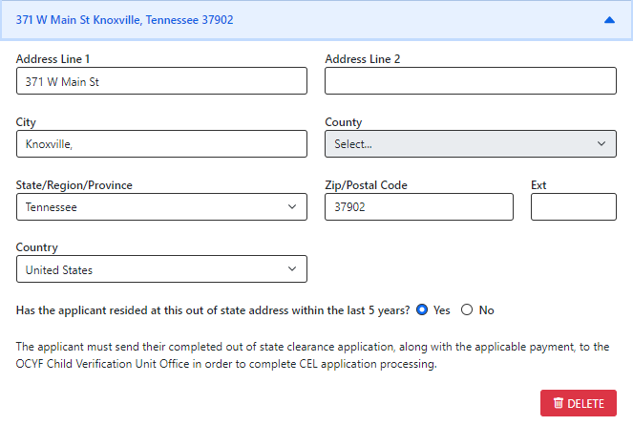
Click the red Delete button, and then click OK on the Delete Confirmation. The address is removed from the list of previous addresses.

Applicant Contact Information
The Applicant Contact Information screen records the applicant’s phone and email information.
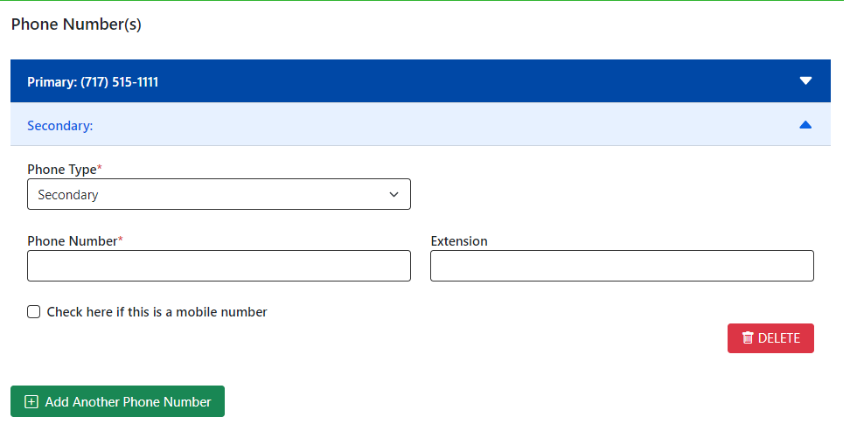
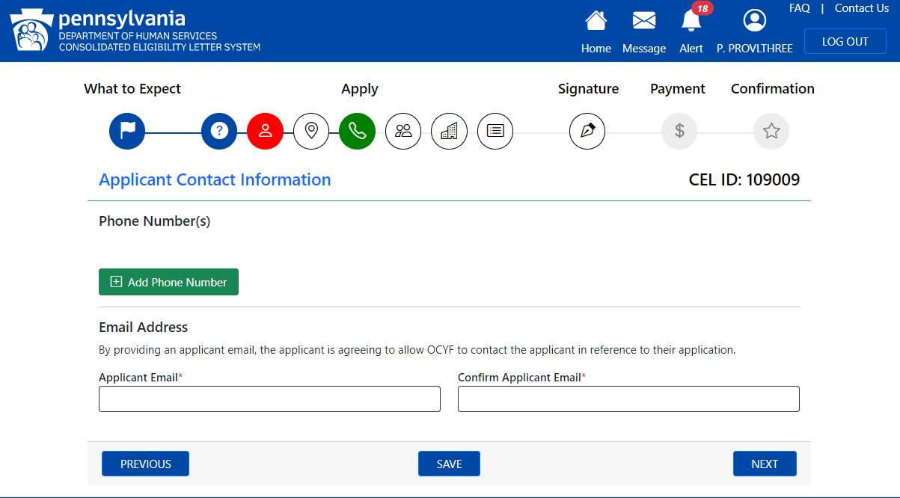
- Click the Add Phone Number button to enter the phone number details.

- On the Phone Type drop-down, select Primary or Secondary, then complete the Phone Number field and optional extension.
- Click the mobile phone number check box if applicable.
- If another phone number must be added, click the Add Another Phone Number button, and continue to Step 5. Otherwise, Skip to Step 7.
- After clicking Add Another Phone Number, CELS displays the first number you entered in a blue box. The new phone number information can now be added in the fields below.
- Complete the information for the additional phone number.
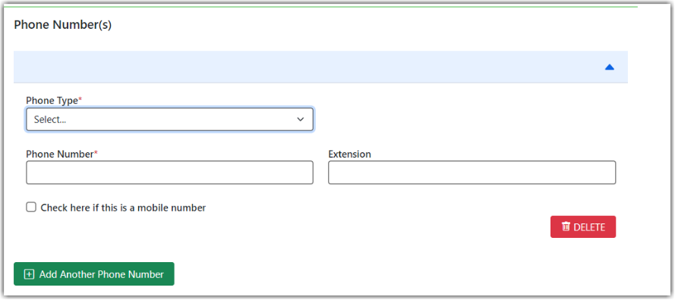
- Complete the Applicant Email and Confirm Applicant Email fields and click Next. (See Step 1 for image)
Note: After clicking Next, CELS automatically adds the additional phone number and opens the Applicant Household Member Information screen.

Applicant Household Member Information
On the Applicant Household Member Information screen, applicants must identify anyone they have resided with anytime since 1975 to the present.
Applicants must also identify at least one person with the relationship of Parent, Guardian, or Grandparent.
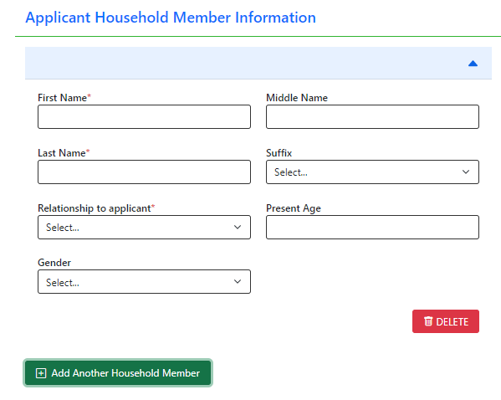
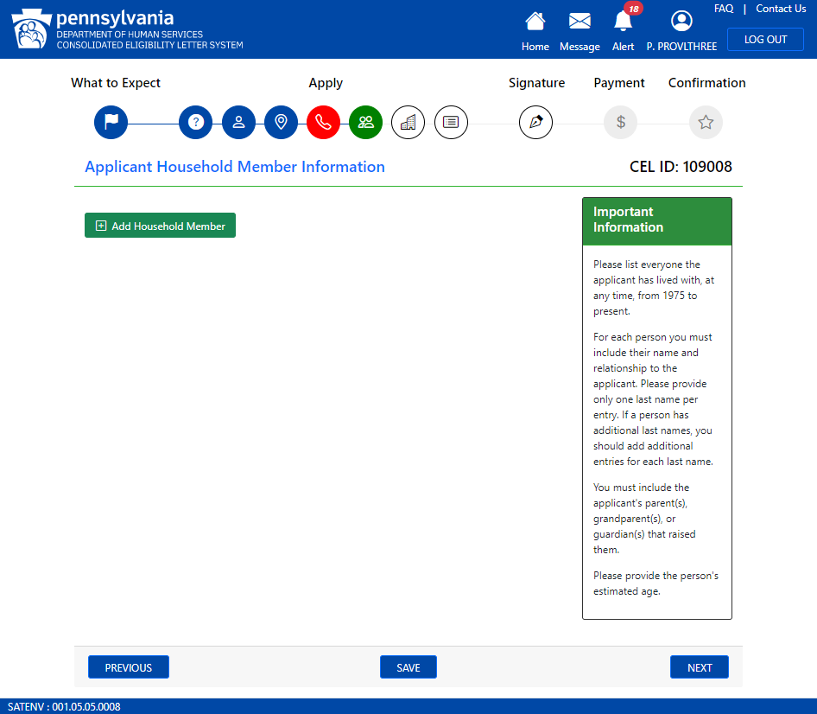
- Click the Add Household Member button.
- Complete the required First Name, Last Name, and Relationship to applicant. Complete any optional fields if data is available.
- If no other household members need to be added, click the Next button at the bottom of the Applicant Household Member Information screen. Otherwise, continue to the next step.
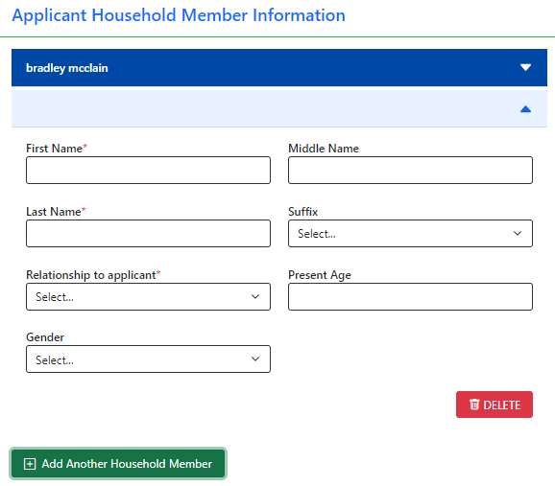
- Click the Add Another Household Member button to continue adding household members.
- Continue adding household members as needed, then click Next to proceed to the Child Care Provider Information screen.

Child Care Provider Information
The Child Care Provider Information screen contains details about the Child Care Provider that has requested the applicant obtain a CEL.
- Complete the Attention field with the name of the individual at the child care facility who will receive the CEL.
- Enter the name of the facility that the CEL will be mailed to in the Provider Name field.
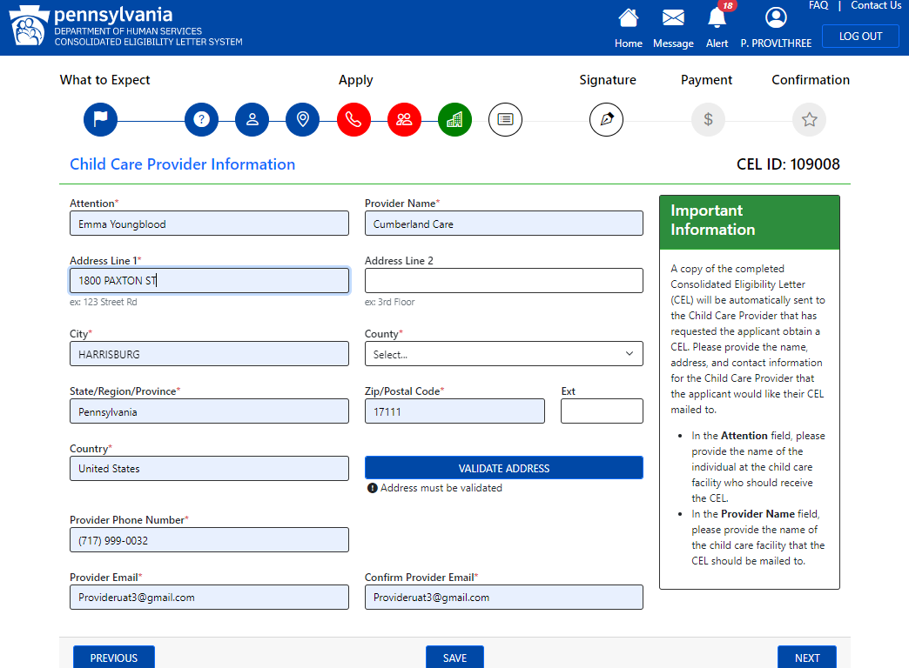
- Complete the required Address, City, County, State, and Zip, then click the Validate Address button.
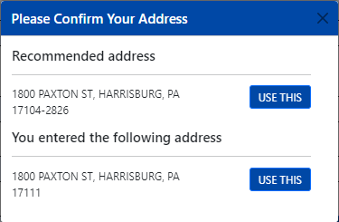
- On the Please Confirm Your Address dialog, click the Use This button for the correct address.
- Click Next.

Application Summary
The user can review each section again and select the Edit button to make changes. After reviewing each section, click Next to continue to the Provider Attestation screen. The entire screen appears below in sections due to the size of the screen.

The summary of the General Questions and Applicant Demographic Information appears in the following graphic.
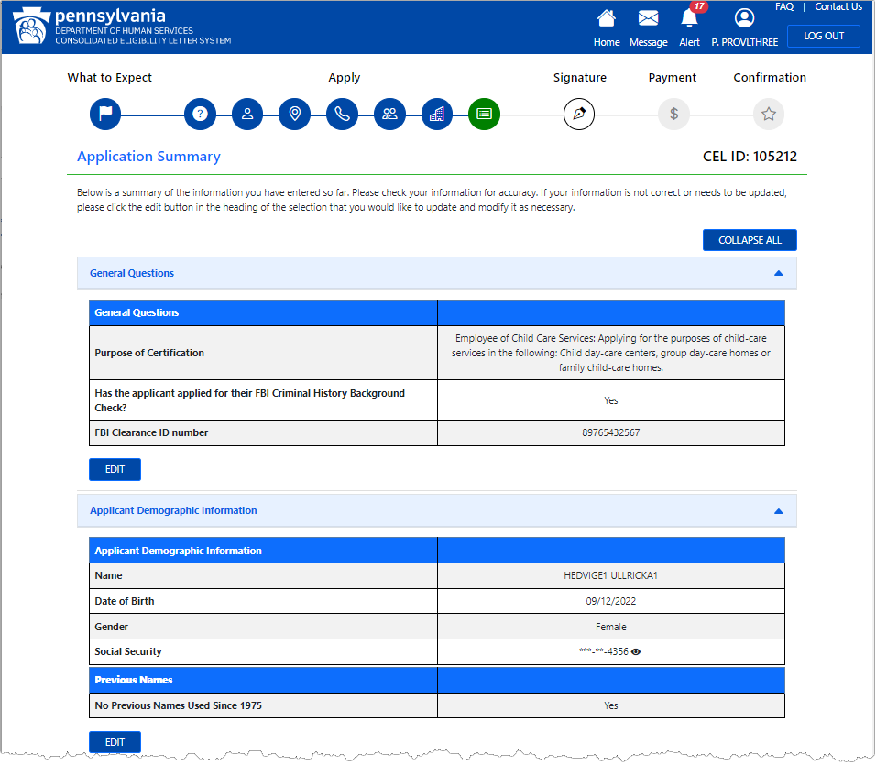
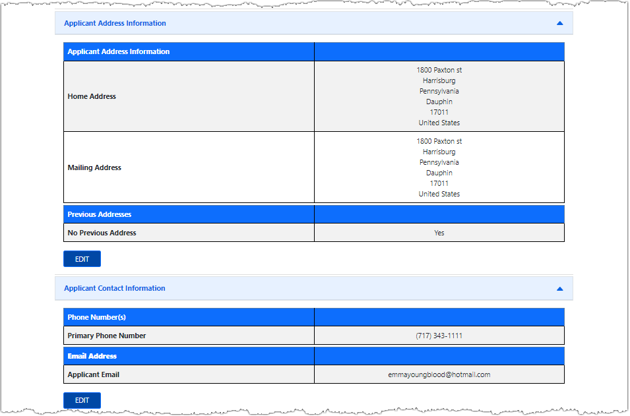
The summary of the Applicant Address Information and Applicant Contact Information appears below.

The summary of the Household Information and Child Care Provider Information appears below.
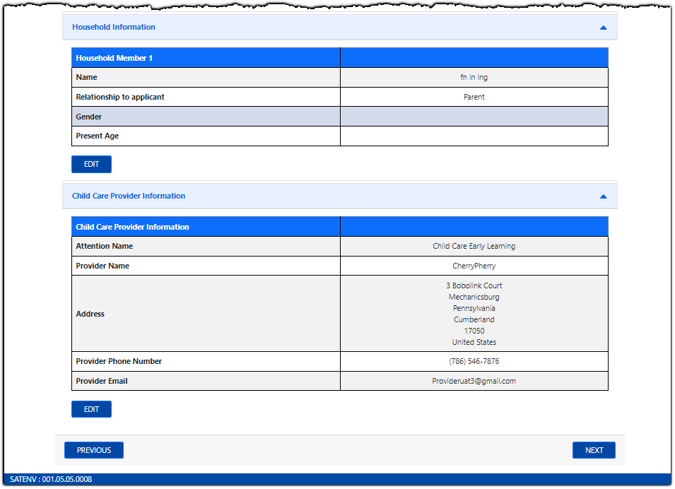

Provider Attestation and eSignature
The Provider Attestation screen captures the user’s attestation that they have received written consent, from the applicant, to submit the application and receive the CEL letter.
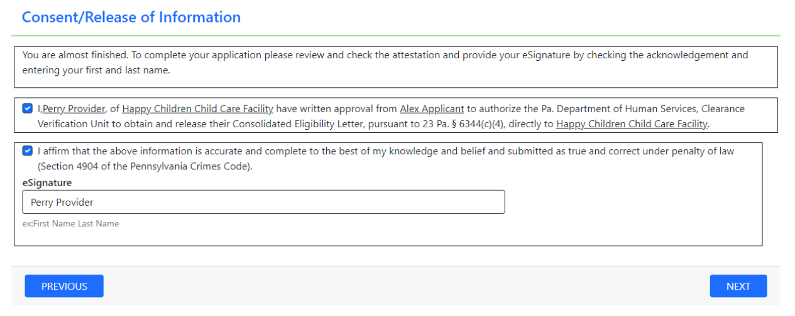
Note: The check boxes on the provider attestation are mandatory.
In addition, the first and last name in the eSignature field must be identical to the first and last name that appears in the provider’s b-account.
After completing the mandatory fields, click Next.

Payment
The Payment Method screen captures what payment mode will be used when submitting the application.
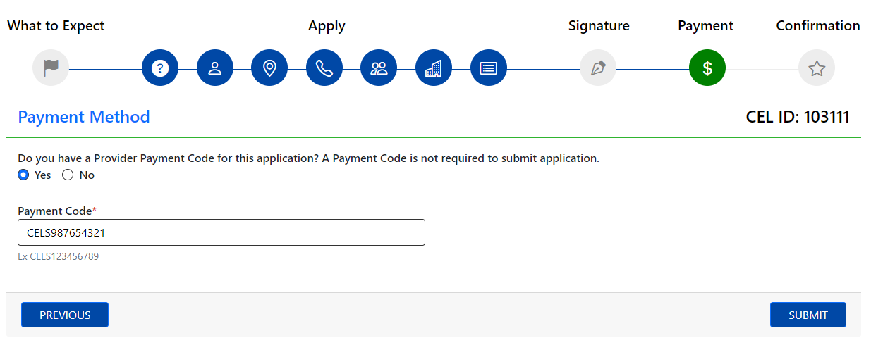
If you are using a prepaid payment code, the you must click the Yes radio button, enter the Payment Code, and then select Submit.

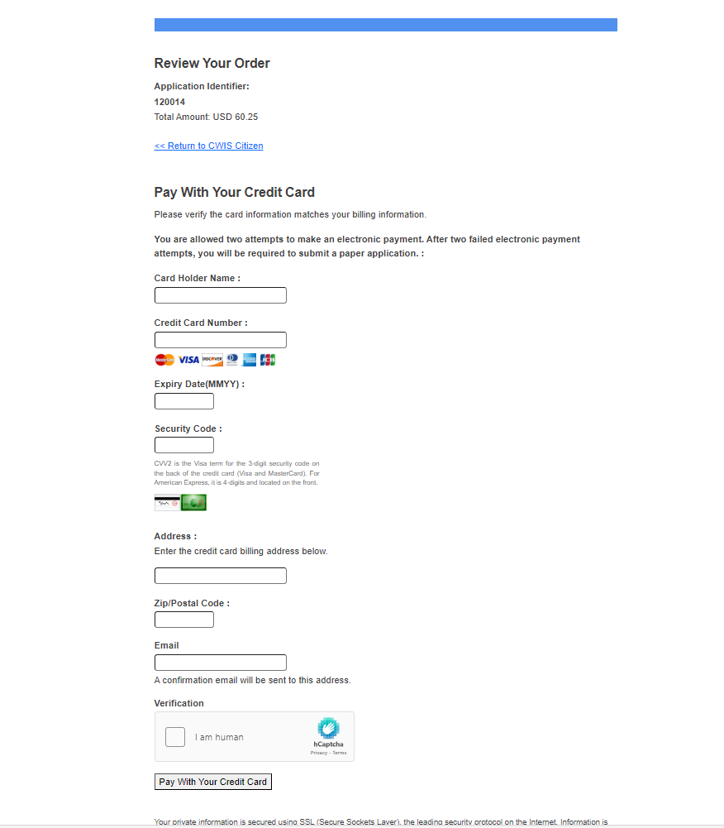
If you select No, and then click Submit, the Credit Card Payment screen displays.
Complete the Card Holder Name, Credit/Debit Card Number, Credit/Debit Card Expiration Month and Year, Credit/Debit Security Code, Billing Street Address, and Billing ZIP code, and Email address. Then click the Pay With Your Credit Card button.

Confirmation
The next screen is the Confirmation Screen. After submitting the application, the user can click the blue Return to Your Account Dashboard button.

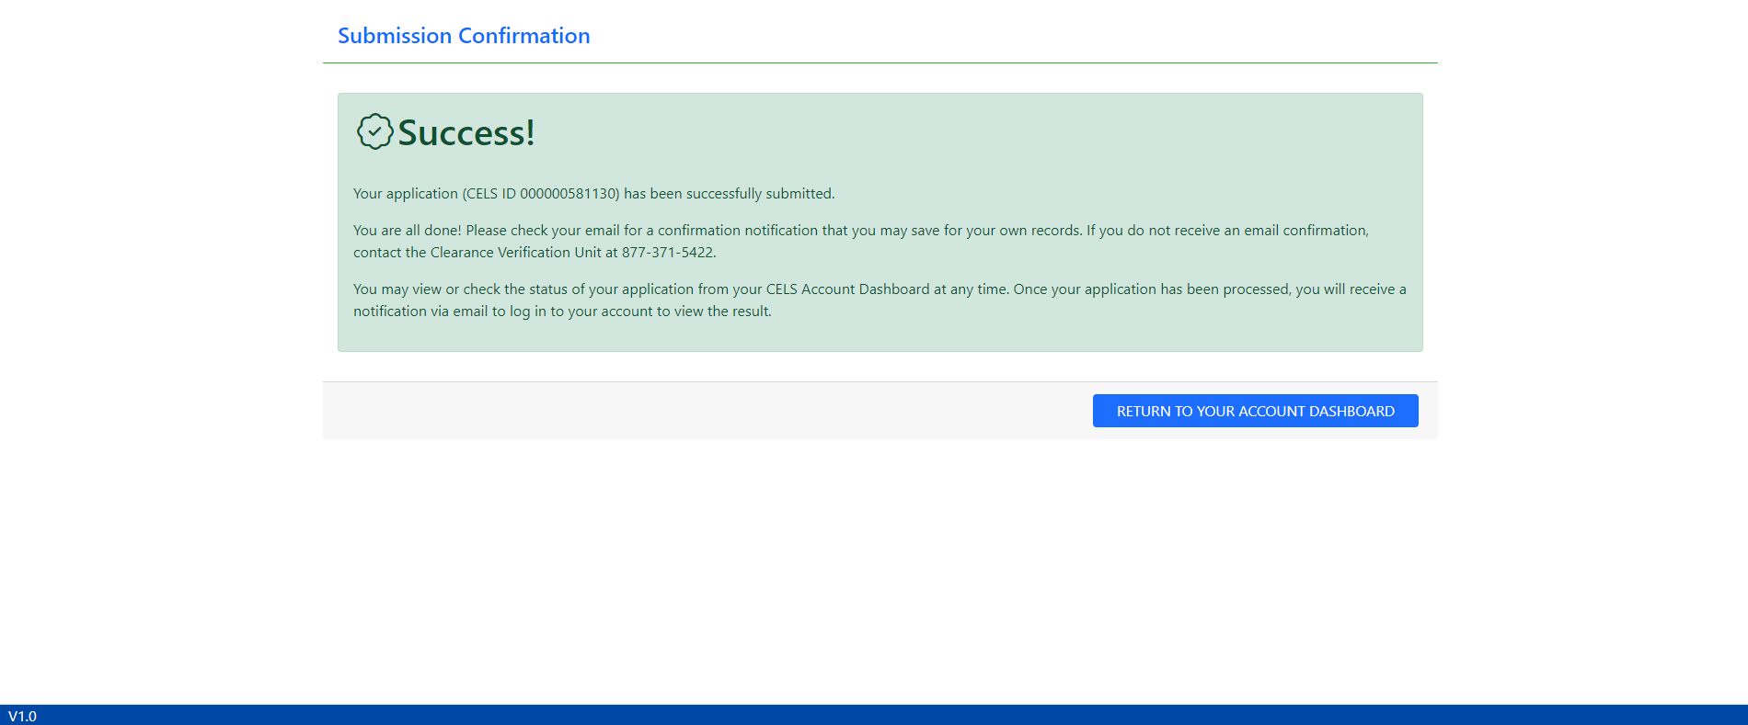
Standard Confirmation Message if Applicant has not resided out-of-state within the past five years.

Confirmation Message if Applicant has resided out-of-state within the past five years.
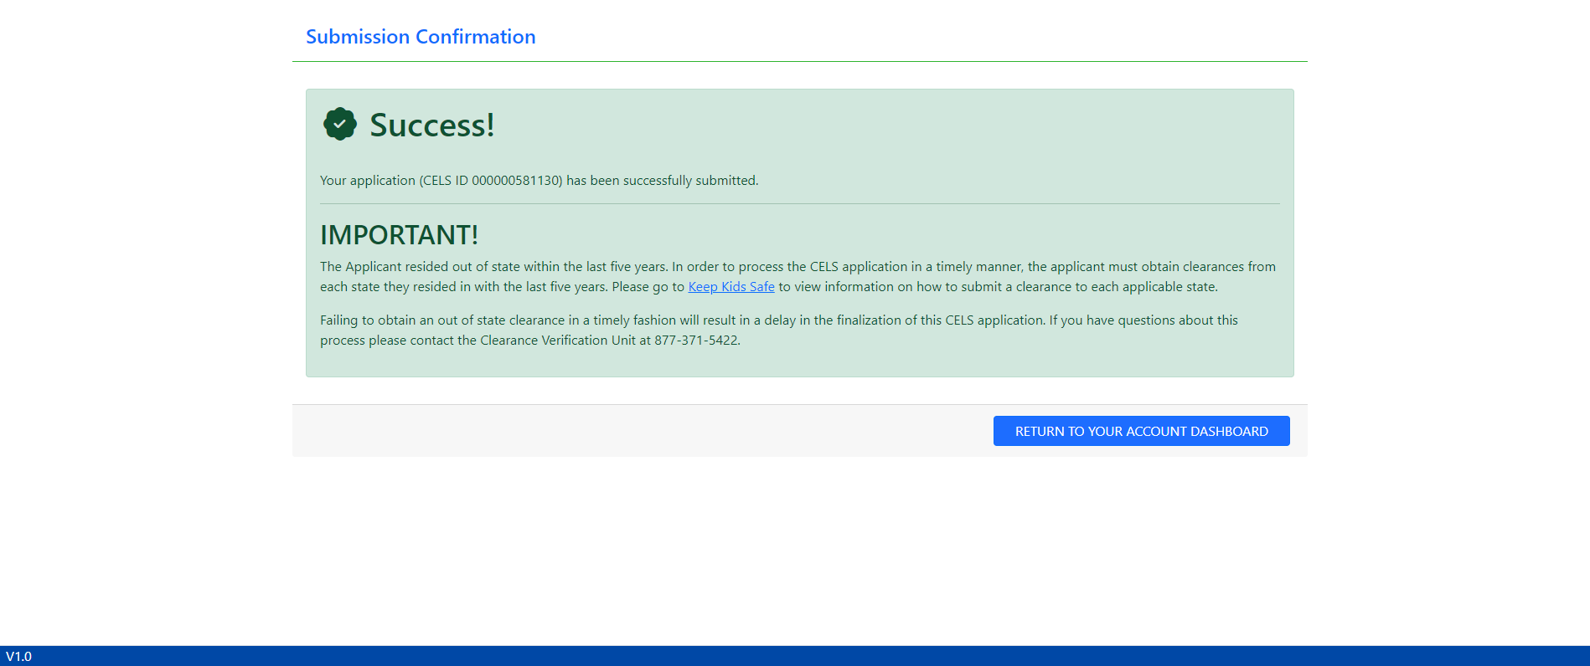

Viewing and Responding to Messages
The Message screen allows providers to view messages from the CVU related to additional information needed for the processing of a submitted application.
When the CVU requests additional information for a CEL, the user will see a red circle appear on their Message icon, indicating a new message was sent. The red circle indicates the number of messages that have been received. Upon viewing the new message, the number in the red circle will be reduced by one. Otherwise, the red indicator will remain on the dashboard until the new message(s) are viewed.
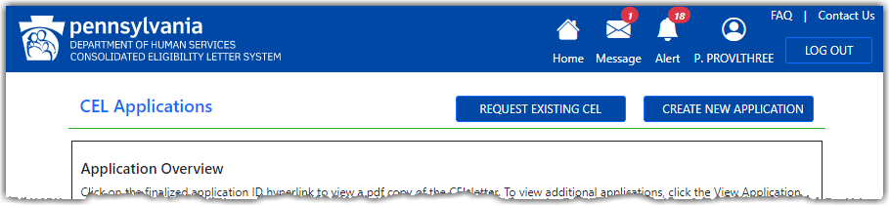
Users are navigated to this screen after clicking on the Messages icon on their account dashboard.
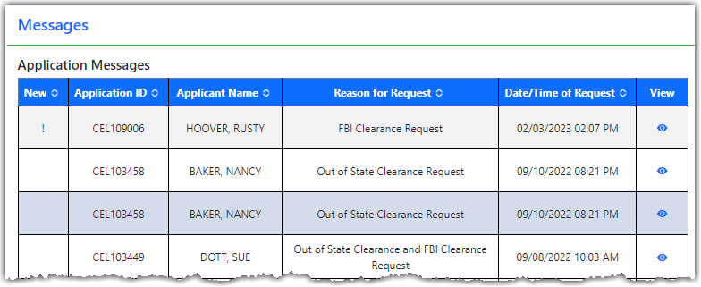
An exclamation point displays in the New column for the newly added message. The name of the applicant, the reason for the request, and the date and time the request was sent also appears in the table. After reviewing the new message by clicking the message’s View icon, the exclamation point in the New column no longer displays. The exclamation point will remain in the new column until the user views the message.

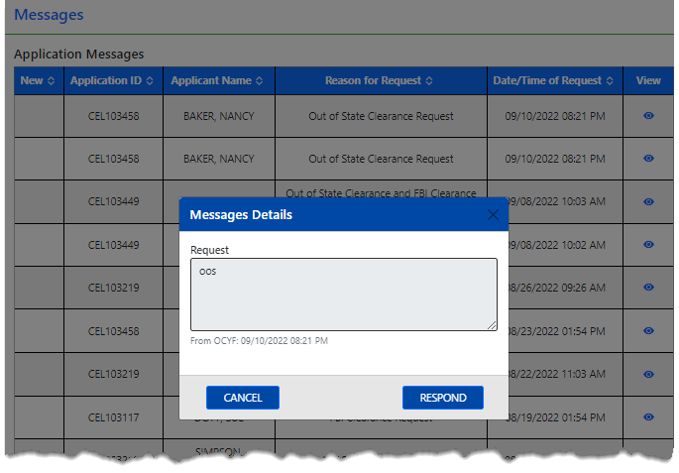
Step 1: Click the View icon to display the Message Details associated with the CEL.
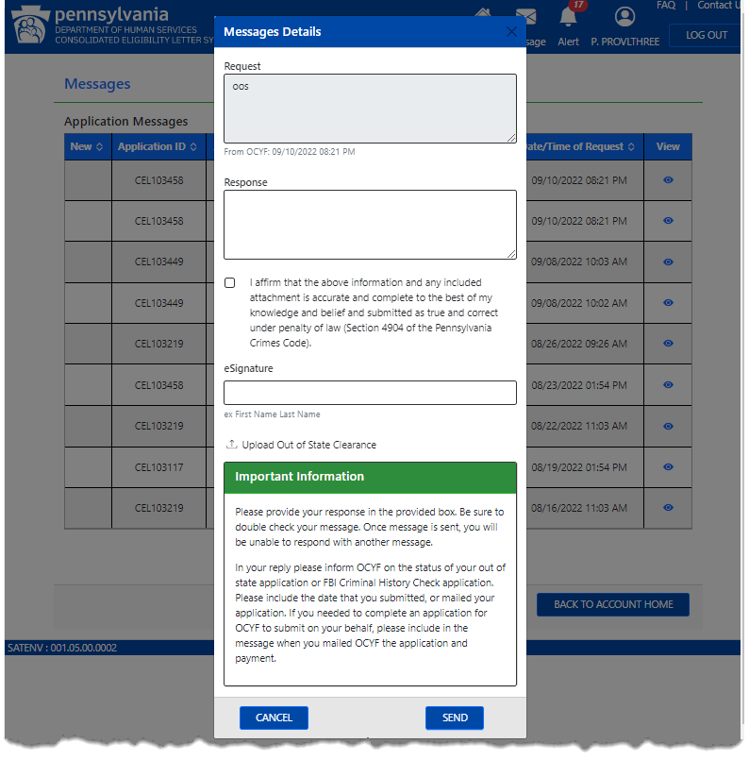
Step 2: Click Respond to respond to the request.
Step 3: Enter the response to the request in the Response text box, click the affirmation checkbox, and enter the applicable eSignature. Then click the Send button.

Working with Alerts
The Alert icon allows providers to see the list of alerts and the associated CEL IDs. The bell-shaped Alert icon includes a red label that indicates the current number of alerts. For example, the Alert icon below indicates that there are 17 alerts to view.
To view the list of alerts, Click the Alert icon. This will open the Alert table.
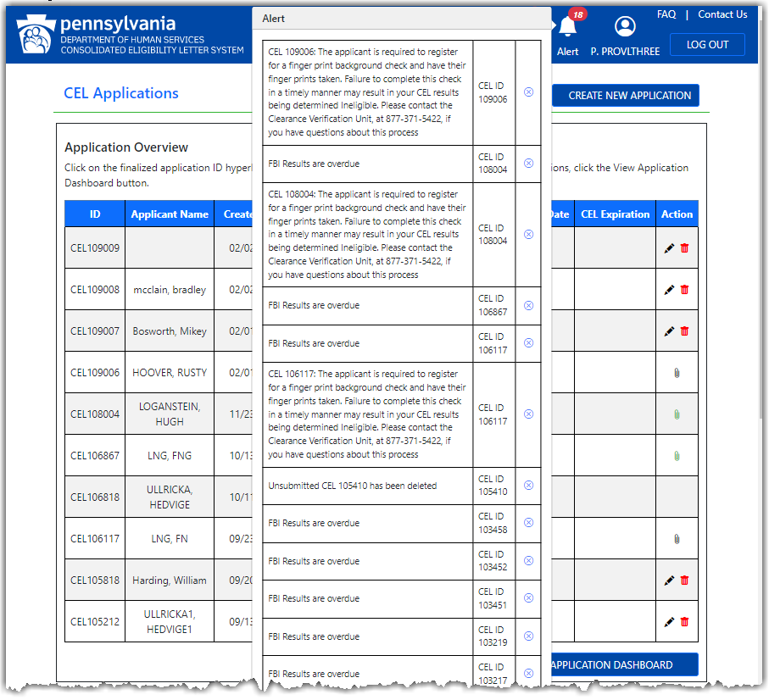
The Alert table displays any system-generated alerts that are triggered after the application has been submitted. Alerts contain the cause of the alert, the CEL ID associated to the alert, and a circular button with an “X” that will clear the alert from the Alert table.
Alerts can be informational (such as, “Unsubmitted CEL123456 has been deleted”) or they may require a response (such as a message that states, “The applicant is required to register for a fingerprint background check and have their fingerprints taken. Failure to complete this check in a timely manner may result in your CEL results being determined Ineligible. Please contact the Clearance Verification Unit, at 877-371-5422, if you have questions about this process”)

Application Dashboard
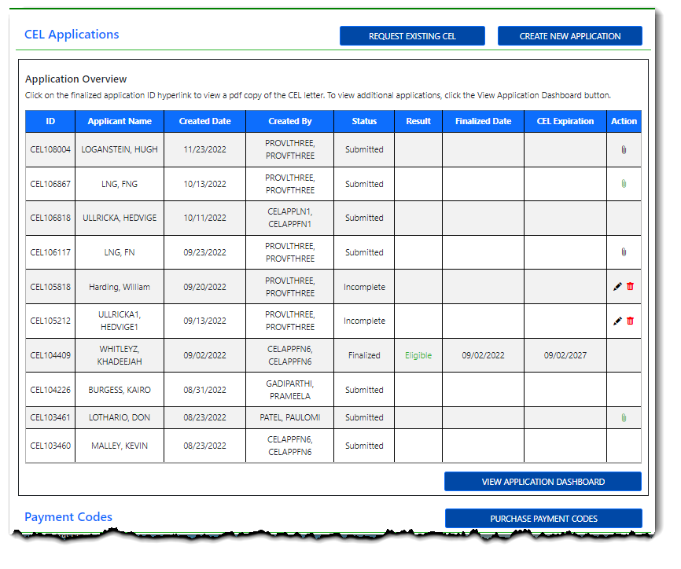
Users can view additional CEL applications on the Application Dashboard by clicking the View Application Dashboard button on the Provider Dashboard.
Note the following when viewing the Application Dashboard:
- CELS are listed order from newest to oldest based on the created date.
- The table includes both applications submitted by a business partner user associated with the provider as well as those that were submitted by applicant users who paid for their CEL application with payment codes associated with the provider.
- There can be a maximum of 25 rows of CELs presented in the table, and potentially multiple pages of applications to view. All applications across the provider organization will appear in the table, which can be paged through using the numbered hyperlinks/Next button at the bottom of the table. An example is displayed in the screen shot below.
An example of the Application Dashboard appears below.
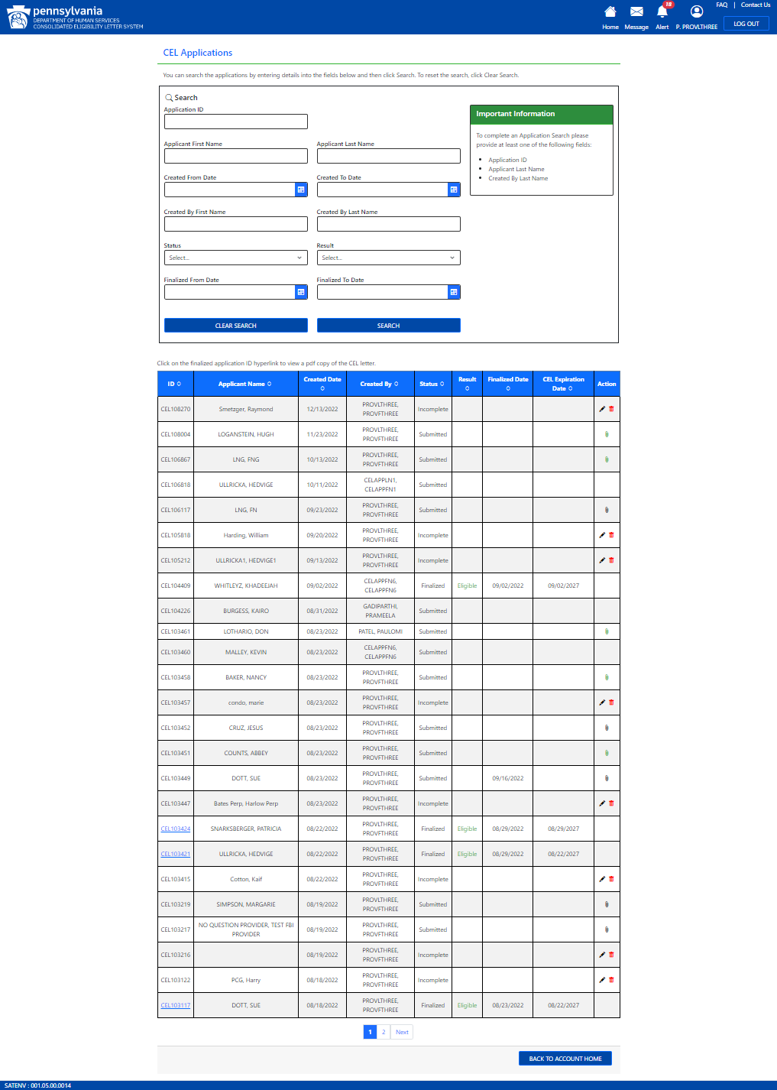
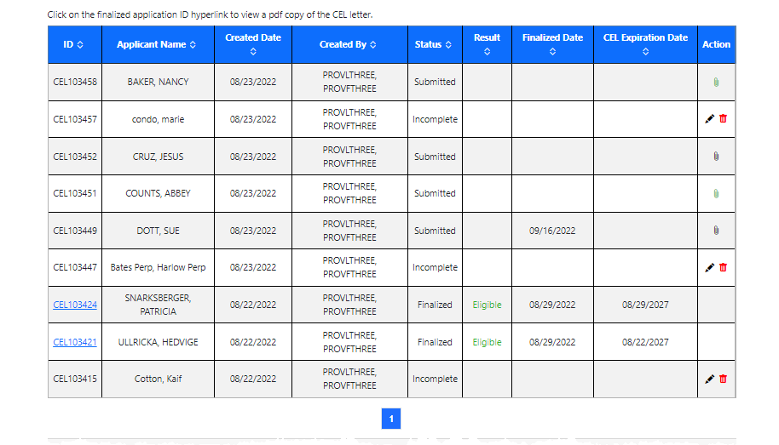
The Created Application Dashboard columns and icons are described below:

Column Name | Description | Sorting
ID | Displays the CEL’s ID number as a label if the application is not in a Finalized status.  If the application is in a Finalized status, the CEL’s ID displays as a hyperlink which navigates the user to the associated results letter. | This column can be sorted by CEL ID number by clicking the up or down arrow. (lowest to highest or highest to lowest)
Applicant Name | Name of the applicant | This column can be sorted alphabetically by last name. (A-Z or Z-A)
Created Date | Displays all applications, sorted by most recent created date. | This column can be sorted by most recently created to oldest, or oldest date to most recent date.
Created By | Name of the individual within the provider organization who created the CEL | This column can be sorted alphabetically by last name. (A-Z or Z-A)
Status | Indicates the current status of the CEL. (Submitted, Incomplete, or Finalized) | This column can be sorted alphabetically by status (Finalized, Incomplete, Submitted or Submitted, Incomplete, Finalized
Result | Displays the application determination status. | This column can be sorted alphabetically by status (Eligible to Ineligible or Ineligible to Eligible)
Finalized Date | Date on which the CEL status was changed to Finalized. | This column can be sorted by most recently finalized date to oldest finalized date or oldest finalized date to most recently finalized date.
CEL Expiration Date | Date on which the CEL application will expire. | This column can be sorted by most recently expiration date to oldest expiration date or oldest expiration date to most recently expiration date.
Action | The Action column displays various icons based on the status of the CEL:  - Submitted – A paperclip icon displays. Clicking this icon causes the Attachments dialog to display.  - Incomplete – A pencil and delete icon display. Clicking the pencil icon opens the CEL to allow editing to continue. Clicking the delete icon launches the Delete CEL Application dialog box. | The Action column cannot be sorted.

Viewing and Printing a CEL
Once a CEL is finalized, users can click on the finalized application ID hyperlink to view a pdf copy of the finalized CEL. A hyperlink is available only on a CEL ID when a CEL is finalized.
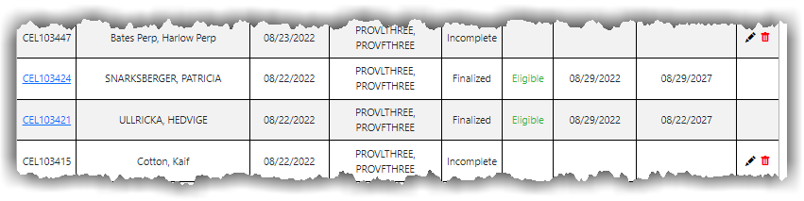
From the Application Dashboard, click on the hyperlinked CEL ID for the applicant whose eligibility letter you wish to see.
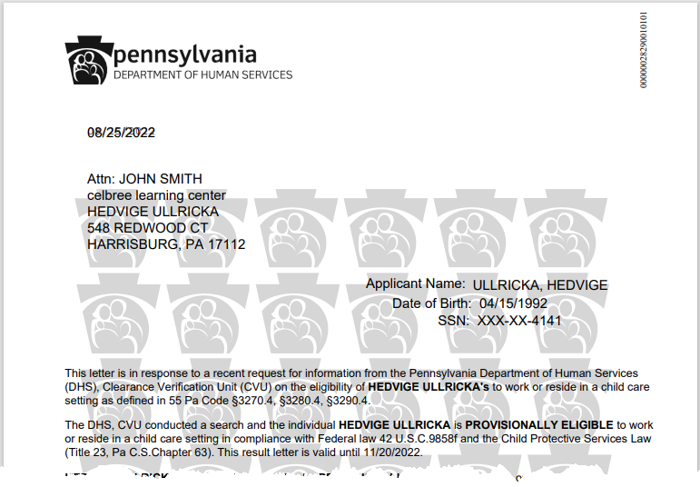
Upon clicking on the hyperlinked CEL ID, the CELS opens a new tab, and display a printable pdf of the finalized CEL:
The Finalized CEL result will also be mailed through the United States Postal Service. Please note that it may take up to 10 business days from the date the CEL result is finalized for you to receive the paper CEL result. A request for a duplicate copy of the CEL result to be mailed to you will not be fulfilled if the CEL result finalized date is within 10 days of the request date.

CEL Application Search
Users can search for existing CEL applications using a variety of search criteria. The Search functionality allows users to search for CEL Applications from a single dashboard. The Search Results will display in a table below the Search screen:
- From the User Dashboard, under CEL Applications, click the View Application Dashboard button to reach the Search feature.
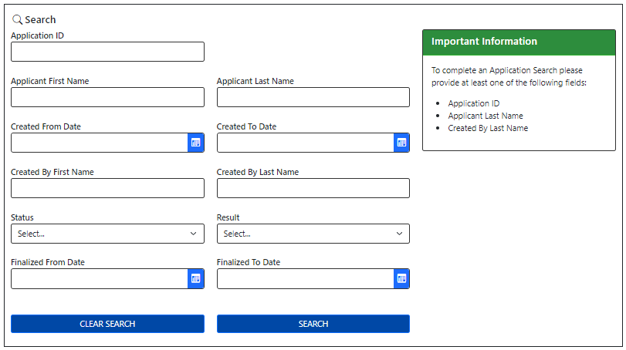
- Complete the application Search fields. (Application ID, Application Last Name, or Created By Last name is required).
- Users can optionally enter any of the following criteria to narrow their search:
Applicant First Name | Created From Date
Created To Date | Created By First Name
Status (Finalized, Incomplete, Submitted) | Result (Eligible, Ineligible)
Finalized From Date | Finalized To Date
- After completing the search fields, click Search.
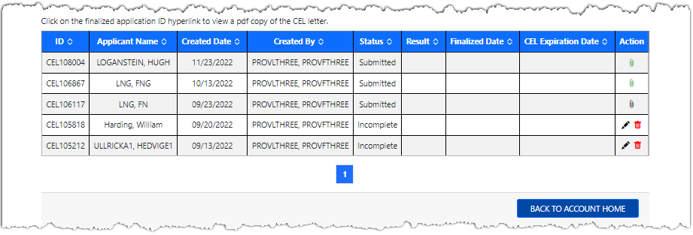
- Review the search results in the search results table. If you receive a No Results Found response, try to reduce your search criteria.
- Click Back to Account Home to return to the Provider Dashboard.

Editing and Correcting a CEL Application
Providers can edit and correct previously created, unsubmitted CEL applications that they or another user within their organization created.
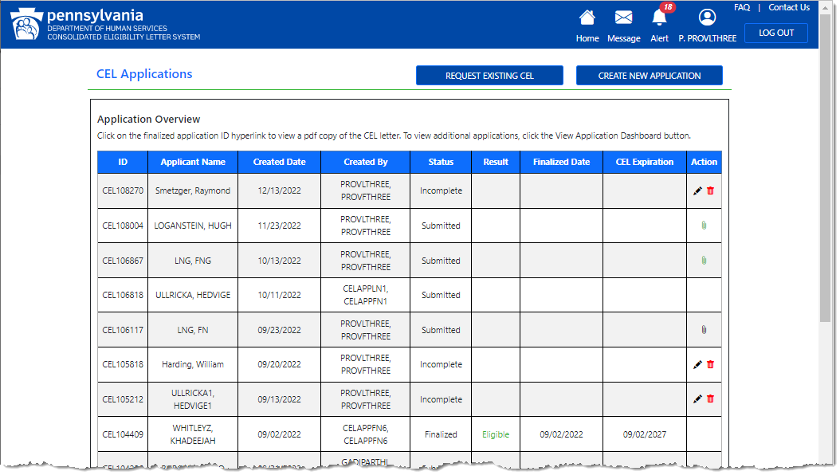
- Log in to CELS to reach the User Dashboard. The Application Overview table displays the ten most recent applications across the provider organization.
- If the CEL ID appears in the Application Overview table, click on the pencil icon found in the Action column (otherwise, go to Step 6 below). The following screen displays.
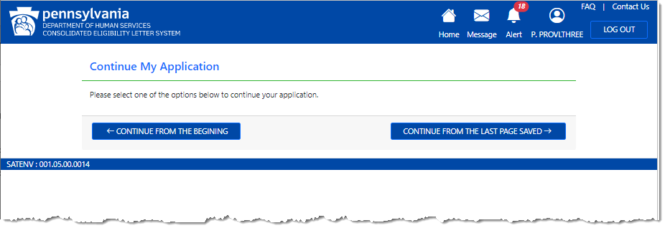
- Choose whether to continue from the beginning of the application or to continue from the last page saved of the application by clicking the appropriate button.

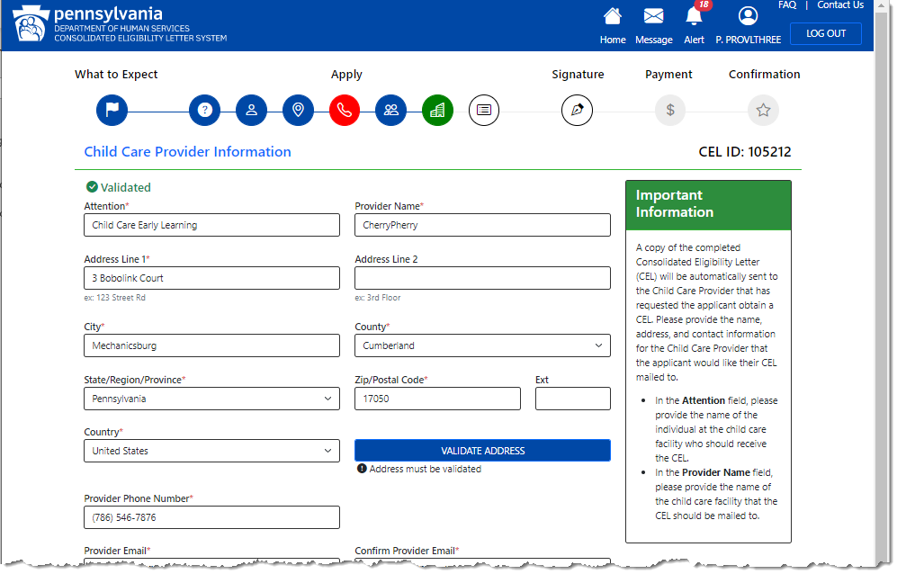
- For this example, the Continue From The Last Page Saved button was selected. The CEL displays the last page that was updated.
- The user can now navigate through the CEL and make whatever updates or edits are needed.
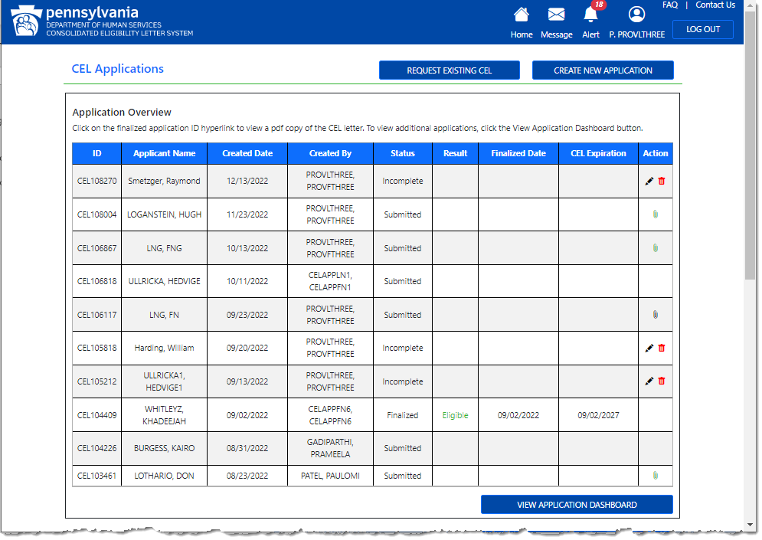
- If the desired CEL did not appear initially in the Application Overview table, the user must search CELS for the desired application. Click the View Application Dashboard button on the Provider Dashboard.
- From the Application Dashboard, complete the Search fields, then click the Search button. More details for performing a CEL search can be found at CEL Application Search found on page 53.

Deleting an Incomplete CEL
Users can permanently remove an incomplete application from the Provider’s account using the Delete Application process.
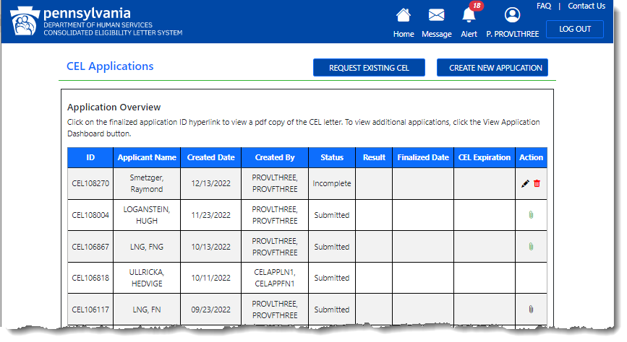
Step 1: From the Provider Dashboard, under CEL Applications, click the Delete icon for the CEL to be deleted.
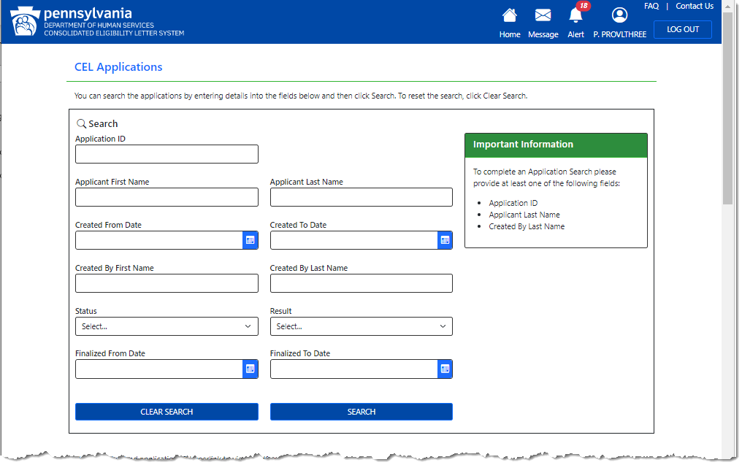
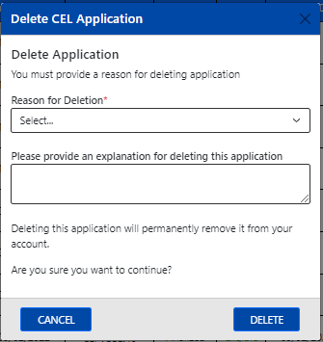
Step 2: The Delete CEL Application pop up displays.

Step 3: Under Reason for Deletion, click the drop-down arrow and select the reason the application is being permanently removed (Application Not Needed, User Error, or Other). This is a required field.
Step 4: Enter an explanation for deleting the application in the textbox labeled Please provide an explanation for deleting this application.
Step 5: Click the Delete button.
Step 6: The Provider dashboard displays and the deleted CEL is removed from the Application Overview table.
Note: When the desired CEL does not appear initially in the Application Overview table, the user must search CELS for the desired application before completing the steps above. Click the View Application Dashboard button on the Provider Dashboard to enter search criteria for the desired CEL. More details for performing a CEL search can be found at CEL Application Search on page 53.

Payment Codes
The Payment Code Dashboard allows you to create, purchase and manage payment codes. You can also view codes, assign/unassign codes, and view the details associated with used codes that have been purchased by you or other members of your organization.
Upon logging into the CELS, the Payment Codes Overview section of the dashboard appears in the lower portion of the screen. The Payment Codes section provides you with an overview of the ten most recently created payment codes. You can view additional payment codes by clicking the View Payment Code Dashboard button.

Payment Code Life Cycle
Payment Codes have different statuses throughout their lifespan (Unused, Assigned, and Used) as described below:
Payment Code Status | Description
Unused | Unused codes have previously been purchased and are available for assignment.
Assigned | Assigned codes have been allocated to an individual, but the code has not been applied.
Used | Used codes have been applied by an individual/applicant when completing the CEL’s payment process.
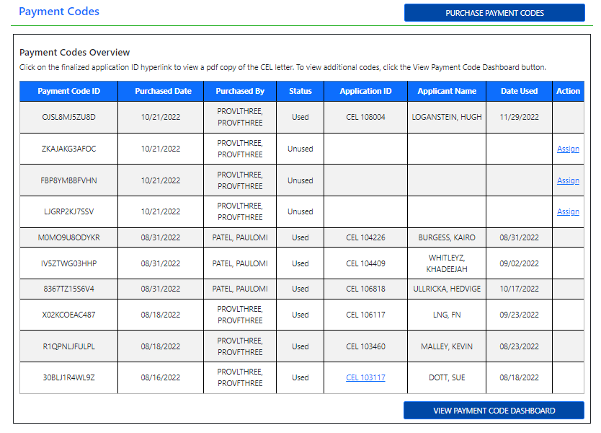
The View Payment Code Dashboard button navigates users to the Payment Code Dashboard. Providers can view unused codes, assign existing codes, and review details about used codes that have been purchased and assigned by their organization.

Payment Code Dashboard
The Payment Code Dashboard displays payment codes across the provider organization.
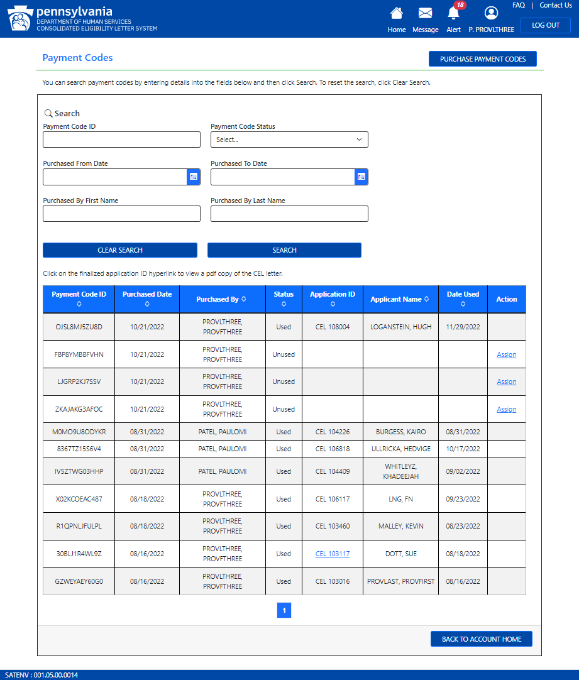

Purchase Payment Codes
You can access the Generate Payment Code screen by clicking on the Purchase Payment Codes button on the dashboard. Complete the following steps to purchase payment codes.

- From the Provider Dashboard, scroll down and click the Purchase Payment Codes button.
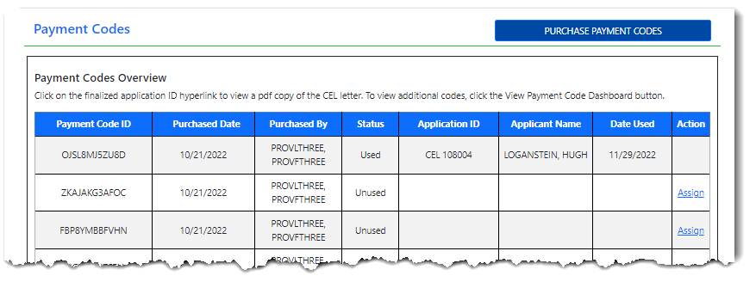
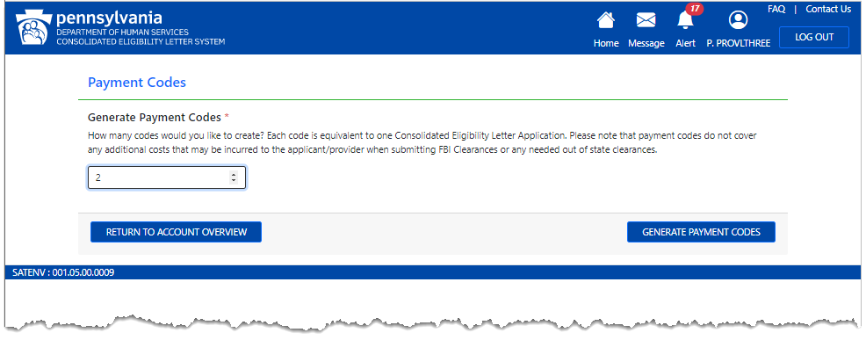
- From the Generate Payment Code screen, click inside the text box under Generate Payment Codes and enter the number of payment codes needed.

Note: Users can also click the Up or Down arrows to select the number of payment codes needed. Payment codes can be ordered in any quantity; for example, 1, 5, 50, and so on up to 100.
- Click the Generate Payment Codes button.

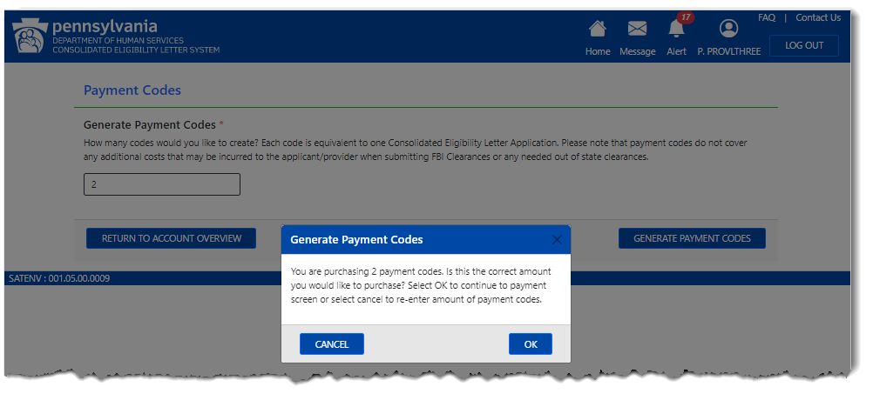
- Review the Generate Payment Codes pop up and click OK to continue to the payment screen. Otherwise click Cancel to return to the Payment Codes screen.
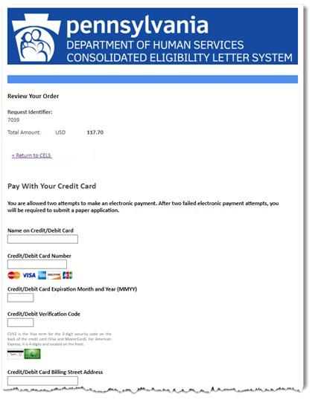
- Upon clicking OK, the payment screen displays.
- Review your order and complete the required fields:

Name on Credit/Debit Card | Credit/Debit Verification Code
Credit/Debit Card Number | Credit/Debit Card Billing Street Address
Credit/Debit Card Expiration Month and Year (MMYY) | Credit/Debit Card Billing Zip Code
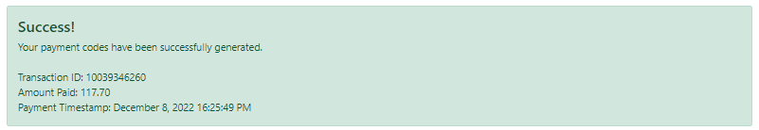
Click the Pay with Your Credit Card button one time. (Click the button only one time. Repeated clicking could cause multiple charges.) CELS returns to the Payment Code Dashboard and displays a confirmation message:

In addition to displaying the payment confirmation, CELS displays the Payment Code Dashboard showing the most recently purchased payment codes at the top of the table.
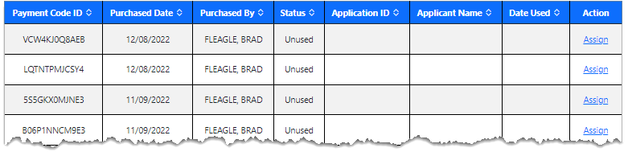
- Click the Back To Account Home button to return to the Provider Dashboard.

Payment Code Search
From the Provider Dashboard, clicking the View Payment Code Dashboard button navigates the user to the to the dashboard and the payment code search functionality. The Payment Code Search feature is a straightforward yet comprehensive tool to search for payment codes using a variety of combinations.
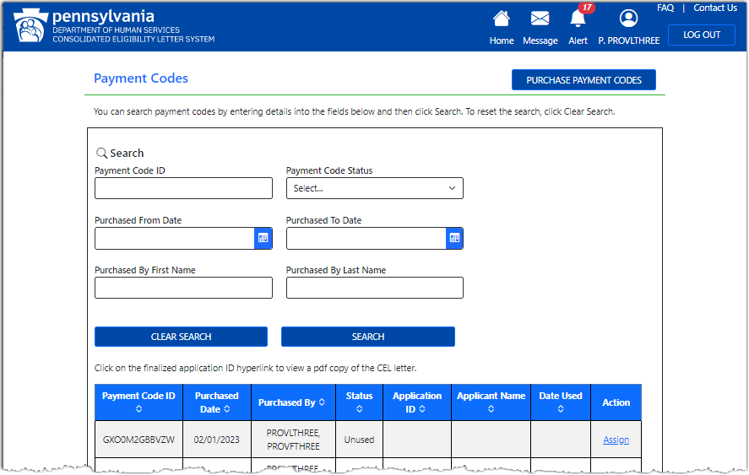
Complete the following steps to search for a payment code within CELS.
- From the Payment Code Overview section of the Provider dashboard, click the View Payment Code Dashboard button.
- Enter the search criteria needed to perform your search:
Field Name | Description
Payment Code ID | The payment code search is case sensitive. All the letters in the payment code must be in CAPS
Payment Code Status | Search for all payment codes in Assigned, Unused, or Used status. Users can also search using a range of dates by combining the Purchase From and Purchased To Date fields.
Purchased From Date | Search for all payment codes purchased from a given date in the past. Can be combined with other search options, such as Payment Code Status and Purchased To Date.
Purchased To Date | Search for all payment codes purchased up to a given date. Can be combined with other search options.
Purchased By First Name | Search for payment codes by the first name of the individual who purchased the code(s). Can be combined with other search options, such as Last Name, but Last Name is not required.
Purchased By Last Name | Search for payment codes by the last name of the individual who purchased the code(s). Can be combined with other search options, such as First Name, but First Name is not required.
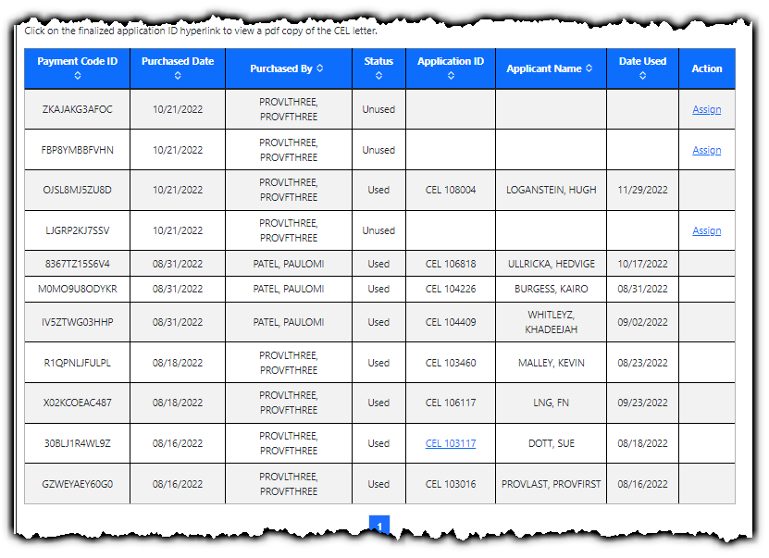
- Click the Search button. The dashboard refreshes and displays the search results:
- Review the search results and adjust the search criteria if the desired payment codes do not appear in the results. (For example you may need to adjust the Purchased From and Purchased To dates to expand the search range).

Assign Payment Codes
The Assign Payment Code feature allows users to add a description to an unused payment code to note that the payment code was assigned to an individual.
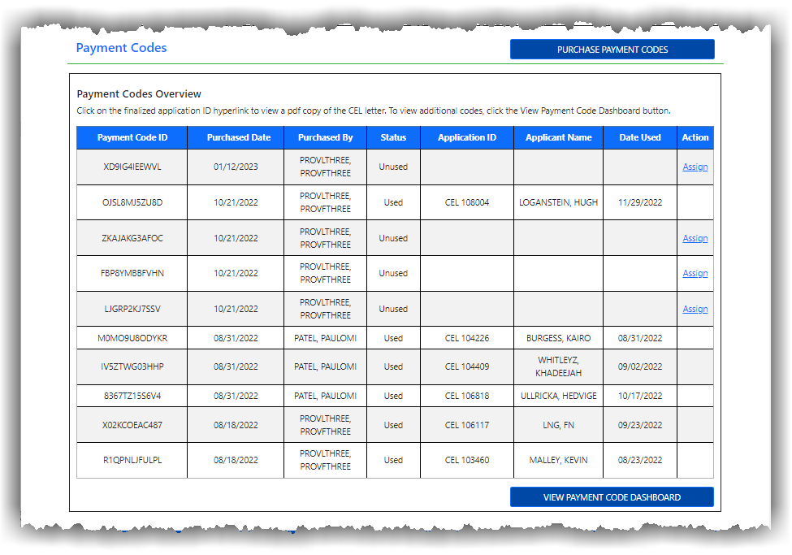
  - From the Provider Dashboard, scroll down to the Payments Codes Overview section of the dashboard.
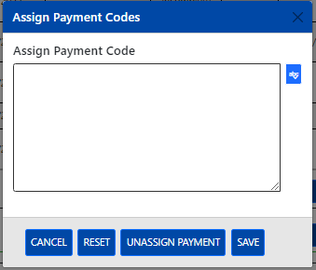
  - Locate the desired unused Payment Code ID., then click the Assign hyperlink in the Action column. The Assign Payment Codes dialog box displays.

  - Click inside the textbox and indicate that the payment code has been assigned. For example, “This payment code has been assigned to John Smith.”
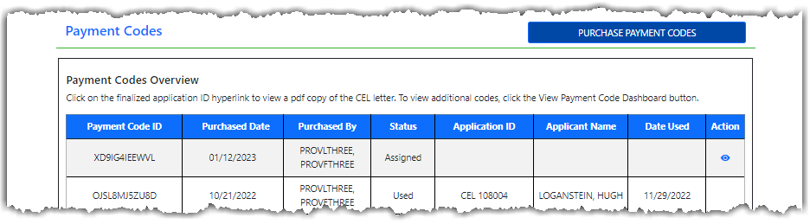
  - Click Save. The Payments Codes Overview section of the dashboard refreshes. The Action column now shows the View icon instead of the previous Assign hyperlink.
Note: The Action column for this payment code now displays the View/eyeball icon. Clicking this icon will display the Assign Payment Codes dialog box with the newly added assignment information.

Unassign Payment Codes
The Unassign Payment Code feature allows users to edit an assigned payment code and make it available to be assigned to another individual.
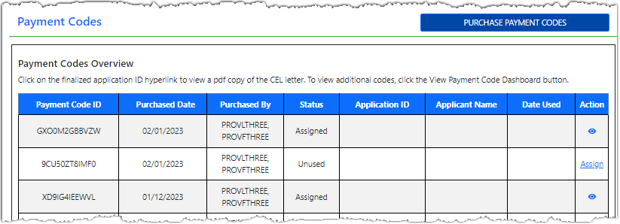
- Step 1: Locate the payment code you wish to unassign. (Assigned codes will show the View/Eyeball icon in the Action column.)
- Step 2: Click the View/Eyeball icon for the payment code you wish to unassign. The Assign Payment Codes dialog box displays.
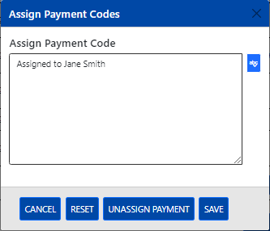
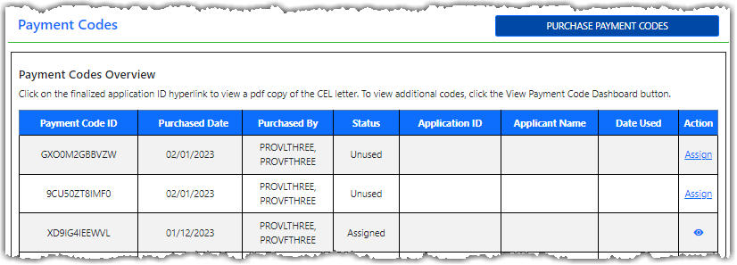
- Click the Unassign Payment button. The dialog box closes and the Payments Codes Overview section of the dashboard refreshes. The payment code now appears in the Action column as ready to assign.

Note: There is no systematic communication to notify an individual when you have assigned or unassigned a payment code. Rather, the assign/unassign feature allows organizations to track the assignment of payment codes internally. It is the responsibility of the organization to notify individuals when a payment code has been assigned/unassigned. Once a payment code is provided to an individual, there is nothing systematically in place to stop them from using the payment code should the organization choose to unassign the payment code.

Attachments
Providers may need to attach documents to a previously submitted application, or to a new, unsubmitted CEL application. Providers may also need to add attachments to messages following receiving a request for information from a CVU worker. A CVU worker may request information from a provider when they submit a CEL application on behalf of an applicant who resided in a Closed Sharing State within the last five years.
The following file types can be uploaded within the CELS:
.pdf | .jpeg
.doc | .jpg
.docx

Upload an Attachment for a Submitted Application
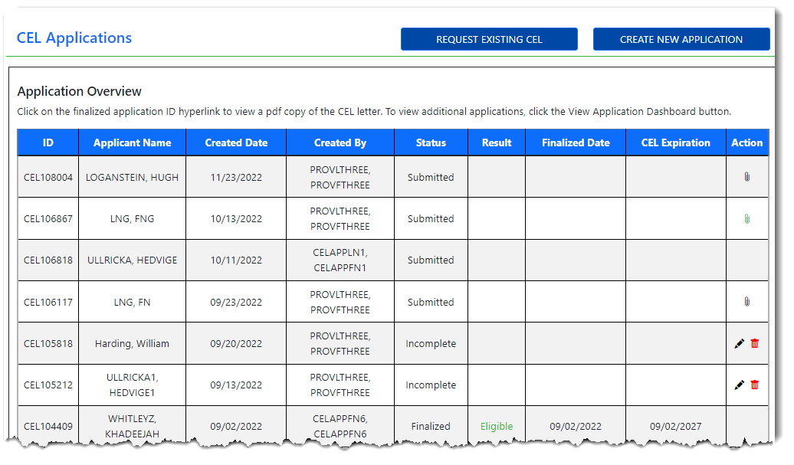
- From the CELS home screen CEL Applications table, click on the paperclip icon of the submitted application.
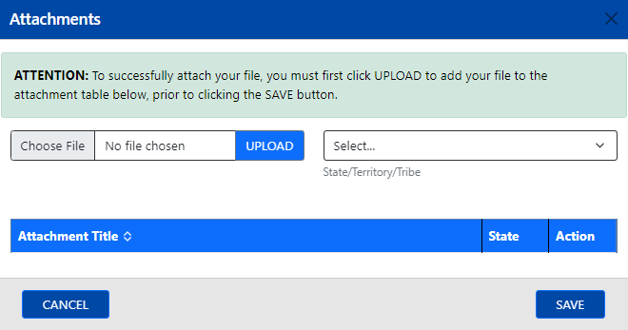
- From the Attachments dialog box, click the Choose File button.

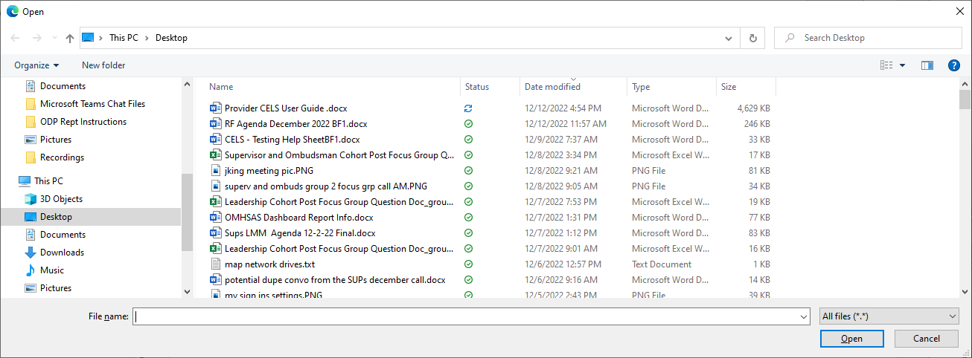
- Navigate to the file to attach to the application. Click on the file to attach, then click Open.
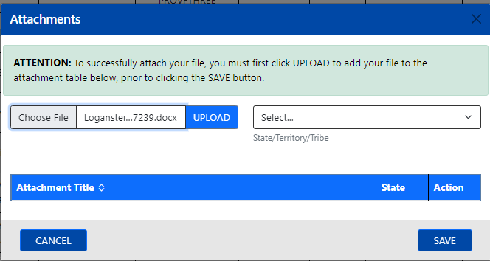
- On the Attachments dialog box, click the select drop-down and select the desired State, Territory, or Tribe.

- Verify the file name and click the Upload button.
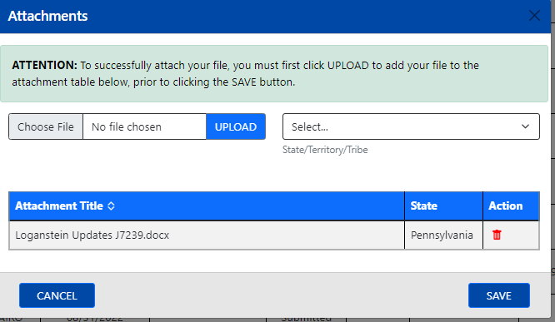
- Review the Attachments dialog box to confirm the selected file and State, Territory, or Tribe are correct, then click Save.

Upload an Attachment for a Previous Address for a New Application
Prerequisite: A new CEL application is in progress, and the Applicant Demographic Information screen has been completed.
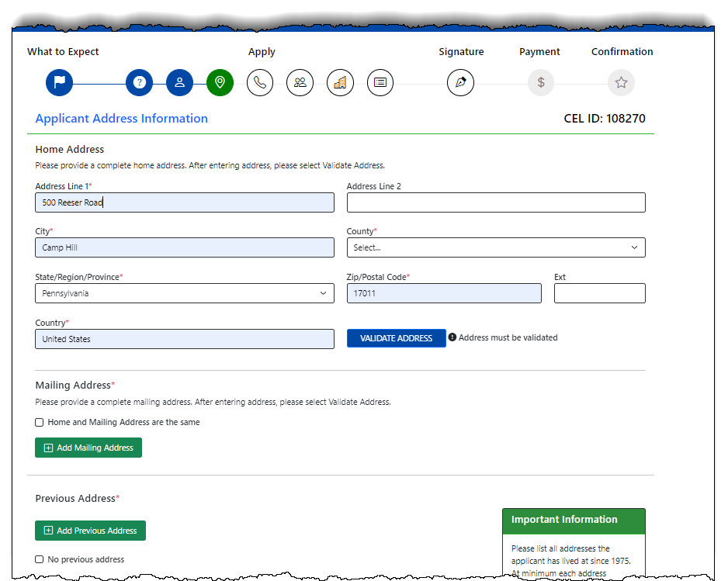
- Complete the Applicant Address Information screen. If an applicant’s home address is out-of-state CELS provide the ability to add an attachment.

- Click the Add Previous Address button under Previous Address.
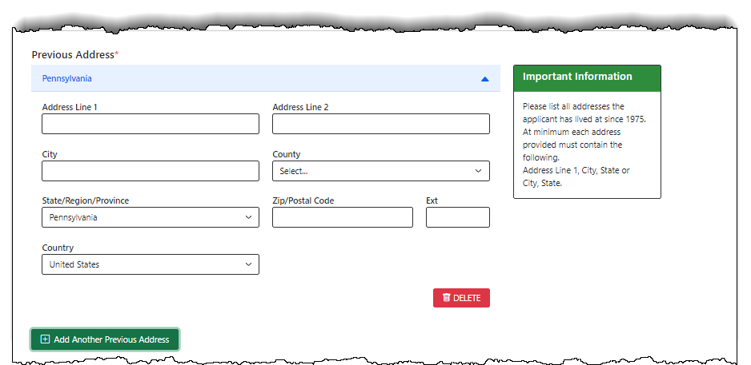
- Complete the Previous Address fields.

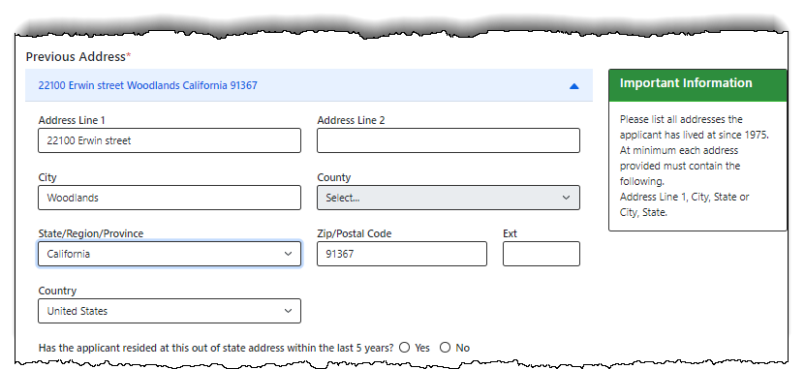
Note: When the State/Region/Province field is updated with another state, CELS automatically prompts the user to indicate if the applicant resided at the out-of-state address within the last 5 years.
- Click the Yes radio button if the applicant resided at the out-of-state address within the last 5 years.
Selecting the Yes radio button will prompt an additional question, “Has the applicant requested their clearances from this state?”
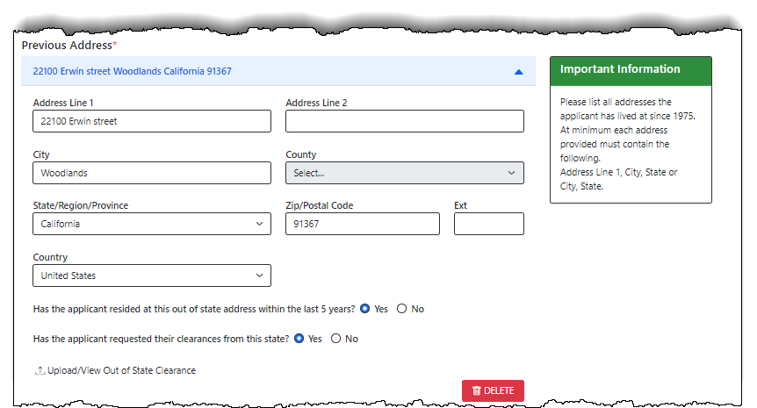
This functionality is based upon each particular state. Users might not receive the prompt, depending on the state that was entered.
If the applicant has requested their clearances, click the Yes radio button. CELS updates the screen with a link to begin the steps to attach the clearances. Otherwise, click the No radio button.
- Click the Upload/View Out of State Clearance hyperlink.
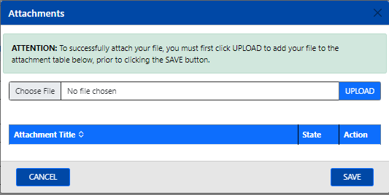
- Click Choose File from the Attachments dialog box.
- Once you navigate to the clearance file to attach to the application, click on the file to attach, then click Open.
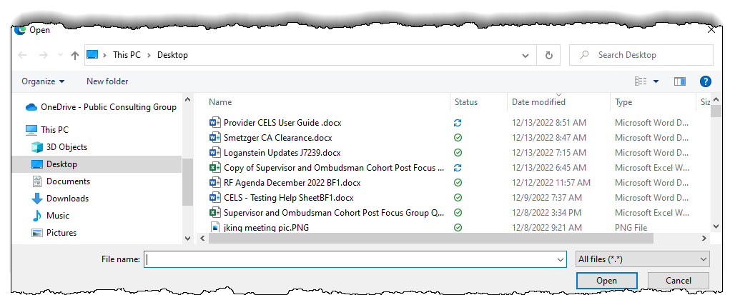
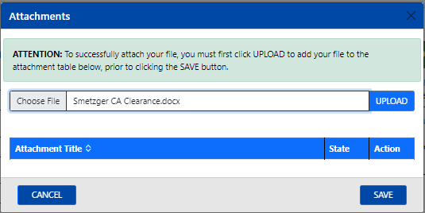
- At the Attachments dialog box, verify the file name and click the Upload button.
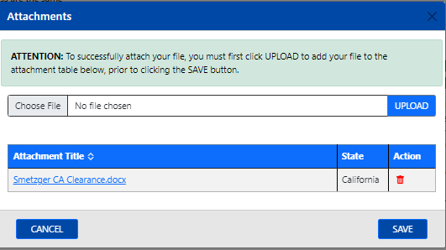
- Review the Attachments dialog box to ensure the attached file appears.
- Click Save to successfully add your file.

Upload an Attachment – CVU Requests Additional Information
Prerequisite: The Provider submitted a CEL Application with a previous out-of-state address within the last 5 years that requires the Individual applicant to obtain their own clearance. The out-of-state clearance result was not provided at the time of the application submission. A CVU worker requests additional information from the Provider regarding the missing out-of-state clearances.
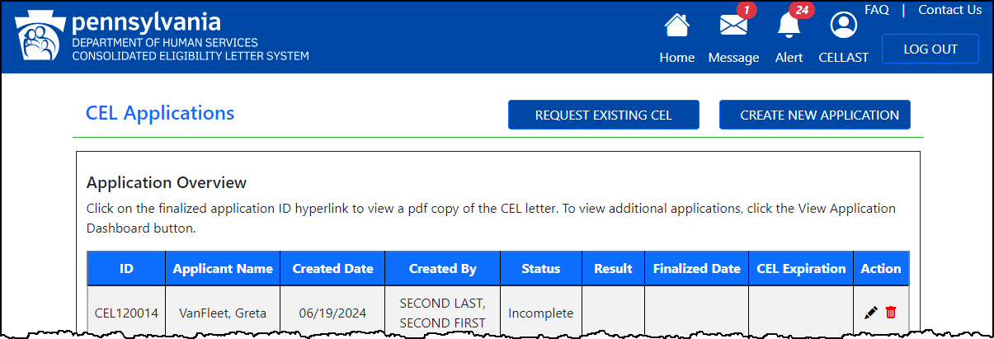
- Click on the Message hyperlink at the top of the screen.
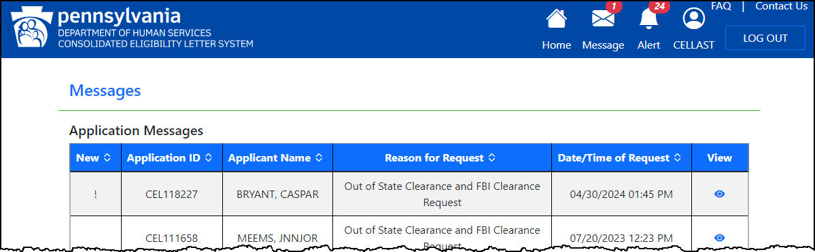
- Click on the View, eyeball, icon on the Application Messages table to identify the specific information that CVU is requesting.
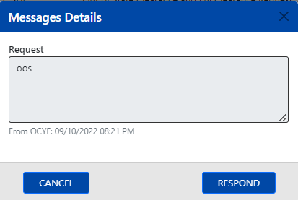
- From the Messages Details pop up, review the Request section text, then click Respond.
- CELS launches a larger Messages Details pop up. The pop up includes a Response text box, an affirmation checkbox, an eSignature field, and a hyperlink to perform a file upload.
Note: The Important Information section: Be sure to double check your message. Once a message is sent, you will be unable to respond with another message.
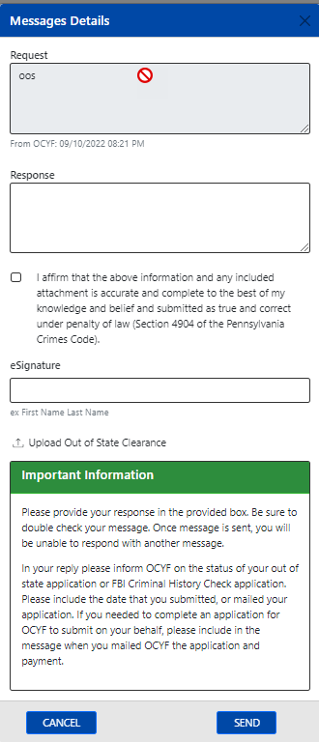
- Complete the Response text box, click the Affirmation check box, and enter the eSignature.

- Click the Upload Out of State Clearance hyperlink.

- From the Attachments dialog box, click the Choose File button.

- Navigate to the clearance file to attach to the application. Click on the file to attach, then click Open
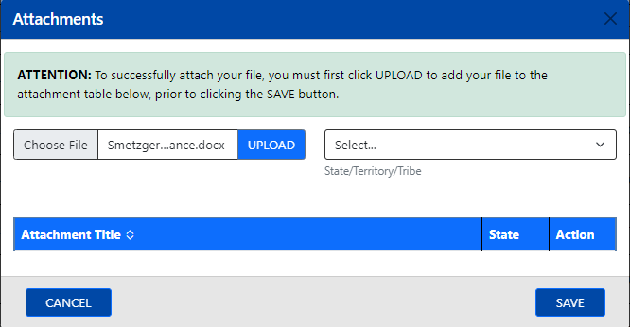
- On the Attachments dialog box, click the Select drop-down and select the desired State, Territory, or Tribe.

- Verify the file name and click the Upload button.
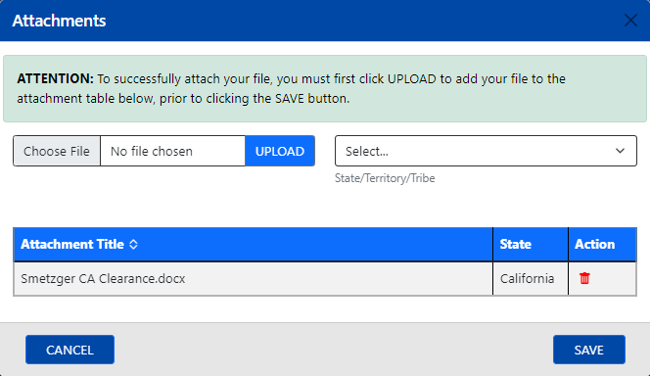
- Review the Attachments dialog box to ensure the attached file appears.

- Click Save to successfully add your file.

Submitting FBI Clearance ID for a Submitted CEL
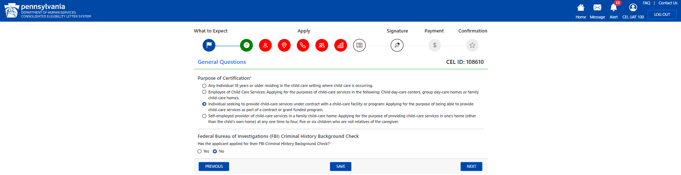
If you do not have your FBI Clearance ID number at the time of completing your CEL Application, select No to the question “Has the applicant applied for their FBI Criminal History Background Check?” in the General Questions section and select the Next button.
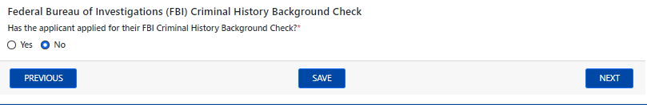
You can submit your FBI Clearance ID number within 45 days of submitting your application.
Note: If you need more information on FBI Clearances, visit Keep Kids Safe: https://www.dhs.pa.gov/KeepKidsSafe/Clearances/Pages/FBI-Fingerprinting.aspx.
Once you have submitted your CEL Application, you cannot make any edits to your application.
Once you submit your CEL Application without your FBI Clearance ID number, you will immediately receive an alert from CELS in your dashboard.
- The main areas on your dashboard related to FBI Clearance ID are:
- You will have alert(s) regarding a specific CEL Application.
- Select the X button to manually clear an alert after you have reviewed it.
- Any alerts will be listed with the specific CEL ID number. The two alerts referring to FBI Clearance(s) are:
Message Example: “FBI results are overdue.”
Message Example: “The applicant is required to register for a fingerprint background check and have their finger prints taken. Failure to complete this check in a timely manner may result in your CEL results being determined Ineligible. Please contact the Clearance Verification Unit, at 877-371-5422, if you have any questions about this process.”

Applicant Dashboard
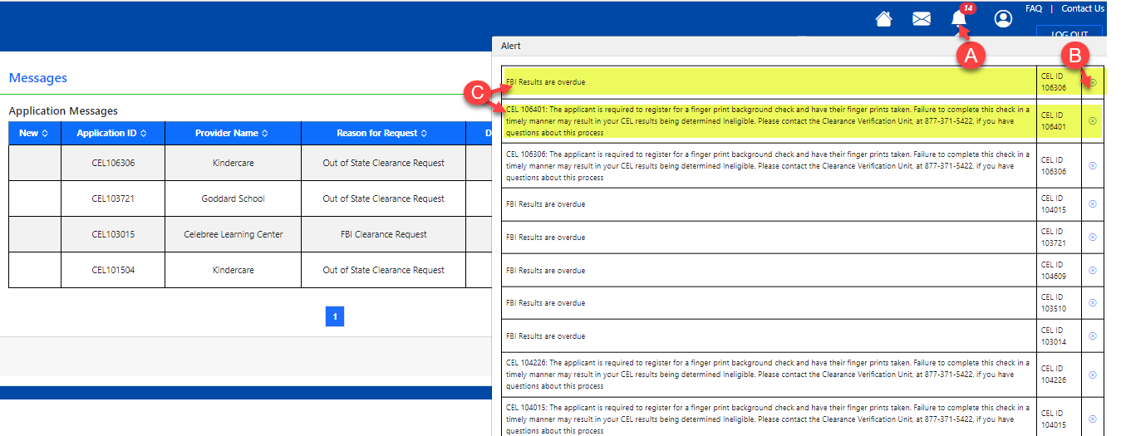

- To respond to a message from CVU, select the message icon from your dashboard home page. Any messages from CVU will be listed based on the specific CEL ID application.
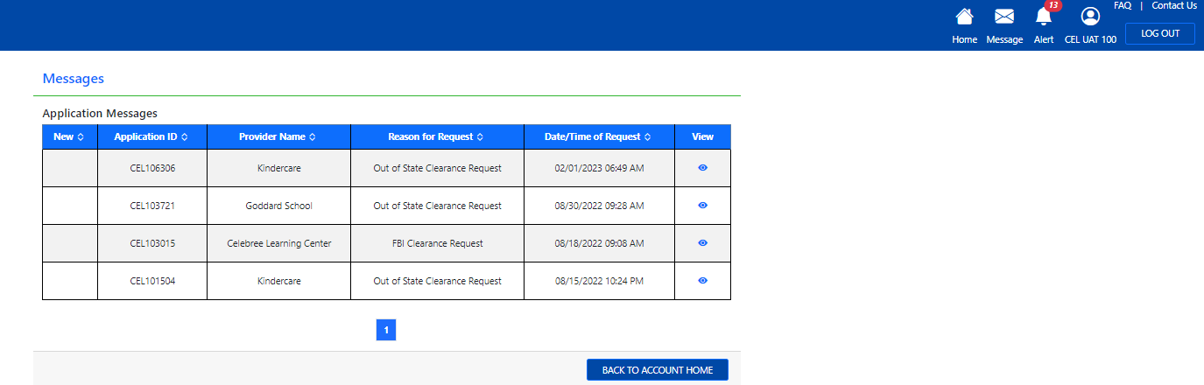
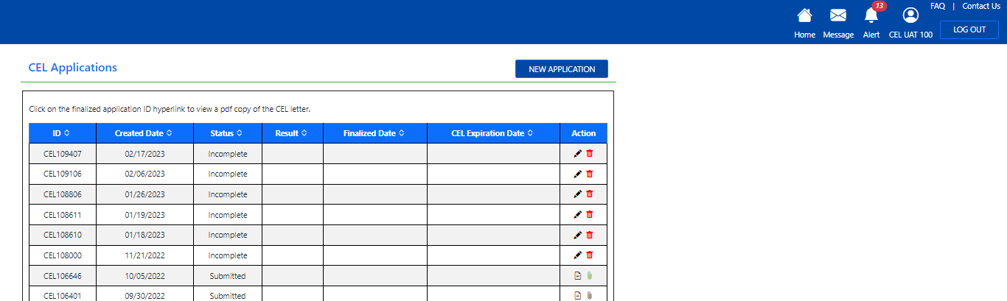

- To respond to a message from your dashboard, from the Message screen, select the View Column (eye icon) to open the Message Details screen in Step 4.

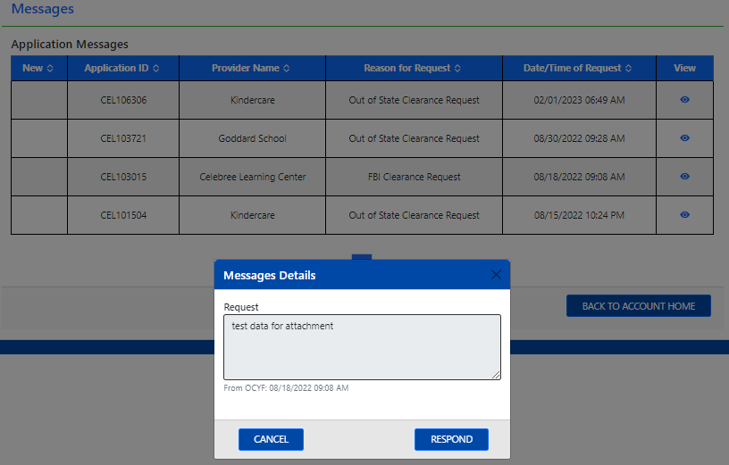
A message from CVU will be here.

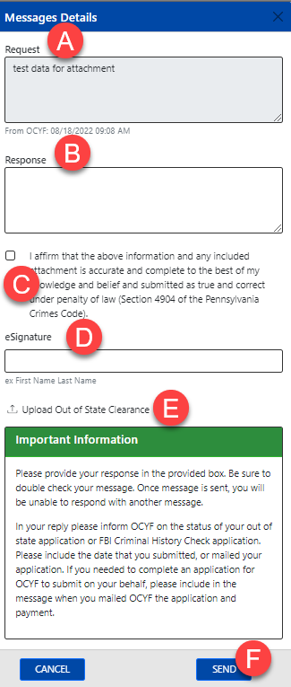
- To respond to a message, from the Message Detail screen, select the Respond button. Complete following fields:
  - Request-The message from CVU for a specific CEL Application will be here for your review.
  - Response-Type your response to the CVU request. If you have your FBI Clearance ID number, you will enter the information in the Response box. For example, “I am providing my FBI Clearance ID number for this application. The FBI Clearance ID number is xxxxxx.”
  - Affirm Box-It is mandatory you check the affirm box to confirm the information you are submitting is accurate.
  - eSignature-It is mandatory for you to provide your first and last name as your eSignature. Your eSignature must be the same name you used to create your account.
  - Out of State Clearance-You can attach your out-of-state clearance(s) or FBI Clearance(s). The attachment will go to CVU for the specific application in the message.
  - Once you complete all mandatory fields in this message details screen, select the Send button to submit the response.
If you submitted your application without your FBI Clearance ID number and have the FBI Clearance results, you can alternately add it as an attachment from your dashboard, which then becomes available for the CVU to view:
- Locate the specific submitted CEL application on your dashboard home page. Select the paper clip icon in the Action column to add your attachment for CVU processing.
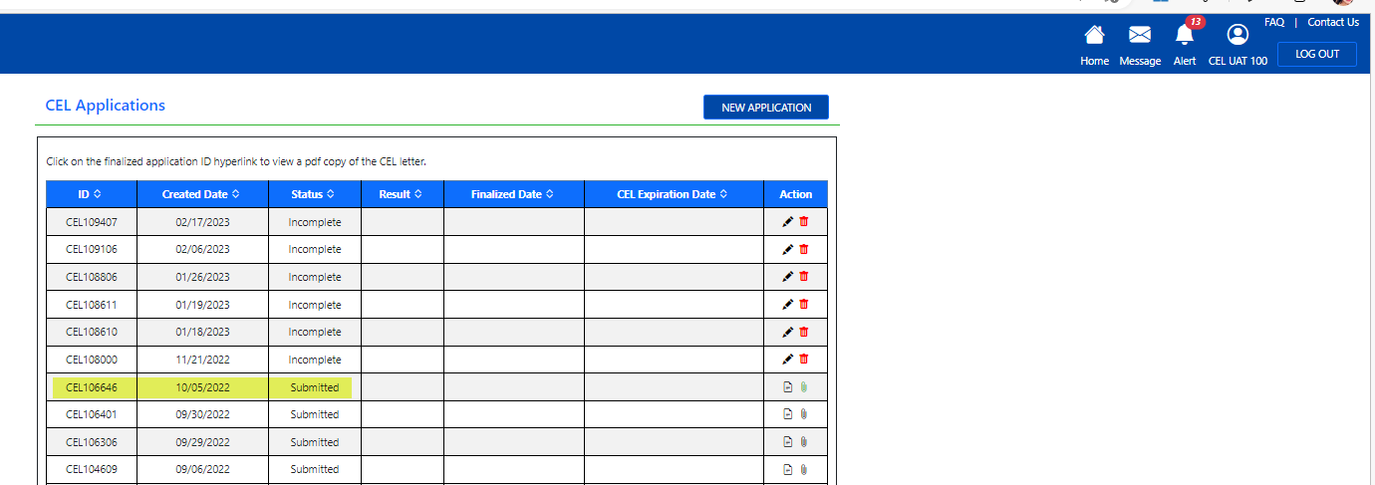

- After you select the paper clip icon in the Action column, the Attachments screen will display. (For further details on adding Attachments, refer to Upload an Attachment for a Submitted Application on page 68).
