**ERAP Benefit Search Instructions**

1. From the COMPASS home page select login from the upper right-hand corner.

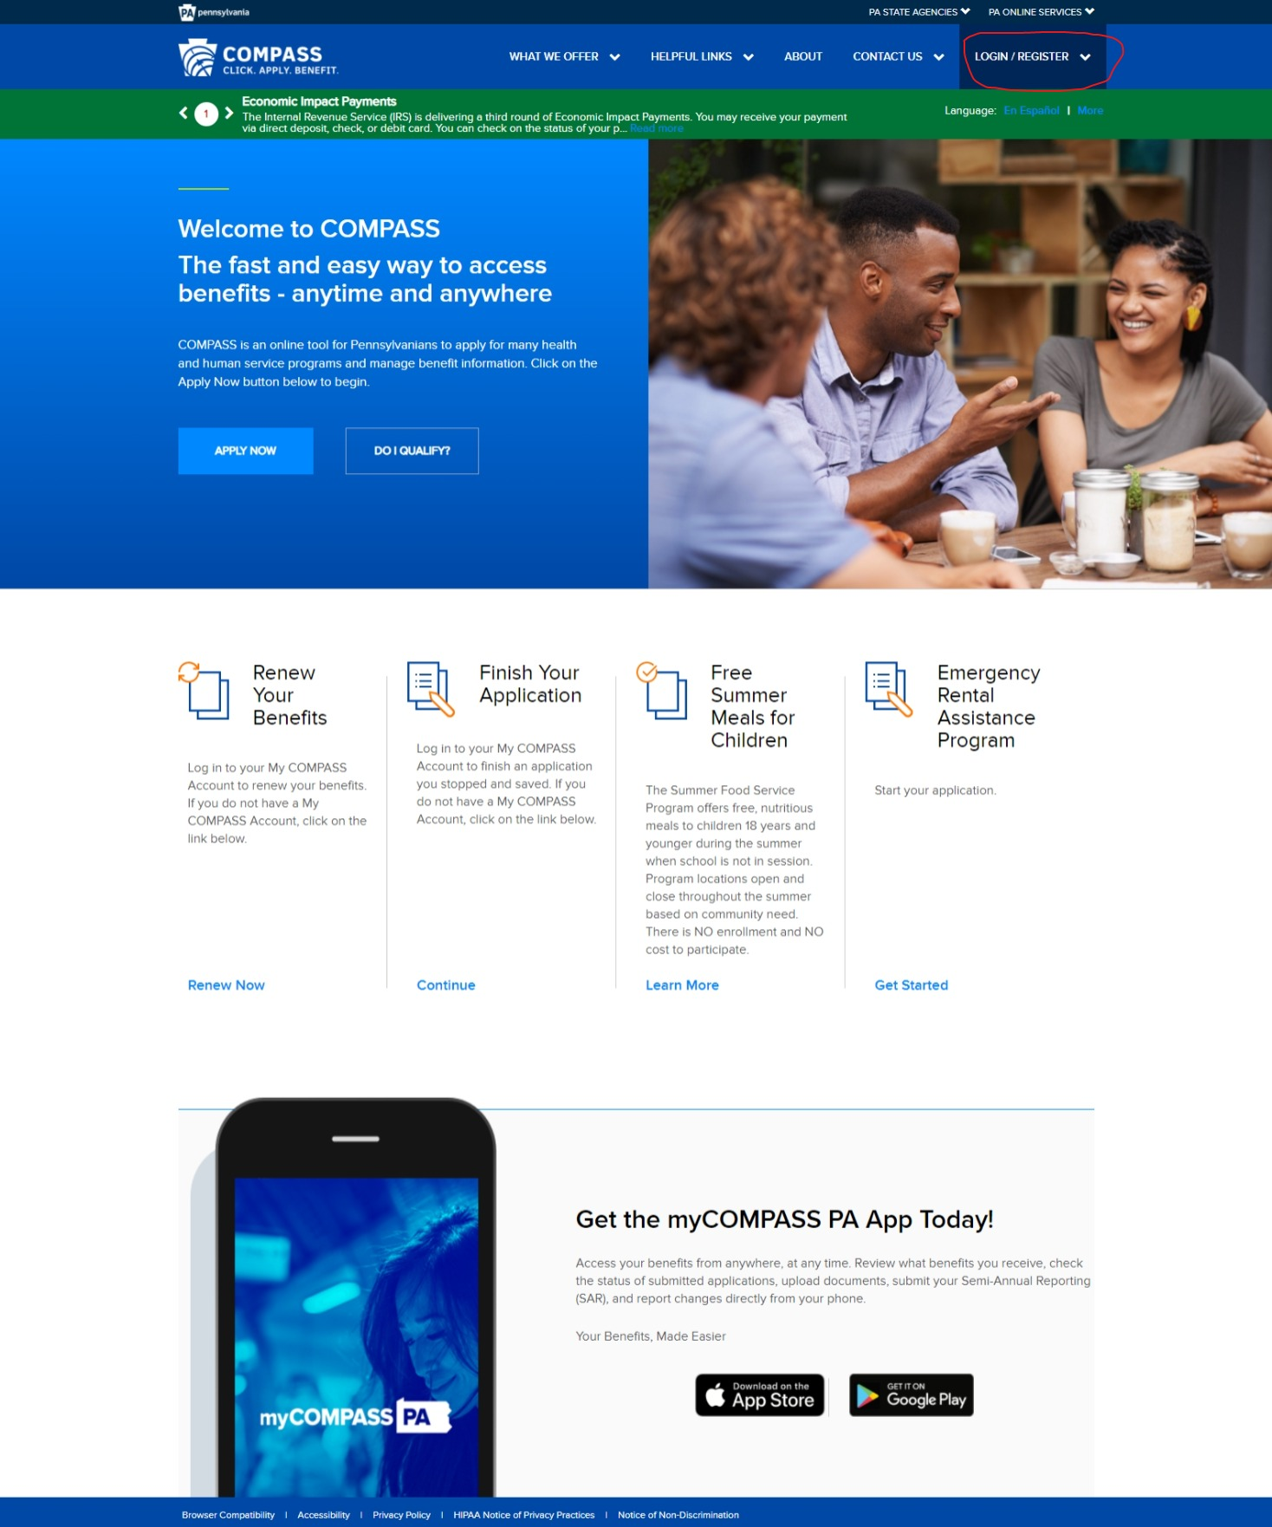

2. Select the Service Provider Login.

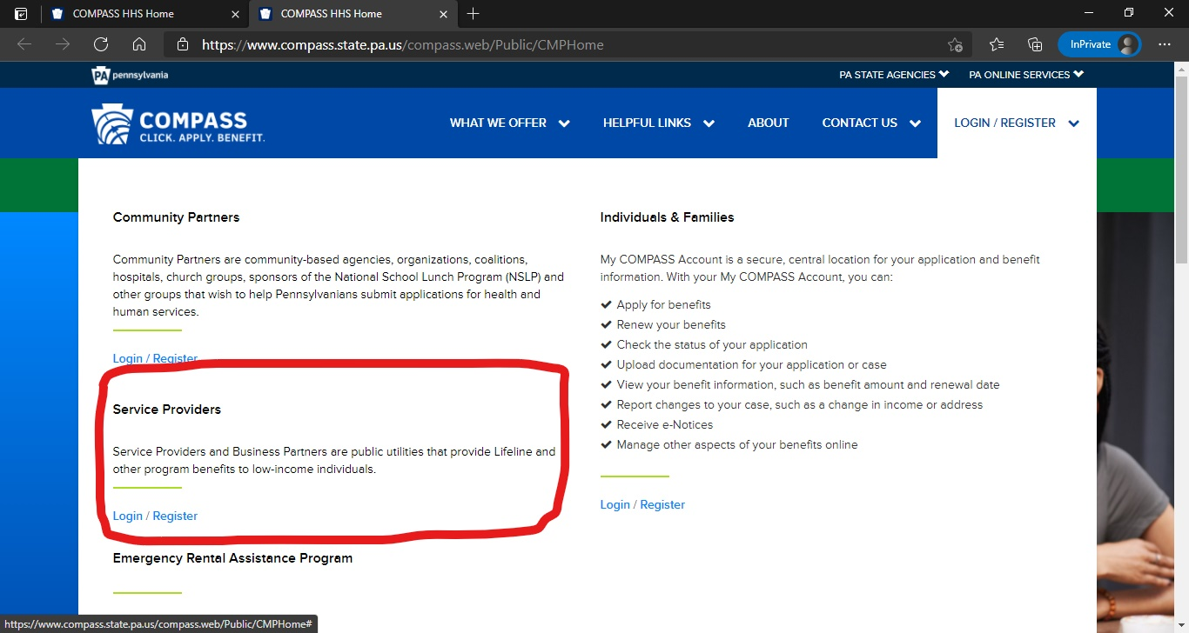

3. Enter b-user login credentials.



4. Perform Benefit Search

Enter up to five individuals per search. Use the “Reset” button to perform another search for up to five persons as needed. Please remember to log out after completing searches.

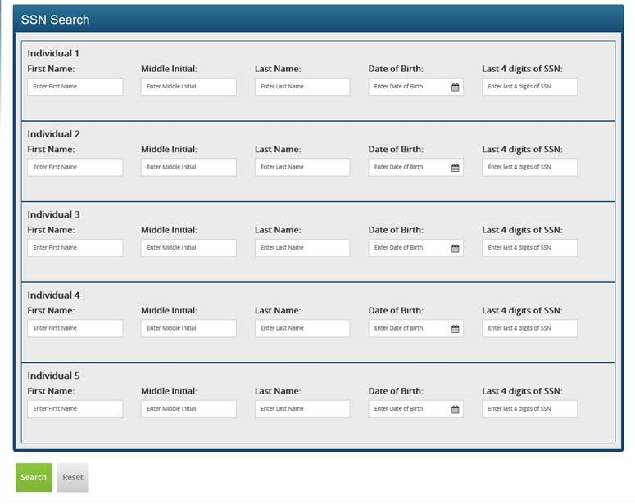

ERAP agencies may use “Yes” results from the COMPASS Benefit Search page to establish categorical income eligibility provided that the applicant has signed an authorization for release of information. A “Yes” indicator for benefits is sufficient verification that the Department of Human Services has established income eligibility at an income limit below the 80 percent area median income after January 1, 2020.