How to View Microsoft Excel Reports
The Low Income reports are provided in Microsoft Excel spreadsheets. To view the reports Microsoft Excel or Excel Viewer is required.

View Reports
The reports are separated into categories;
- Private and Non-Public Schools Percent of Low Income
- Public Schools Percent of Low Income
To view reports select;
- Category
- Year
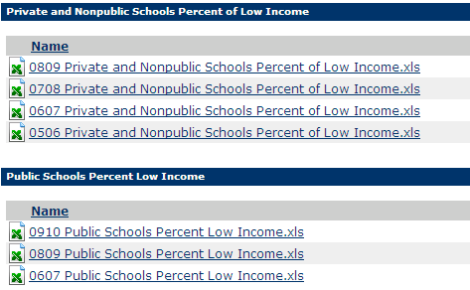
The selected spreadsheet displays. Excel spreadsheets have tabs at the bottom of the page that provide access to different reports, and each tab is labeled with the name of the report.

The Private and Non-Public Schools Percent of Low Income Reports has two tabs;
- Low Income (LI) greater than (>) 30% Schools
- Private and Non-Public School % of Income
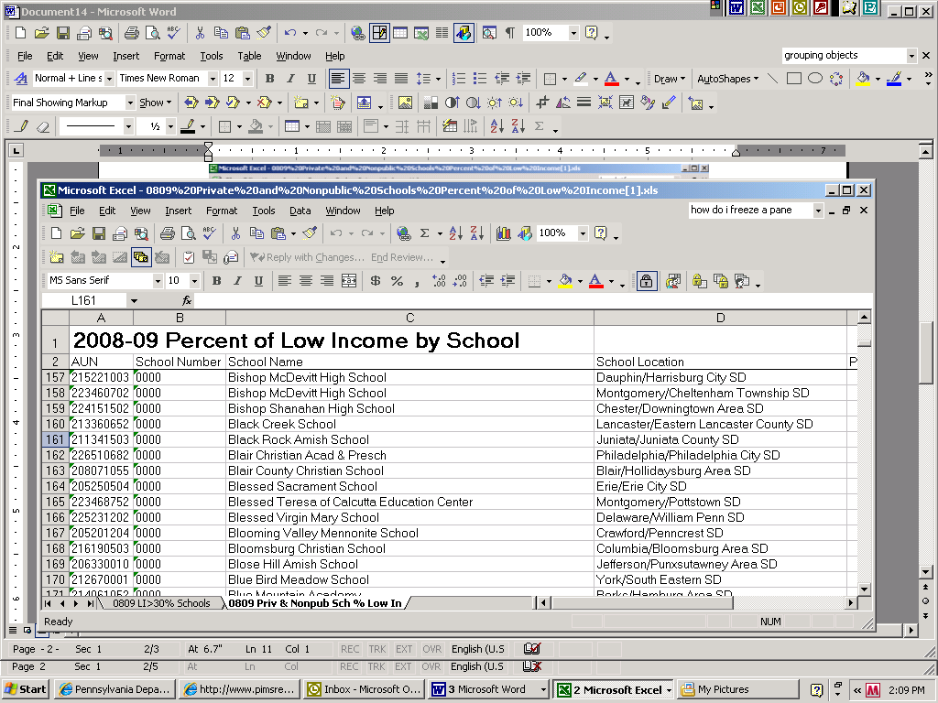
The Public Schools Percent Low Income report has four tabs at the bottom of the report.
- Contact Information and Definitions
- Low Income Percent (LIP) by LEA
- Low Income Percent (LIP) by School
- Low Income (LI) greater than (>) 30% Schools
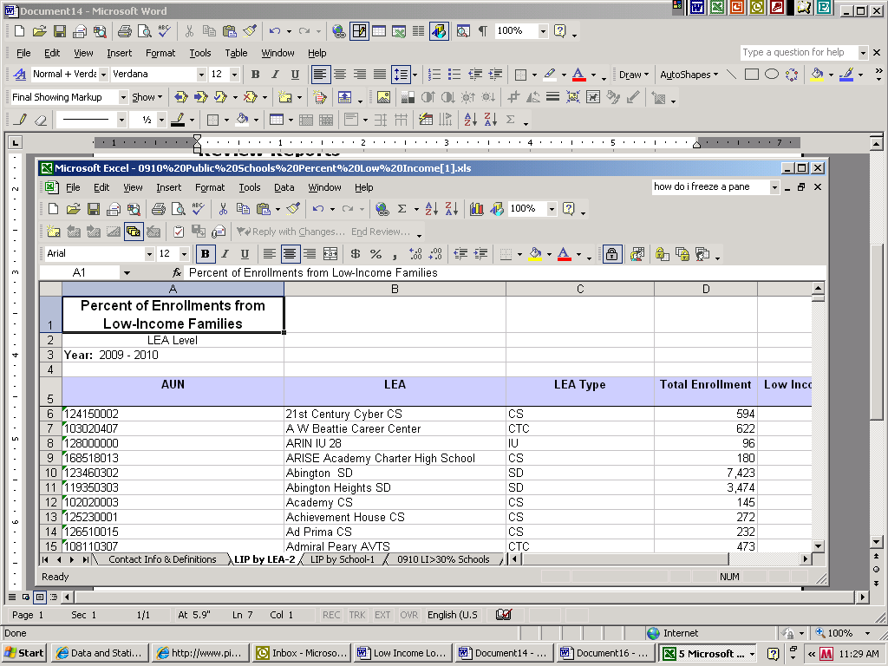
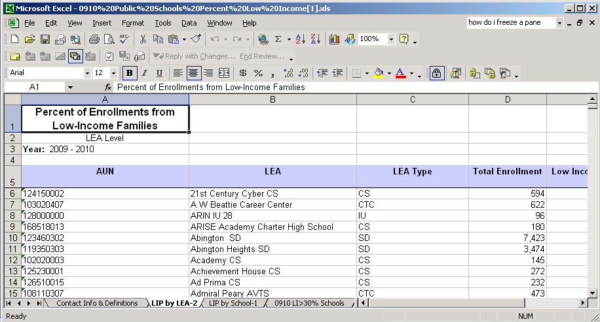
Click on the tab to view the report.

