Type POS Math descriptor here | = |  | Apply geometric concepts to model and solve real world problems
Program Task: Enter task here. |  | PA Core Standard: CC.2.3.HS.A.14  Description: Apply geometric concepts to model and solve real world problems.
Program Associated Vocabulary:  ENTER PROGRAM VOCABULARY HERE |  | Math Associated Vocabulary:  AREA, CROSS SECTION, LENGTH, WIDTH, ROUND, BASE, HEIGHT, RADIUS, RECTANGULAR PRISM
Program Formulas and Procedures:  Display program example of math concept by entering text, graphic, and formulas in this column. |  | Formulas and Procedures:  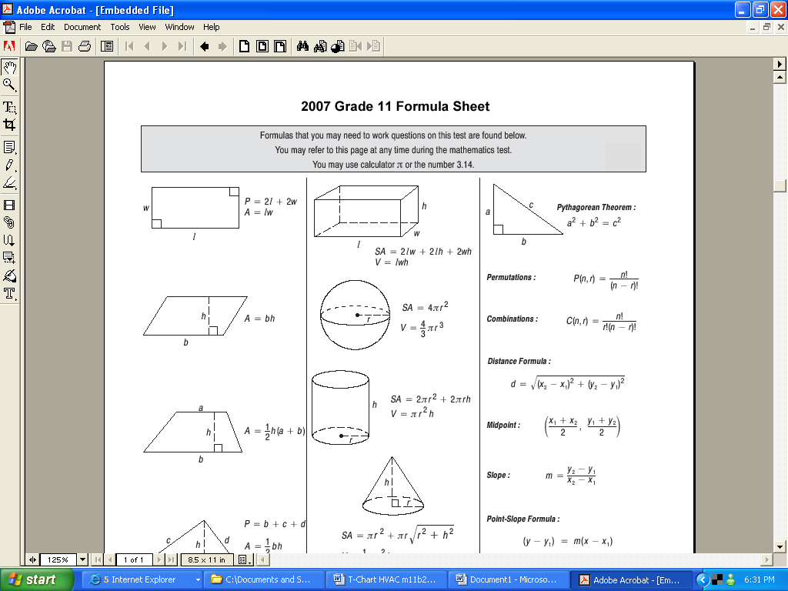  Surface Area:  Cylinder:  SA = 2𝛑r² + 2πrh  Cone:  SA = π r² + πr (r²+h²)  Rectangular Prism:  SA = 2lw + 2wh+ 2hl  Sphere:  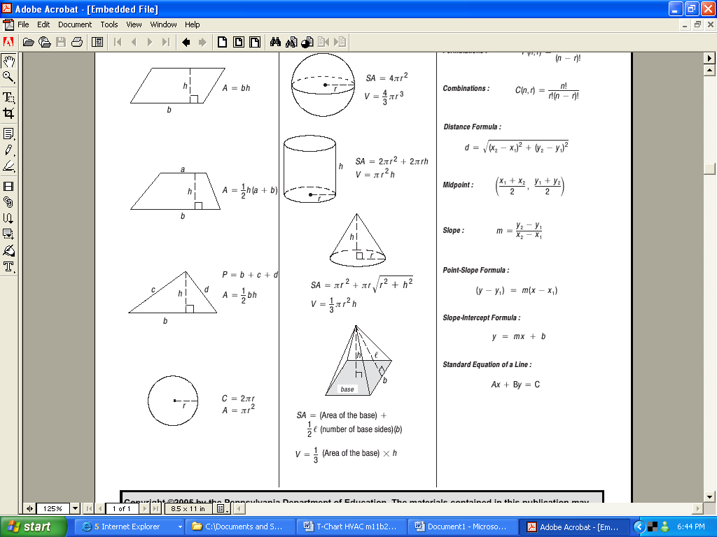  SA = 4πr²  Pyramid:  SA = (area of the base) + ½ l (perimeter of base)  b = base, h = height, l= slant length  Example: Find the surface area of the cylinder below.  r = ½ • 38” = 19” h = 60”  38”  60”  Cylinder SA = 2πr² + 2πrh  SA = 2π(19)² + 2π(19)(60)  SA = 722π + 2,280π  SA = 3,002π  SA ≈ 9,426.28 in

Instructor's Script – Comparing and Contrasting
The Math or program area instructor should fill in this area by comparing academic math problems to lab area problems. The instructor should describe ways that trade math is similar to or different from the academic math that occurs in the PA Core Math standard or on Keystone related exams.

Common Mistakes Made By Students
Using incorrect formula: Students may use an incorrect formula to solve a problem. To rectify these errors have the students correctly identify the type of object they are dealing with and use the appropriate formula. Frequently two formulas may be needed for complex problems.

Using consistent units: If the problem asks for the answer in square feet instead of square inches, be sure to either convert your given measurements into feet first (inches ÷ 12 = feet) or convert your square inch answer into square feet (sq. inches ÷ 144 = sq. feet).

Not “removing” unnecessary surface areas from calculations: Depending on the problem, not all surface areas included in formula may be needed. Identify the areas that are required for the calculation and remove from formula as needed.

CTE Instructor's Extended Discussion
The CTE instructor may add comments here describing the importance of this math skill in relationship to the program task, or note common problems which students have when making the computations.

Problems Career and Technical Math Concepts Solutions
- Program relevant problem | Allow work space here
- Program relevant problem | Allow work space here
- Program relevant problem | Allow work space here
Problems Related, Generic Math Concepts Solutions
- You need fabric to cover a 4 sided pyramid with base sides of 12’ & slant length of 20’. How many square feet of fabric will you need to cover all sides of the pyramid? How many square yards? Note: 1yd² = 9 ft².
- One soup can has a radius = 3” and height = 4”; another soup can has a radius = 4” and height = 3”. Which can has a greater total surface area?
- A size 7 regulation basketball has a d = 9.39”. A size 6 regulation basketball has a d = 9.07”. What is the surface area of each basketball?
Problems PA Core Math Look Solutions
- Find the surface area of a cylinder with a diameter of 13.75’ and a height of 28.45’.
- Find the surface area of a sphere that has a diameter of 27.75”.
- Find the total surface area of a cone with base diameter of 15.50” and a height of 22”.

Problems Career and Technical Math Concepts Solutions
- Program relevant problem | Provide answer here
- Program relevant problem | Provide answer here
- Program relevant problem | Provide answer here
Problems Related, Generic Math Concepts Solutions
- You need fabric to cover a 4 sided pyramid with base sides of 12’ & slant length of 20’. How many square feet of fabric will you need to cover all sides of the pyramid? How many square yards? Note: 1yd² = 9 ft². | Pyramid: SA = (base area) + ½ l (number of base sides)(b)  SA = 144 + ½ (20)(4)(12)  SA = 144 + 480  SA = 624 ft²  SA = 624 ft² ÷ 9 ≈ 69.3 yd².
- One soup can has a radius = 3” and height = 4”; another soup can has a radius = 4” and height = 3”. Which can has a greater total surface area? | Can 1: Can 2: (Greater surface Area)  SA = 2π(3²) + 2π(3)(4) SA = 2π(4²) + 2π(4)(3)  SA ≈ 57 + 75 SA ≈ 101 + 75  SA ≈ 132 in² SA ≈ 176 in²
- A size 7 regulation basketball has a d = 9.39”. A size 6 regulation basketball has a d = 9.07”. What is the surface area of each basketball? | Ball 1: r = 4.695 Ball 2: r = 4.535  SA = 4π(4.695²) SA = 4π(4.535²)  SA = 4π(22.04) SA = 4π(20.57)  SA ≈ 277 in² SA ≈ 259 in²
Problems PA Core Math Look Solutions
- Find the surface area of a cylinder with a diameter of 13.75’ and a height of 28.45’. | Cylinder SA = 2πr² + 2πrh  radius = ½ d = 6.875’  SA = 2π(6.875) ² + 2π(6.875)(28.45)  SA = 94.53125π + 391.1875π  SA = 485.71875π  SA = 1525.9 ft².
- Find the surface area of a sphere that has a diameter of 27.75”. | One Sphere SA = 4πr²  Radius = 27.75/2 = 13.875”  SA = 4π(13.875) ²  SA = 770.0625 π  SA ≈ 2,419.2 in²
- Find the total surface area of a cone with base diameter of 15.50” and a height of 22”. | Cone:  SA = π r² + πr (r²+h²)  SA = π(7.75)² + π(7.75)  SA = 60.0625π + π(7.75)  SA = 60.0625π + π(7.75)  SA = 60.0625π + π(7.75)(23.325)  SA = 60.0625π + π(180.769)  SA = 240.83π  SA ≈ 756.2 in².

