Type in POS Math descriptor here | = | Apply geometric theorems to verify properties of circles
Program Task: Enter POS task here. |  | PA Common Core Standard: CC.2.3.HS.A.8  Description: Apply geometric theorems to verify properties of circles.
Program Associated Vocabulary:  ENTER PROGRAM VOCABULARY HERE |  | Math Associated Vocabulary:  RADIUS, DIAMETER, TANGENT, CIRCLE, CONGRUENT, PERPENDICULAR, POINT OF TANGENCY, EXTERNAL, INTERNAL, CIRCUMFERENCE, AREA, VOLUME
Program Formulas and Procedures:  Display program example of math concept by entering text, graphic, and formulas in this column. |  | Formulas and Procedures:  Area of a Circle: A = π  Circumference of a Circle: C = 2πr  Cylinder: SA = 2π + 2πrh V = πh  Sphere: SA = 4 π V = (4/3) x π x  Cone: SA = π + πr V = 1/3πh  - Two tangents to the same circle from the same external point will be congruent.  - A radius always meets a tangent to the circle at a right angle and at a point that is called the point of tangency.  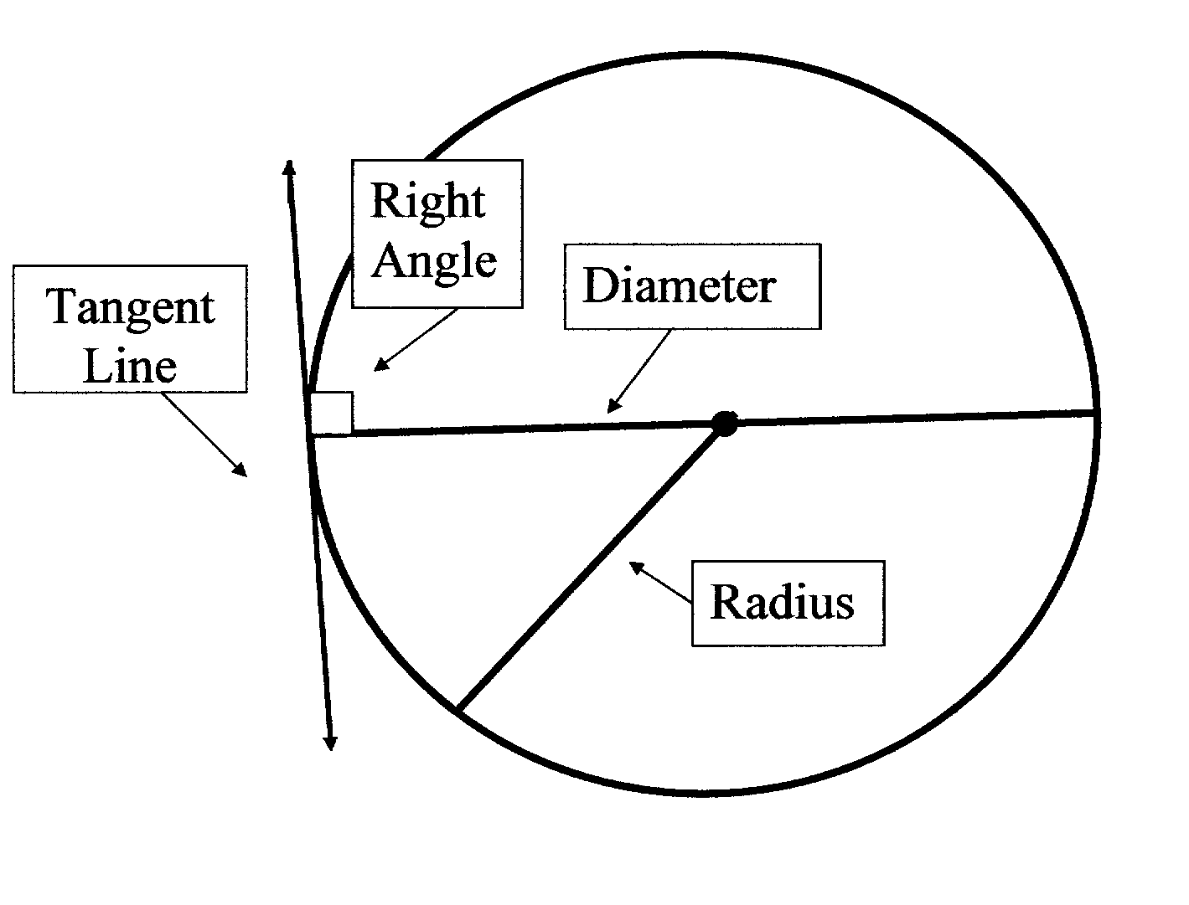  The picture below shows tangent circles with a common interior tangent line.  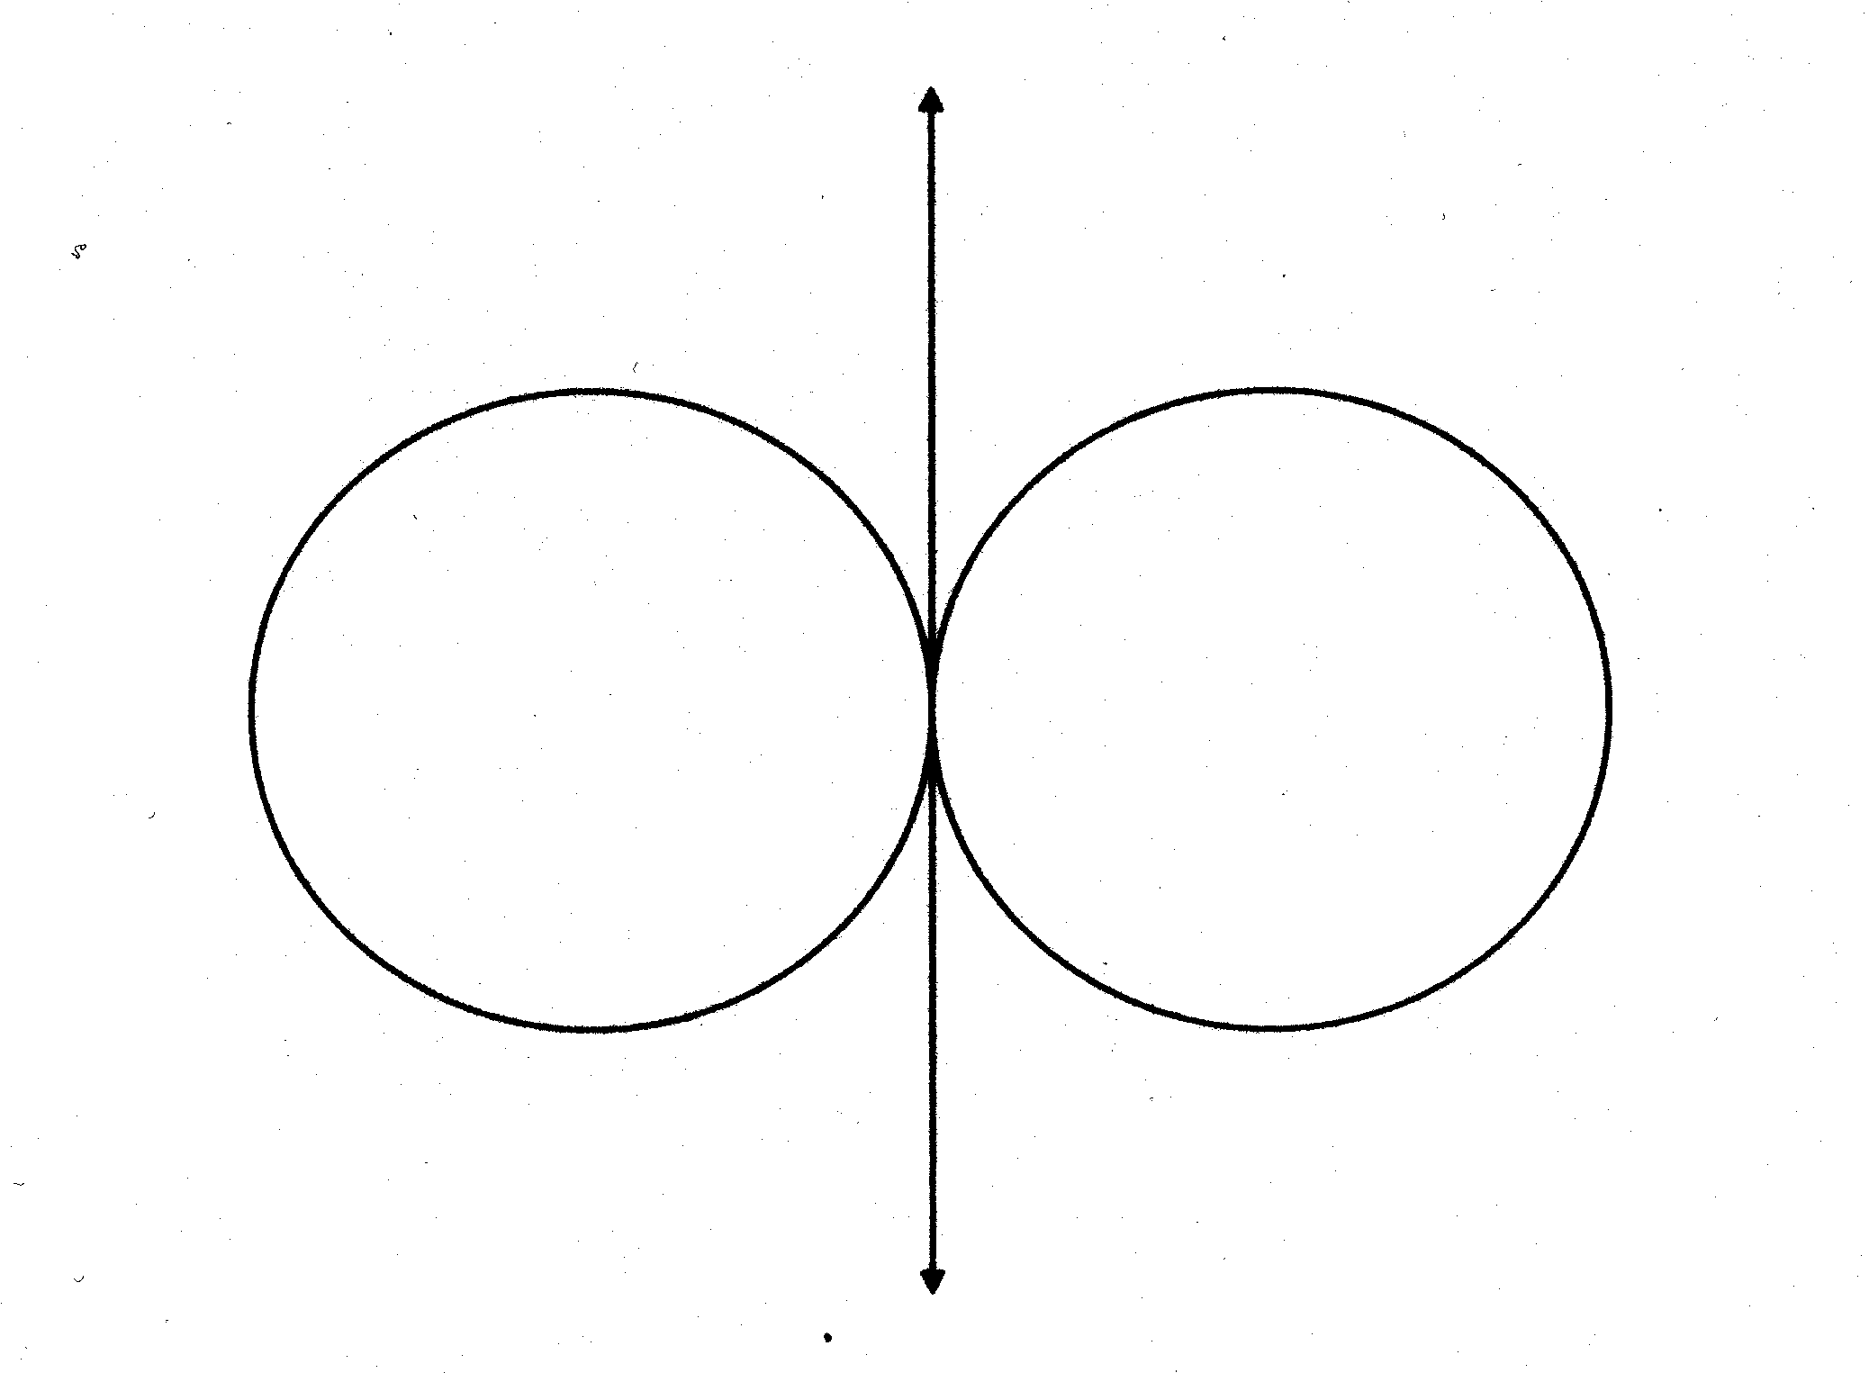

Instructor's Script – Comparing and Contrasting
The Math or program area instructor should fill in this area by comparing academic math problems to lab area problems. The teacher should describe ways that CTE program math is similar to or different from the academic math that occurs in the PA Core Math standard or on Keystone related exams.

Common Mistakes Made By Students
Students do not know the concepts or how to apply them.

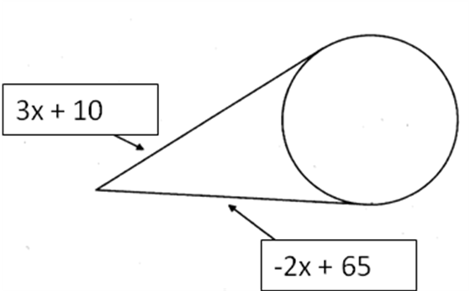
Example: Find the value of x
3x + 10 = -2x + 65 Set up the equation.
3x = -2x + 55 Subtract 10 from each side of the equation.
5x = 55 Add 2x to each side of the equation.
x = 11 Divide by 5.

The value of x is 11.

CTE Instructor's Extended Discussion
The CTE instructor may add comments here describing the importance of this math skill in relationship to the program task, or note common problems which students have when making the computations.

Problems Career and Technical Math Concepts Solutions
- Program relevant problem | Allow work space here
- Program relevant problem | Allow work space here
- Program relevant problem | Allow work space here
Problems Related, Generic Math Concepts Solutions
- What must the radius be of a cylinder whose height is 3” and whose volume is 35 in³ of fluid?
- A family would like to build a fence in their backyard for a riding ring for their horse. How much fence should they buy if the ring covers ½ an acre of land? (1 acre = 4840 yards²)
- A family has 75 feet of fencing to fence in their circular garden. What is the approximate radius of the garden?
Problems PA Core Math Look Solutions
- Find the radius of a circle whose circumference is 20’.
- Find the radius of a circle whose area is 45 in².
- Find the height of a cylinder whose volume is 300 ft³ and whose radius is 6 ft.

Problems Career and Technical Math Concepts Solutions
- Program relevant problem | Allow work space here
- Program relevant problem | Allow work space here
- Program relevant problem | Allow work space here
Problems Related, Generic Math Concepts Solutions
- What must the radius be of a cylinder whose height is 3” and whose volume is 35 in³ of fluid? | r =  The radius of the cylinder must be about 1.93 inches.
- A family would like to build a fence in their backyard for a riding ring for their horse. How much fence should they buy if the ring covers ½ an acre of land? (1 acre = 4840 yards²) | ½ acre = 2420yds.²  2420 = π r = r ≈ 27.75 yds.  C = 2πr C = 2π(27.75) C = 174.36 yds.  They should buy about 175 yards of fencing.
- A family has 75 feet of fencing to fence in their circular garden. What is the approximate radius of the garden? | C = 2πr 75 = 2πr r = r ≈ 11.94 feet  The radius is approximately 11.94feet.
Problems PA Core Math Look Solutions
- Find the radius of a circle whose circumference is 20’. | C = 2πr 20 = 2πr r = r ≈ 3.18 feet
- Find the radius of a circle whose area is 45 in². | A =π 45 = π r = r ≈ 3.78 inches
- Find the height of a cylinder whose volume is 300 ft³ and whose radius is 6 ft. | V = πh 300 = πh 300 = 36πh = h  h ≈ 2.65 feet

