Type in POS Math descriptor here | = |  | Apply the properties of rational and irrational numbers to solve real-world or mathematical problems
Program Task: Enter POS task here |  | PA Core Standard: CC.2.1.HS.F.2  Description: Apply the properties of rational and irrational numbers to solve real-world or mathematical problems.
Program Associated Vocabulary:  ENTER PROGRAM VOCABULARY HERE |  | Math Associated Vocabulary:  IRRATIONAL NUMBER, SQUARE ROOT, PI
Program Formulas and Procedures:  Display program example of math concept by entering text, graphic, and formulas in this column. |  | Formulas and Procedures:  Irrational Number: a non-repeating & non-terminating decimal number that cannot be written as a fraction.  π: The number π is a mathematical constant, commonly approximated as 3.14159.  Square Root: The square root of a number is a number which, when multiplied by itself, yields that original number.  Example 1: Locate the following numbers on a number line.$\sqrt{2},\sqrt{5},π$  General steps:  - Rewrite the number as a decimal to the nearest tenth or hundredth digit.  - Use marks (1/4, 1/2, 3/4,) to approximate the location on the number line.  Example 2: Identify $\sqrt{2}$on the number line below:  .  $\sqrt{2}$=1.41421356237…. ≈ 1.41  1.41 is between 1.25 and 1.5, but closer to 1.5.  -2 -1 0 1 2

Instructor's Script – Comparing and Contrasting
The Math or program area instructor should fill in this area by comparing academic math problems to lab area problems. The teacher should describe ways that CTE program math is similar to or different from the academic math that occurs in the PA Core Math standard or on Keystone related exams.

Common Mistakes Made By Students
Taking the square root of a number: This mostly occurs when the student is unfamiliar with a calculator. Some calculators require the student to press the number then the square root button; others require that the square root button is pressed before the number. It may be important to show students to take the square root of 4, using both methods to evaluate which order gives the correct answer of 2.

Using the appropriate rounding technique for the given situation: In most cases, it is beneficial to round the number to the nearest hundredth. If the number line is broken into quarters, thirds, or tenths, then rounding the number to the closest hundredth would provide the information necessary to correctly identify the number’s location.

Being able to partition a number line and identify the location of the decimal number: Sometimes the number line uses integer values only (…,-2, -1, 0, 1, 2, 3…). In this case, the student must be able to mentally divide the space between the integers into quarters or thirds to best approximate the location of the irrational number.

CTE Instructor's Extended Discussion
The CTE instructor may add comments here describing the importance of this math skill in relationship to the program task, or note common problems which students have when making the computations

Problems Career and Technical Math Concepts Solutions
- Program relevant problem | Allow work space here
- Program relevant problem | Allow work space here
- Program relevant problem | Allow work space here
Problems Related, Generic Math Concepts Solutions
- The location of $\sqrt{8}$is closest to which point on the number line below?
a b c d e
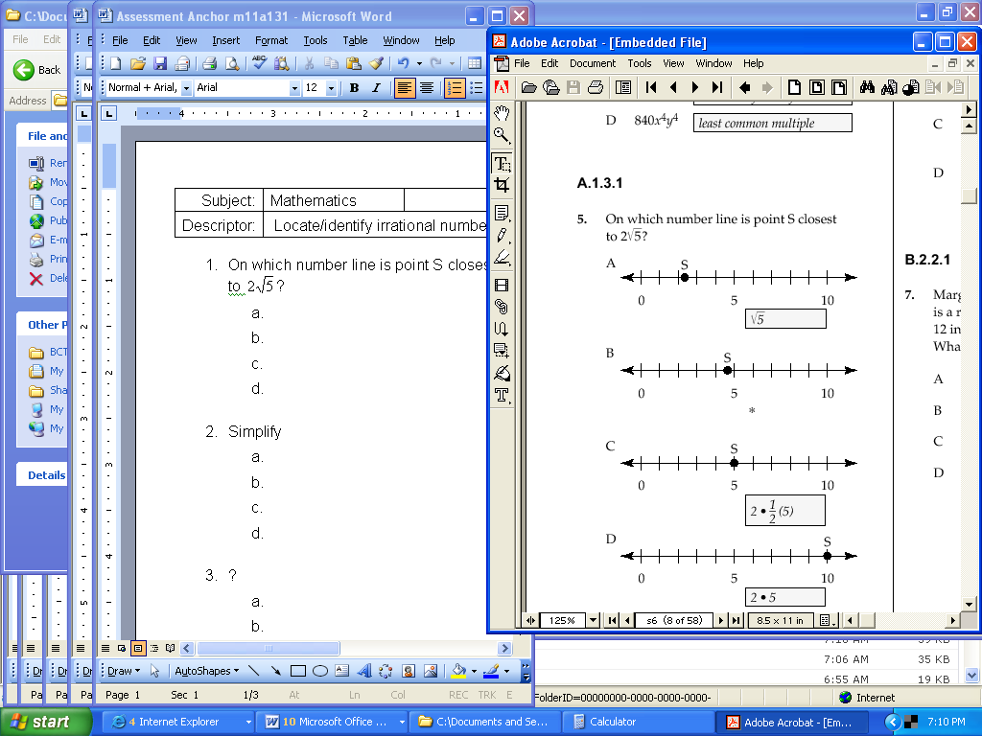
-1 0 1 2 3 4
- What can’t the square root of π be a rational number?
- Using the Pythagorean Theorem, a student finds that she needs$\sqrt{7}$inches of material. Identify the location of this measurement on the measuring tape below.
2
3

Problems PA Core Math Look Solutions
- Which of the following numbers would be located between 9 and 10 on the number line?
a) 2π
b) 3π
c) 2
d) 5
- The location of $\sqrt{\text{13}}$is closest to which point on the number line below?
a b c d e
0 1 2 3 4 5
- Which of the following would be closest to the value of$\sqrt{8}$?
a) 2 ¾
b) 3 ¼
c) 4
d) 2 ½

Problems Career and Technical Math Concepts Solutions
- Program relevant problem | Allow work space here
- Program relevant problem | Allow work space here
- Program relevant problem | Allow work space here
Problems Related, Generic Math Concepts Solutions
- The location of $\sqrt{8}$is closest to which point on the number line below?  a b c d e  -1 0 1 2 3 4 | d. $\sqrt{8}$ = 2.828
- What can’t the square root of π be a rational number? | Because π is an irrational number, and any rational number squared would produce a rational number.
- Using the Pythagorean Theorem, a student finds that she needs$\sqrt{7}$inches of material. Identify the location of this measurement on the measuring tape below.  2  3 | Since $\sqrt{7}$=2.645751…., we round to 2.65 inches.  ,  2  3
Problems PA Core Math Look Solutions
- Which of the following numbers would be located between 9 and 10 on the number line?  a) 2π  b) 3π  c) 2  d) 5 | b) 3π
- The location of $\sqrt{\text{13}}$is closest to which point on the number line below?  a b c d e  0 1 2 3 4 5 | d) $\sqrt{\text{13}}$≈3.61
- Which of the following would be closest to the value of$\sqrt{8}$?  a) 2 ¾  b) 3 ¼  c) 4  d) 2 ½ | a) 2 ¾  If you convert 2 ¾ to its decimal format 2.75, and 2 ½ to its decimal format 2.5, then you find that answer a is the closest value to the$\sqrt{8}$.

