Type in Program Math descriptor here | = |  | Summarize, represent, and interpret data on two categorical and quantitative variables
Program Task: Enter program task here. |  | PA Core Standard: CC.2.4.HS.B.2  Description: Summarize, represent, and interpret data on two categorical and quantitative variables.
Program Associated Vocabulary:  ENTER PROGRAM VOCABULARY HERE |  | Math Associated Vocabulary:  CIRCLE, LINE GRAPH, BAR GRAPH
Program Formulas and Procedures:  Display program example of math concept by entering text, graphic, and formulas in this column. |  | Formulas and Procedures:  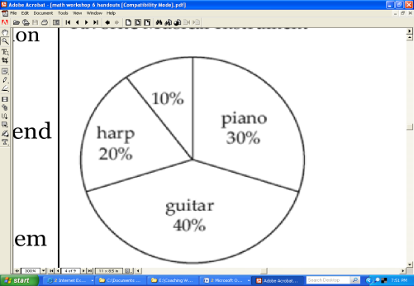  Predictions can be made from information presented in graphs by estimating or calculating. Common types of graphs include circle (pie) graphs, line graphs, and bar graphs. The process for making predictions depends upon the type of graph. A circle graph requires an understanding of percentages. Bar graphs are used to compare amounts. Line graphs are used to show trends.  Making Predictions: Circle Graphs  If 170 students selected the piano as their favorite musical instrument, approximately how many students were surveyed?  - Read and comprehend the graph.  30%, or 170 of the total students surveyed chose the piano  - Translate the problem into an algebraic expression.  30% of the students is 170.  0.30(s) = 170  - Solve for the unknown variable.  $$0.30s=170→\frac{0.30s}{0.30 }=\frac{170}{0.30}→s=566.\overline{66}$$  Approximately 567 students were surveyed.  Bar Graphs:  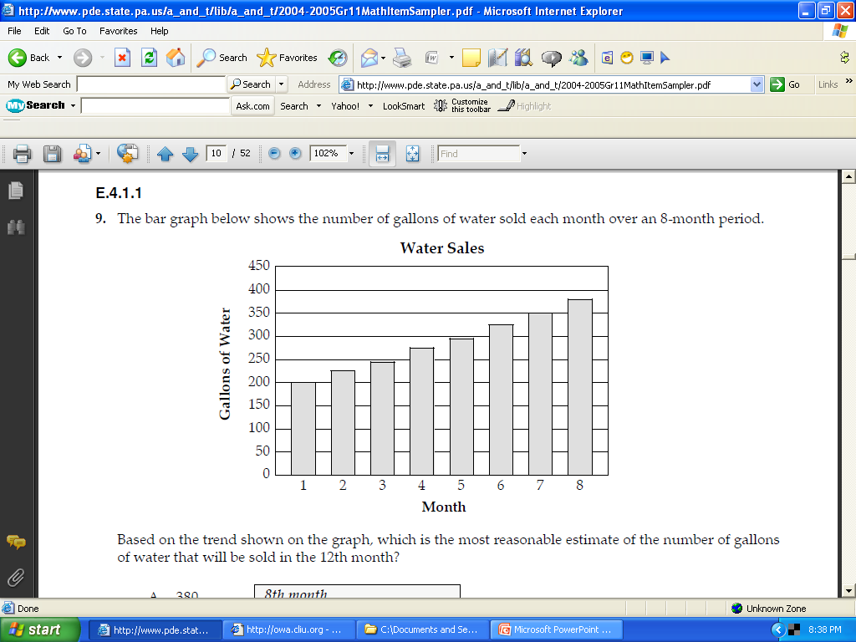  By what percentage did water sales increase between the first and eighth months?  - Read and comprehend the graph.  The graph shows the number of gallons of water sold each month over an 8 month period.  - Determine the amount of change.  Month 1 = 200 gallons, Month 8 ≈ 375 gallons  375-200 = 175  - Calculate percentage of increase.  175/200 = .875 or 87.5%

Instructor's Script - Comparing and Contrasting
In some text books, the information is frequently presented in a table, rather than a circle graph. Making predictions using circle graphs relies heavily on the ability to perform calculations with percentages.
To increase the rigor of the problem, a teacher may omit the percentage for one of the categories or select from a variety of question stems.
Omit the percentage for one of the categories
- Because the percentage is omitted, students must recognize that a circle graph depicts part of a whole and all of the percentages must add up to 100%.
Select from a variety of question stems
- What amount is allocated for (name of category)?
- How many (subject of the graph) selected or are allocated for ___ and ___? (combine two categories)
- If the total (subject of graph) was unknown, but category ___ was (value), what would be the total?
- If category ___ increased from ___% to ___%, what would be the increase of (subject of graph)?

Common Mistakes Made By Students
Incorrectly converting percents to decimals:
Many of the mistakes students make when converting percentages to decimals involve one or 3 digit numbers. For instance, students mistakenly write 6% as 0.6 instead of 0.06 or they write 125% as 0.125 instead of 1.25.
Incorrect computation with percentages: Write an algebraic expression from the information provided. Use key words to determine the appropriate operation. For instance, “of” means “x”; “is” means “=.” Students who do not write algebraic expressions have a tendency to divide when they should multiply and vice versa.

CTE Instructor’s Extended Discussion
The CTE instructor may add comments here describing the importance of this math skill in relationship to the program task, or note common problems which students have when making the computations.

Problems Occupational (Contextual) Math Concepts Solutions
- Program relevant problem | Allow work space here
- Program relevant problem | Allow work space here
- Program relevant problem | Allow work space here
Problems Related, Generic Math Concepts Solutions
- If there are 2,825 teenagers enrolled in your school, about how many would you expect to be employed in retail? | 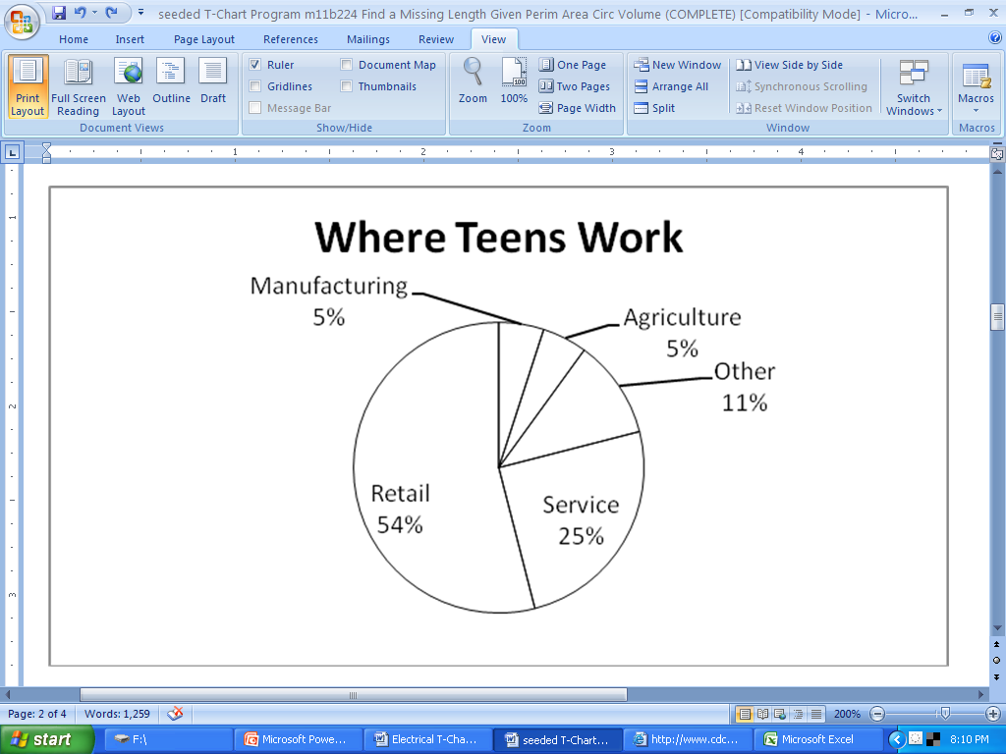  Where Teens Work
- If approximately 25,000 teenagers work in the service industry, about how many working teenagers are there?
- If there are 2,825 teenagers enrolled in your school, about how many teenagers work in manufacturing or agriculture?
Problems PA Core Math Look Solutions
- The total amount of expenditures of the company is how many times that spent on taxes?

- If $250,000 is spent on advertising, then what is the difference in expenditure between taxes and transport?

- If the loan interest is $275,000 then what is the total amount of expenditure on advertisement, taxes, and research and development?

Problems Occupational (Contextual) Math Concepts Solutions
- Program relevant problem | Provide answer here
- Program relevant problem | Provide answer here
- Program relevant problem | Provide answer here
Problems Related, Generic Math Concepts Solutions
- If there are 2,825 teenagers enrolled in your school, about how many would you expect to be employed in retail? | 54% of 2,825 is the number employed in retail.  0.54(2,825) = x 1,525.5 or 1,526 students
- If approximately 25,000 teenagers work in the service industry, about how many working teenagers are there? | 25,000 is 25% of the number of working teenagers  25,000 = 0.25x $\frac{25,000}{0.25}=\frac{0.25x}{0.25}$  x = 100,000 working teens
- If there are 2,825 teenagers enrolled in your school, about how many teenagers work in manufacturing or agriculture? | Manufacturing = 5%, agriculture = 5%  10% of 2,825 is the number of teens who work in manufacturing or agriculture  0.10(2,825) = 282.5 or 283 students
Problems PA Core Math Look Solutions
- The total amount of expenditures of the company is how many times that spent on taxes? | Taxes =20%.  5 × 20% = 100% (total expenditures)  Total expenditures are 5 times the amount of taxes.
- If $250,000 is spent on advertising, then what is the difference in expenditure between taxes and transport? | Advertising = 10% = $250,000  Taxes (20%) – Transport (15%) = 5% , which would be half of $250,000  $125,000 is the difference between taxes and transport.
- If the loan interest is $275,000, then what is the total amount of expenditure on advertisement, taxes, and research and development? | Loan interest = 5% = $275,000.  Advertising = 10%, taxes = 20%, and R & D = 5%  $550,000 + $1,100,000 + $275,000 = $1, 925,000  $1,9250,000

