Type in Program Math descriptor here | = |  | Verify and apply theorems involving similarity as they relate to plane figures
Program Task: Enter POS task here. |  | PA Core Standard: CC.2.3.HS.A.3  Description: Verify and apply theorems involving similarity as they relate to plane figures.
Program Associated Vocabulary:  ENTER PROGRAM VOCABULARY HERE |  | Math Associated Vocabulary:  CONGRUENT, SIMILAR, EQUILATERAL, ISOSCELES, SCALENE, RIGHT, OBTUSE, ACUTE
Program Formulas and Procedures:  Display program example of math concept by entering text, graphic, and formulas in this column. |  | Formulas and Procedures:  - Procedures for proving triangles congruent:  SSS (side-side-side), SAS (side-angle-side), ASA (angle-side-angle), AAS (angle-angle-side), HL (hypotenuse-leg)  - Procedures for proving triangles similar:  Angle-Angle Similarity (AA) Side-Angle-Side Similarity (SAS) Side-Side-Side Similarity (SSS)  The Triangle Inequality Theorem:  The sum of the lengths of any two sides of a triangle is greater than the length of the third side. The sum of the angles of a triangle is 180º.  A  D  Example:  B  C  E  F  A  B  C  O  A  B  C  O  A  B  C  O  A  B  C  O  A  B  C  O  What are the congruent parts?  CONGRUENT SIDES  CONGRUENT ANGLES

Instructor's Script – Comparing and Contrasting
The Math or program area instructor should fill in this area by comparing academic math problems to lab area problems. The instructor should describe ways that career and technical program math is similar to or different from the academic math that occurs in the PA Core Math standard or on Keystone related exams.

Common Mistakes Made By Students
- Lack of familiarity with the concept and understanding of the vocabulary associated with the concept.
- Setting up the proportion incorrectly.
- Confusing the properties of congruent triangles with the properties of similar triangles.
A

Example:
D
2x - 3
Find the length of AC.
1x + 1
E
F
Since the triangles are similar the ratio of the corresponding sides is proportional.
B
C
7
13

Using x = 34, you can substitute to find the length of AC.
AC = 2x – 3
2(34) – 3 = 65
AC would be 65 units.

CTE Instructor’s Extended Discussion
The CTE instructor may add comments here describing the importance of this math skill in relationship to the program task, or note common problems which students have when making the computations.

Problems Career and Technical Math Concepts Solutions
- Program relevant problem | Allow work space here
- Program relevant problem | Allow work space here
- Program relevant problem | Allow work space here
Problems Related, Generic Math Concepts Solutions
- Name all congruent parts.
- Which of the following side lengths can NOT make a triangle?
a) 3, 4, 4
b) 2, 4, 5
c) 3, 7, 9
d) 10, 14, 2
- If an isosceles triangle has a vertex angle that is 3 times the measure of the base angles, what are the angles of the triangle?
Problems PA Core Math Look Solutions
- What value of x would make the triangles congruent?
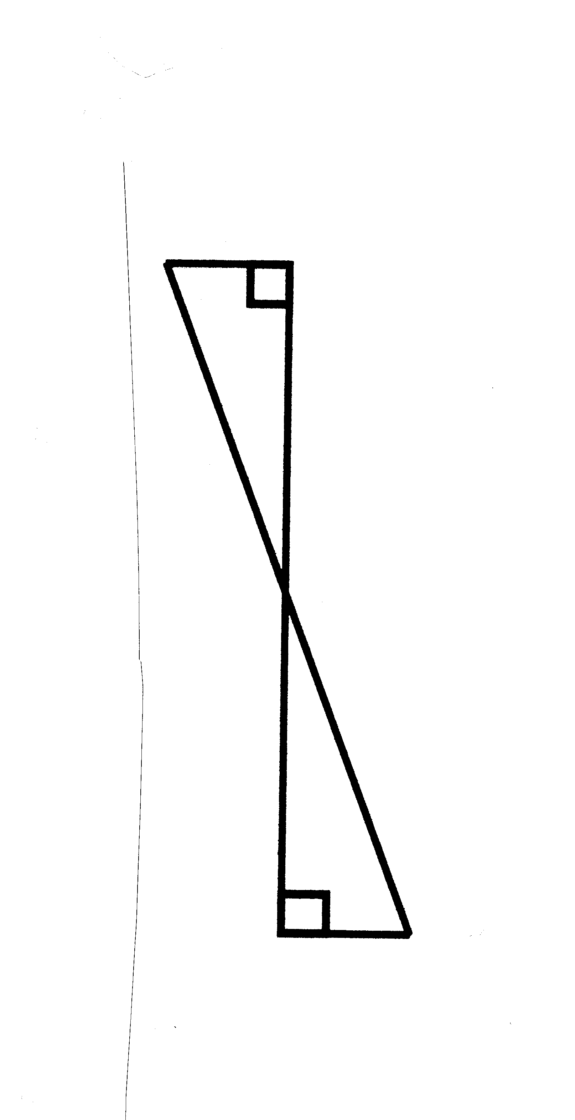
2x - 2
x + 5
x + 5
- What congruence theorem could you use to prove the triangles congruent?
- What is the length of the congruent sides for which measurements are shown?

Problems Career and Technical Math Concepts Solutions
- Program relevant problem | Allow work space here
- Program relevant problem | Allow work space here
- Program relevant problem | Allow work space here
Problems Related, Generic Math Concepts Solutions
- Name all congruent parts.
- Which of the following side lengths can NOT make a triangle?  a) 3, 4, 4  b) 2, 4, 5  c) 3, 7, 9  d) 10, 14, 2 | d) 10 + 2 is not greater than 14, so this can NOT make a triangle.
- If an isosceles triangle has a vertex angle that is 3 times the measure of the base angles, what are the angles of the triangle? | 3x + x + x = 180º5x = 180ºx = 36º  3x = 3(36) 3x = 108º  The vertex angle is 108º, and the base angles are 36º each.
Problems PA Core Math Look Solutions
- What value of x would make the triangles congruent?  2x - 2  x + 5  x + 5 | 2x - 2 = x + 5  The sides would need to be equal in length for the triangles to be congruent.  x – 2 = 5  2x - 2  2x - 2  2x - 2  2x - 2  Subtract x from each side of the equation.  Add 2 to each side of the equation.  x = 7
- What congruence theorem could you use to prove the triangles congruent? | You would use the AAS (angle-angle-side) congruence postulate.
- What is the length of the given congruent sides, for which measurements are shown? | x + 5 = 7 + 5 x = 12  2x – 2 = 2(7) - 2 x = 12

