<LEA NAME AND LOGO>

**LIEP Evaluation and Improvement Plan**

<SCHOOL YEAR>

Contents

Overview 3

Possible pathways through this process (*not exhaustive*) 3

LIEP improvement planning team 4

Summary of program review and improvement activities 5

Area 1: Instruction 5

Area 2: Program 6

Area 3: Procedures 7

Area 4: Climate 8

Area 5: Family Engagement 9

Area 6: Resourcing 10

Area 7: Outcomes 11

Goals 11

Goal 1 11

Goal 2 12

Goal 3 12

Goal 4 13

# Overview

This document is meant to assist in the process of program evaluation and improvement planning. It should be used with the *Consideration for Program Review* document, which can be found under *Program Evaluation Tools* on the [LIEP page of the EL website](https://www.education.pa.gov/Teachers%20-%20Administrators/Curriculum/English%20As%20A%20Second%20Language/Pages/ELDProgram.aspx).

There are two major sections –

1. A summary of the review that contains actions item aimed at improving the LIEP, and
2. measurable goals to determine if program improvement efforts are effective.

This is an iterative process. Teams can complete these two sections in whatever order makes the most sense. For example, goals can be established based on a review of data and/or a review of the program design, and then action items can be determined based on the goals, or the review summary and action items can be completed and then goals can be established and linked to action items. In either case, once complete, the entire plan should be reviewed to ensure consistency and coherence.

## Possible pathways through this process (*not exhaustive*)

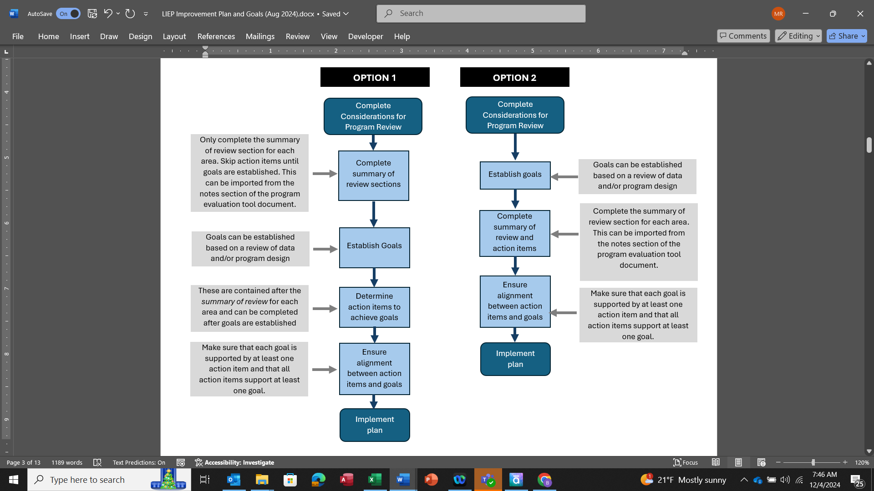

# LIEP improvement planning team

The team should consist of ESL staff, content teachers who work with ELs, family members, building and/or central administrators, guidance counselors, special education staff working with ELs, and any other staff working with ELs.

|  |  |
| --- | --- |
| **Name** | **Role** |
|  |  |
|  |  |
|  |  |
|  |  |
|  |  |
|  |  |
|  |  |
|  |  |
|  |  |

# Summary of program review and improvement activities

For each section, summarize the findings of the program review. This can be imported from the notes section of the program evaluation tool document. Note any areas of concern or strength. If changes are to be made, list them in the appropriate sections. Any improvements or changes should be linked to a measurable goal defined in *Area 7: Outcomes*. For example, if the LEA decides to add an ESL teacher to the staff at an elementary school because it found that the resourcing at that school was inadequate, then the additional teacher might be linked to an expected improvement in ELP growth (defined by the LEA in Area 7) for ELs in that building.

|  |  |
| --- | --- |
| Area 1: Instruction | |
| Summary of review |  |

|  |
| --- |
| ACTION ITEMS - Improvements/changes to be made based on review findings |
|  |

|  |
| --- |
| What resources will be needed to implement improvements/changes? |
|  |

|  |
| --- |
| Timeline for implementation of improvements/changes |
|  |

|  |
| --- |
| To which measurable goal is this effort linked? (see area 7: Outcomes) |
|  |

*\* Any changes to the program should be linked to a measurable goal outlined in Area 7: Outcomes.*

|  |  |
| --- | --- |
| Area 2: Program | |
| Summary of review |  |

|  |
| --- |
| ACTION ITEMS - Improvements/changes to be made based on review findings |
|  |

|  |
| --- |
| What resources will be needed to implement improvements/changes? |
|  |

|  |
| --- |
| Timeline for implementation of improvements/changes |
|  |

|  |
| --- |
| To which measurable goal is this effort linked? (see area 7: Outcomes) |
|  |

*\* Any changes to the program should be linked to a measurable goal outlined in Area 7: Outcomes.*

|  |  |
| --- | --- |
| Area 3: Procedures | |
| Summary of review |  |

|  |
| --- |
| ACTION ITEMS - Improvements/changes to be made based on review findings |
|  |

|  |
| --- |
| What resources will be needed to implement improvements/changes? |
|  |

|  |
| --- |
| Timeline for implementation of improvements/changes |
|  |

|  |
| --- |
| To which measurable goal is this effort linked? (see area 7: Outcomes) |
|  |

*\* Any changes to the program should be linked to a measurable goal outlined in Area 7: Outcomes.*

|  |  |
| --- | --- |
| Area 4: Climate | |
| Summary of review |  |

|  |
| --- |
| ACTION ITEMS - Improvements/changes to be made based on review findings |
|  |

|  |
| --- |
| What resources will be needed to implement improvements/changes? |
|  |

|  |
| --- |
| Timeline for implementation of improvements/changes |
|  |

|  |
| --- |
| To which measurable goal is this effort linked? (see area 7: Outcomes) |
|  |

*\* Any changes to the program should be linked to a measurable goal outlined in Area 7: Outcomes.*

|  |  |
| --- | --- |
| Area 5: Family Engagement | |
| Summary of review |  |

|  |
| --- |
| ACTION ITEMS - Improvements/changes to be made based on review findings |
|  |

|  |
| --- |
| What resources will be needed to implement improvements/changes? |
|  |

|  |
| --- |
| Timeline for implementation of improvements/changes |
|  |

|  |
| --- |
| To which measurable goal is this effort linked? (see area 7: Outcomes) |
|  |

*\* Any changes to the program should be linked to a measurable goal outlined in Area 7: Outcomes.*

|  |  |
| --- | --- |
| Area 6: Resourcing | |
| Summary of review |  |

|  |
| --- |
| ACTION ITEMS - Improvements/changes to be made based on review findings |
|  |

|  |
| --- |
| What resources will be needed to implement improvements/changes? |
|  |

|  |
| --- |
| Timeline for implementation of improvements/changes |
|  |

|  |
| --- |
| To which measurable goal is this effort linked? (see area 7: Outcomes) |
|  |

*\* Any changes to the program should be linked to a measurable goal outlined in Area 7: Outcomes.*

|  |  |
| --- | --- |
| Area 7: Outcomes | |
| Summary of review |  |

# Goals

Based on the review of outcomes summarized above, list the goals for improvement. Each goal should be measurable and be bound within a defined timeline. Goals should also be based only on outcomes. Action items aimed at achieving the goals should be defined in the previous areas. For example, if one of the goals is to improve oral language growth from year to year for elementary ELs from an average of 20 scale score points to 25 scale score points over the next two years, then there should be a program change or improvement action listed in one of the areas above that is aimed at achieving this. Several improvements or changes may be linked to a single goal (e.g. making changes to staffing as well as updating the ELD curriculum may be linked to a single goal of improving overall growth from year to year).

|  |  |
| --- | --- |
| Goal 1 |  |

|  |  |
| --- | --- |
| Timeline |  |

|  |  |
| --- | --- |
| Measures |  |

|  |
| --- |
| Action items that support this goal - which areas listed above relate to this goal? |
|  |

|  |  |
| --- | --- |
| Goal 2 |  |

|  |  |
| --- | --- |
| Timeline |  |

|  |  |
| --- | --- |
| Measures |  |

|  |
| --- |
| Action items that support this goal - which areas listed above relate to this goal? |
|  |

|  |  |
| --- | --- |
| Goal 3 |  |

|  |  |
| --- | --- |
| Timeline |  |

|  |  |
| --- | --- |
| Measures |  |

|  |
| --- |
| Action items that support this goal - which areas listed above relate to this goal? |
|  |

|  |  |
| --- | --- |
| Goal 4 |  |

|  |  |
| --- | --- |
| Timeline |  |

|  |  |
| --- | --- |
| Measures |  |

|  |
| --- |
| Action items that support this goal - which areas listed above relate to this goal? |
|  |