FAFSA Go! Social Posts Toolkit

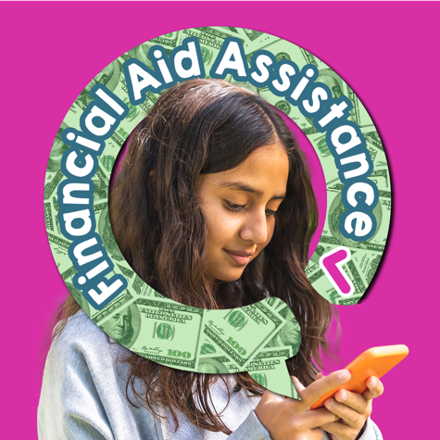 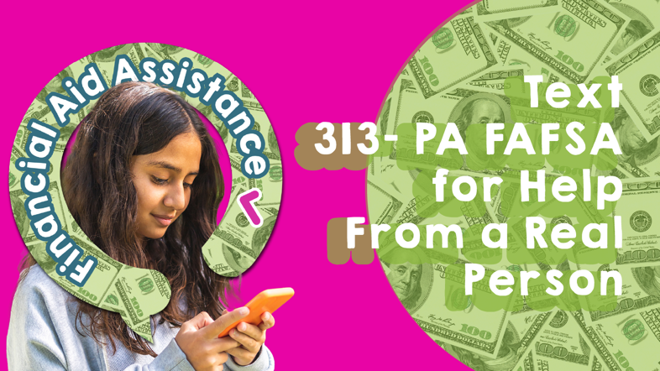

FAFSA is a free application for financial aid, and now there’s free assistance just a text away all summer for PA students + families! Text 313-PA FAFSA (723-2372) to get free, expert + personalized advice from a real person.

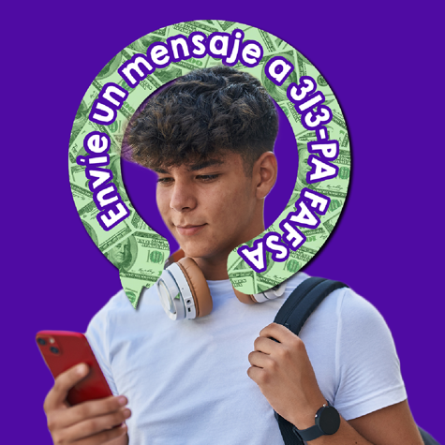 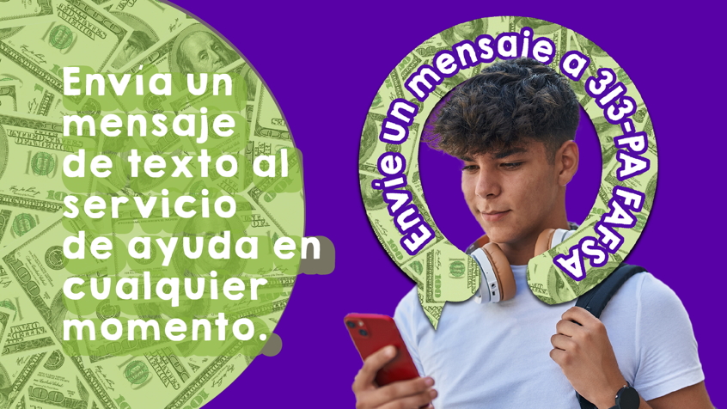

¿Se acabó de graduarse o está pensando asistir a la universidad en el otoño? Acceso gratuito e ilimitado a los consejos de la ayuda financiera está solamente un mensaje de distancia. ¡Envíe un mensaje a 313-PA FAFSA hoy!

 

We're here to help, wherever you are, whenever you want. Live FAFSA advisors are standing by and will respond within 24 business hours to provide personalized support as you complete your 2024-25 FAFSA form. Text 313-PA FAFSA (723-2372)

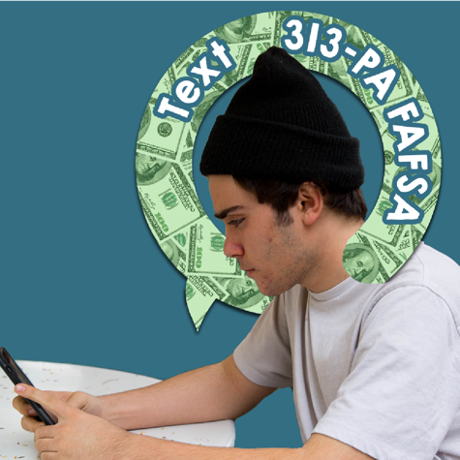 

Just graduated high school or planning to attend college in the fall? PA FAFSA summer helpline is now open! Get free, unlimited access to expert financial aid advice when you text 313-PA FAFSA (723-2372)

 

The PA FAFSA summer helpline is LIVE. FAFSA advisors are standing by and ready for even the most complicated circumstances. Text 313-PA FAFSA (723-2372) today!