Dear Applicant:

Thank you for your interest in becoming a Pennsylvania Fishing License Issuing Agent. Enclosed with this letter you will find the following:

- Application for Fishing License Issuing Agency (must provide an email address)
- Fishing License Issuing Agent Agreement
- Licensing Issuing Agent Equipment Selection form
- The Commission has implemented the Pennsylvania Automated License Service. PALS has replaced the manual process of issuing fishing licenses. This new system requires issuing agents to use an automated Point of Sale (POS) system for the sale and printing of fishing licenses. The Commission will provide one set of Web-Based PC equipment for you to accompany your PC. You must provide a PC that meets the standards as stated in the Equipment Selection form.
- Fish Issuing Agent Bond; Surety Bond for a minimum of $6,000 is required, properly signed and notarized along with the Power of Attorney

The new Agent Handbook for Issuing Pennsylvania Fishing Licenses and Permits is located at www.fishandboat.com/images/admin/lars/agents/agent_handbook_fish.pdf for your review prior to signing the above documents. Upon completion, the application, agent agreement, equipment selection form, bond document(s) and application fee should be submitted to the address provided above. The application fee is a $250.00 nonrefundable remittance payable to PFBC.

The following criteria will be used to evaluate applicants:
  - Number of agents and their locations in relation to the population of the area.
  - Geographic location.
  - Nature of your business - Fishing licenses are generally sold in stores that also sell fishing equipment.
  - Business hours – Your business should have weekend and/or evening hours
  - Public access – Available parking, accessible location, etc.
  - Representation of the Commission – Appearance of facilities, providing the public with full fishing license service throughout the license sales period, etc.
  - Accuracy of your business registration information on file with the Pennsylvania Department of State, Bureau of Corporations and Charitable Organizations at https://www.corporations.pa.gov/

Upon receipt, your application materials will be thoroughly reviewed, and you will be notified in writing regarding the results. This process may take eight to ten weeks from the time all completed documents have been received, so please allow adequate time if applying for the upcoming Trout Season. If you have any questions, please call 877-707-4085.

Sincerely,
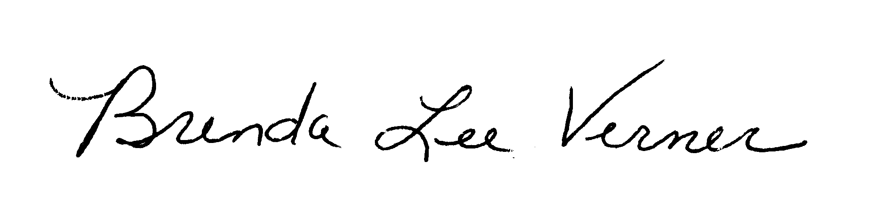

Brenda Lee Verner, Division Chief
Division of Licensing & Registration
Enclosures

