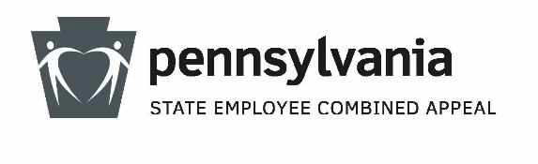

SECA 2024
Sample Communication from Agency Leader(s)

September 2024

Dear [Agency Name] employees:
Often, even a small group of people committed to a common cause can accomplish great things. Just imagine what thousands of commonwealth employees can accomplish when we come together for this year’s State Employee Combined Appeal (SECA) theme of “Chip In To Make A Difference!”

Since SECA began in the 1970’s, employees have raised more than $150 million. Many of your colleagues give each year because SECA allows them to easily donate to the causes most important to them.

Personally, SECA is important to me because [insert personal comments about why charitable giving is important to you, the agency head.]

This year, our agency is striving to meet our goals of $[XXX] and [XX] donors. Employees can elect a recurring or one-time deduction from your pay, or you can donate using a check or money order.

To contribute, just visit ESS or use a paper pledge form to designate your amount and charities. Take your donation a step further by dedicating it to someone special.

Employees who give just an hour or half-hour of pay per month are recognized as Governor’s Circle and Gold Givers. ESS will calculate your minimum leadership giving amount, and you can also read more about leadership giving.

If you have questions about SECA, please contact our agency SECA coordinator, [insert name] at [insert phone] or [insert email]. Additionally, look for more information soon about the exciting fundraisers we have planned for this year.

The 2024 SECA campaign ends October 25. This year, be a leader and join me in supporting our agency’s SECA campaign and those it benefits. “Chip In To Make A Difference!”

Sincerely,

[Agency Head Name & Title]
HERE’S HOW TO MAKE YOUR SECA PLEDGE!
USING ESS: Go to www.MyWorkplace.state.pa.us, then “Voluntary Deductions,” then “SECA Enrollment.”
USING A PAPER PLEDGE FORM: Obtain a pledge form from our agency coordinator or at www.seca.state.pa.us. Return the completed form to our agency coordinator for submission.
HERE’S HOW TO MAKE YOUR SECA PLEDGE!
USING ESS: Go to www.MyWorkplace.state.pa.us, then “Voluntary Deductions,” then “SECA Enrollment.”
USING A PAPER PLEDGE FORM: Obtain a pledge form from our agency coordinator or at www.seca.state.pa.us. Return the completed form to our agency coordinator for submission.
HERE’S HOW TO MAKE YOUR SECA PLEDGE!
USING ESS: Go to www.MyWorkplace.state.pa.us, then “Voluntary Deductions,” then “SECA Enrollment.”
USING A PAPER PLEDGE FORM: Obtain a pledge form from our agency coordinator or at www.seca.state.pa.us. Return the completed form to our agency coordinator for submission.
HERE’S HOW TO MAKE YOUR SECA PLEDGE!
USING ESS: Go to www.MyWorkplace.state.pa.us, then “Voluntary Deductions,” then “SECA Enrollment.”
USING A PAPER PLEDGE FORM: Obtain a pledge form from our agency coordinator or at www.seca.state.pa.us. Return the completed form to our agency coordinator for submission.

